71 Photoelectric Effect

Checkpoint

Checkpoint 1 (p.11)

1. Yes   
because the frequency of X-rays is higher than that of ultraviolet light.

2. (a) No   
because the opposing voltage becomes higher.

(b) Yes   
because the anode (on the right) becomes positive and attracts photoelectrons.

3. F  
Photoelectrons are still emitted but their KE are not high enough to overcome the reverse voltage to reach the anode.

4. The maximum KE is *K*max = **1.94 eV**.

Because %FontSize=10
%TeXFontSize=10
\documentclass{article}
\pagestyle{empty}
\endofdump
\begin{document}
$
K_{\max} = \half mv^2
$
\end{document}, the max. initial speed is   
%FontSize=10
%TeXFontSize=10
ontSize=10
%TeXFontSize=10
\documentclass{article}
\pagestyle{empty}
\endofdump
\begin{document}
\begin{align*}
v &= \sqrt{\frac{2 K_{\max}}{m}} 
  = \sqrt{\frac{ 2(1.94)(\num{1.6e-19}) }{ (\num{9.11e-31}) }} \\
%\therefore\; v 
&\approx \SI{8.25e5}{\mps} 
 = \bx{\num{2.75e-3} c}
\end{align*}
\end{document}

▪ We can have a rough estimation of the answer by noting that *mc*2 ≈0.5 MeV for electron.  
%FontSize=10
%TeXFontSize=10
\documentclass{article}
\pagestyle{empty}
\endofdump
\begin{document}
\begin{align*}
K_{\max} &= \half mv^2 = \half\cdot mc^2\cdot \frac{v^2}{c^2} \\
\therefore\; \frac{v^2}{c^2} &= \frac{2 K_{\max}}{mc^2}
  = \frac{2 (1.94)}{\num{0.5e6}} 
\approx \num{8e-6} 
\quad
\end{align*}\end{document}

Therefore, *v* ≈ 3 × 10−3 *c*.

Checkpoint 2 (p.15)

1. (1) T, T (2) T, F (3) F, T (4) T, F

2. (a) Yes (b) No (c) Yes (d) No

What matters here is the light frequency, but not the light intensity. Ranking in ascending order of frequency, we get: infrared, red, orange, threshold *f*0, blue, violet, X-rays.

Obviously violet light and X-rays have frequencies higher than *f*0, while infrared and red light have frequencies lower than *f*0.

3. (a) Yes, it contradicts the observation. Photoelectrons are emitted immediately, even under the dimmest light (if *f* > *f*0). There is no time lag.

(b) No, it agrees with the observation.

(c) Yes, it contradicts the observation. The KE of the photoelectrons, average or maximum, is independent of the light intensity.

Checkpoint 3 (p.19)

1. (a) T   
A photon carries energy *E* = *hf*. The white light consists of different frequencies.

(b) T   
The energy of a photon *E* = *hf* and the frequencies of X-rays are obviously higher than that of visible light.

(c) F  
Note that *E*tot = *N* × *hf*. Thus two light rays of the same intensity but different frequencies deliver different number of photons on a surface in each second.

2. Note that *E* = *hf* = *hc*/λ, where   
%FontSize=10
%TeXFontSize=10
\documentclass{article}
\pagestyle{empty}
\endofdump
\begin{document}
\[
hc = \frac{(6.63\E{-34})(3\E{8})}{1.60\E{19}} 
= \SI{1243}{\eV\nm}
\]
\end{document}

For radio wave (~1010 nm), photon energy  
%FontSize=10
%TeXFontSize=10
\documentclass{article}
\pagestyle{empty}
\endofdump
\begin{document}
\[
E = \frac{hc}{\lambda}
= \frac{1243}{10^{10}}
\sim \bx{\SI{e-7}{\eV}}
\]
\end{document} or **10−26 J**

For gamma ray (∼10−3 nm), photon energy  
%FontSize=10
%TeXFontSize=10
\documentclass{article}
\pagestyle{empty}
\endofdump
\begin{document}
\[
E = \frac{hc}{\lambda}
= \frac{1243}{10^{-3}}
\sim \bx{\SI{e6}{\eV}}
\]
\end{document} or **10−13 J**

3. Energy delivered by every photon   
%FontSize=10
%TeXFontSize=10
\documentclass{article}
\pagestyle{empty}
\endofdump
\begin{document}
\begin{align*}
E &= \frac{hc}{\lambda}
= \frac{(\num{6.63e-34})(\num{3e8})}{\num{560e-9}} \\
&= \SI{3.55e-19}{\joule}
\end{align*}
\end{document}

Total energy transferred in 5 min or 300 s:  
%FontSize=10
%TeXFontSize=10
\documentclass{article}
\pagestyle{empty}
\endofdump
\begin{document}
\[ 
E_\text{tot} = Pt = (0.01\E{-4})(300) = \SI{3e-4}{\joule}
\]
\end{document}

No. of photons hit on the surface in 5 min  
%FontSize=10
%TeXFontSize=10
ontSize=10
%TeXFontSize=10
\documentclass{article}
\pagestyle{empty}
\endofdump
\begin{document}
\begin{align*}
N = \frac{E_\text{tot}}{E} 
= \frac{\num{3e-4}}{\num{3.55e-19}} = \bx{ \num{8.45e14} }
\end{align*}
\end{document}

**OR:** Noting *hc* = 1243 eV nm. For each photon,   
*%FontSize=10
%TeXFontSize=10
\documentclass{article}
\pagestyle{empty}
\endofdump
\begin{document}
\[
E = hf = \frac{hc}{\lambda} 
= \frac{1243}{560} = \SI{2.220}{\eV} 
\]
\end{document}*

%FontSize=10
%TeXFontSize=10
\documentclass{article}
\pagestyle{empty}
\endofdump
\begin{document}
\[
\therefore N = \frac{Pt}{E} 
= \frac{3\E{-4}}{(2.220)(1.6\E{-19})} 
= 8.45\E{14}
\]
\end{document}

Checkpoint 4 (p.24)

1. (a) Correct.   
One photon can only be absorbed by one electron.

(b) Incorrect.   
When its energy is absorbed, a photon disappears.

(c) Incorrect.   
Work function is the *minimum* energy required for an electron to escape.

2. F  
The reason is wrong. Part of the energy gained by an electron from a photon is lost through a number of collisions with the surrounding electrons/ions.

3. (a) The threshold frequency  
%FontSize=9
%TeXFontSize=9
\documentclass{article}
\pagestyle{empty}
\endofdump
\begin{document}
\begin{align*}
f_0 &= \frac{\phi}{h} 
= \frac{(1.9)\left(\num{1.6e-19}\right)}{\num{6.63e-34}} \\
&= \bx{ \SI{4.59e14}{\hertz} }
\end{align*}
\end{document}

(b) Note that *E* = *hf* = *hc*/λ, where  
%FontSize=10
%TeXFontSize=10
\documentclass{article}
\pagestyle{empty}
\endofdump
\begin{document}
\begin{align*}
hc 
&= \frac{(\num{6.63e-34})(\num{3e8})}{\num{1.60e-19}}
\\
&= \SI{1243}{\eV\nm}
\end{align*}
\end{document}.

The maximum KE is

*K*max = *hc*/λ − *ϕ* = 1243/400 − 1.9 = **1.21 eV**

(c) The energy of the 750 nm photon is   
*E* = *hc*/λ = 1243/750 = 1.66 eV, which is smaller than the work function. Therefore, no photoelectrons would be emitted.

Checkpoint 5 (p.31)

1. (a) F

Because of *E*tot = *N*·*hf*, if the intensity is fixed but the frequency is increased, the number of photons will decrease.

(b) T

The photoelectrons move faster because   
*K* = *hf* − (escape energy).

2. B

Photons of sufficiently high frequencies are filtered. By the way, note that we cannot alter the frequency of a photon by a filter.

3. Graph:

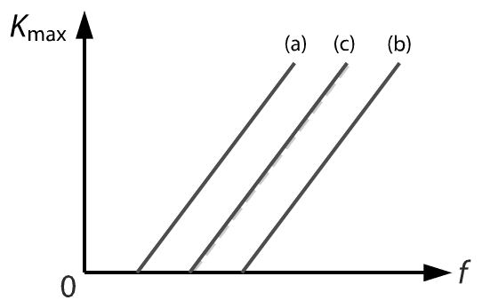

4. Graph:

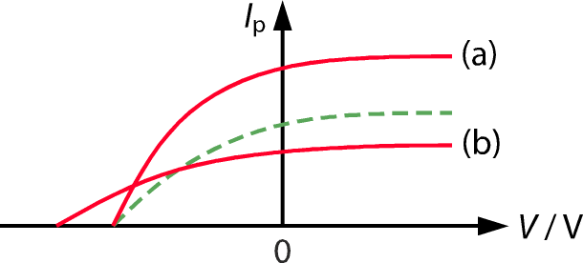

▪ See the note in textbook p.30 bottom for the value of the saturated photocurrent in (b). Here we assumed the photoelectric efficiency is unchanged.

5. An electron will be ejected immediately once it absorbs a photon of sufficiently high frequency (higher than the threshold frequency of the metal). This is independent of the intensity of the light.

Exercise

Exercise 71.1 (p.15)

1. (a) Yes (b) No (c) No

Photoemission occurs as long as the light frequency is higher than the threshold frequency, no matter how low the intensity of light is.

2. (a) Yes (b) No (c) No

The maximum KE of the photoelectrons depends on the light frequency, but not the light intensity.

3. (a) Photoelectric effect is that, if we shine light of sufficiently high frequency onto a metal, electrons will be emitted from the metal surface.

(b) (i) When *P* is shone by blue light, photoelectrons are emitted from *P* and attracted to *X* (positively charged), forming a current through the circuit.

(ii) The registered current remains unchanged when a battery of the same polarity but a larger emf is used.

4. (a) When ultraviolet radiation is directed onto the aluminium surface, photoelectrons are emitted with a range of kinetic energies.

Although the anode is negatively charged (has a lower potential) and repels some of the photoelectrons away, those of high enough kinetic energy can reach the anode, forming a current through the circuit.

(b) (i) When the applied voltage *V* reaches the stopping potential, even the photoelectrons of the highest kinetic energy are unable to reach the anode, thus the current drops to zero.

(ii) No current will be registered.

(iii) From the graph, the stopping potential is 4.1 V, and hence the maximum kinetic energy of the photoelectrons is **4.1 eV**. The maximum kinetic energy *K*max of the photoelectrons in joules is  
%FontSize=10
%TeXFontSize=10
\documentclass{article}
\pagestyle{empty}
\endofdump
\begin{document}
\begin{align*}
K_{\max} &= qV 
= (\num{1.60e-19})(4.1) \\
&= \bx{ \SI{6.56e-19}{\joule} }
\end{align*}
\end{document}

5. (a) In the wave theory of light, energy is transferred in a continuous manner. Electrons in a metal need time to absorb enough energy before they can escape.  
A time delay is thus expected during the emission of photoelectrons.

(b) (i) A weak radiation is chosen because, in the wave theory of light, a longer time delay is expected.

(ii) Radiation with sufficiently high frequency, regardless of its intensity, induces the emission of photoelectrons without any time delay.

6. (a) (i) The wave theory of light predicts that the intensity is proportional to the energy transfer rate.

(ii) The wave theory of light predicts that energy transfer rate is independent of the frequency.

(b) First, experiments show that the photoelectrons are emitted only if the frequency of the radiation is higher than a threshold frequency.

This contradicts the prediction of the wave theory of light that the emission should occur regardless of the frequency.

Second, experiments also show that the maximum KE of the photoelectrons increases with the frequency of the radiation and is independent of its intensity.

This result contradicts the prediction of the wave theory of light that, as the radiation of a higher intensity transfers more energy to the metal per second, the photoelectrons have a higher maximum kinetic energy.

Exercise 71.2 (p.32)

1. *B*

because of *E* = *hf*

2. (a) Yes (b) No (c) Yes

3. Assume the pupil is circular in shape. The number of photons entering the eyeball per second is   
%FontSize=10
%TeXFontSize=10
ontSize=10
%TeXFontSize=10
\documentclass{article}
\pagestyle{empty}
\endofdump
\begin{document}
\begin{align*}
N &= \frac{IAt}{E}  
= \frac{I \cdot \pi r^2 \cdot t}{hc/\lambda}  \\
&= \frac{ (\num{1})\times \pi (\num{1.5e-3})^2 \times (1) }
   { (\num{6.63e-34})(\num{3e8}) / (\num{600e-9}) }  \\
&= \num{2.13e13} 
\approx \bx{\num{2e13}}
\end{align*}
\end{document}

4. A

As the intensity of *X* is twice that of *Y*, the energy transferred (per second) of *X* is twice that of *Y* to a surface of equal area.

However, by *E* = *hf*, doubling the frequency doubles the energy carried by each photon, and hence the numbers of photons hitting on both surfaces (per second) are the same.

**OR:** Expressed in symbols,  
%FontSize=10
%TeXFontSize=10
\documentclass{article}
\pagestyle{empty}
\endofdump
\begin{document}
\[ 
\frac{N_1}{N_2} 
= \frac{I_1/hf_1}{I_2/hf_2}
= \frac{I_1}{I_2}\cdot \frac{f_2}{f_1}
= \frac{I_1}{I_2}\cdot \frac{\lambda_1}{\lambda_2} 
\]
\end{document}

So doubling the intensity but reducing the wavelength by half at the same time results in the same numbers of photons per second.

5. (a) Yes, because *E* = *hf*.

(b) Yes, zero under *f* < *f*0 .

(c) Yes, because *K* = *hf* − (escape energy).

6. C

Every term in the equation represents some form of energy.

7. (a) From Einstein’s equation *K*max = *eV*s = *hf* − *ϕ*, it follows that  
%FontSize=10
%TeXFontSize=10
\documentclass{article}
\pagestyle{empty}
\endofdump
\begin{document}
\[ 
V_\text{s} = \frac{h}{e}\cdot f - \frac{\phi}{e} 
\]
\end{document}

Thus, the slope is *h*/*e* = **4.14 × 10−15 V s**.

(b) From the vertical intercept, the work function *ϕ* = **4.7 eV**.

(c) Threshold frequency  
*%FontSize=10
%TeXFontSize=10
\documentclass{article}
\pagestyle{empty}
\endofdump
\begin{document}
\begin{align*}
f_0 &= \frac{\phi}{h} 
= \frac{ \SI{4.7}{\eV} }{h}
= \frac{ (4.7)(1.6\E{-19}) }{ 6.63\E{-34} } \\
&= \bx{ \SI{1.13e15}{\hertz} }
\end{align*}
\end{document}*

▪ Generally speaking, we can find the threshold frequency *f*0 from either the horizontal intercept or the vertical intercept. Beware of the unit of energy (J or eV).

8. (a) Light (or electromagnetic radiation) could only be absorbed and emitted in discrete packets of energy known as photons, rather than as a continuous wave.

A photon can only be absorbed and emitted as a whole and cannot be divided.

(b) The Einstein’s photoelectric equation is  
%FontSize=10
%TeXFontSize=10
\documentclass{article}
\pagestyle{empty}
\endofdump
\begin{document}
\[
\pmb{ K_{\max} = hf -\phi }
\]
\end{document}, where *K*max is the max. initial kinetic energy of the photoelectrons, *h* is the Planck constant, *f* is the frequency of a photon (so *hf* gives the energy of a photon), and *ϕ* is the work function, i.e. the minimum energy required for an electron to escape from the metal surface.

9. (a) As the energy of a photon depends on the frequency of the radiation (*E* = *hf*), no electron in the metal can escape by absorbing a photon if the light frequency is lower than the threshold frequency.

In contrast, in the wave theory of light, the energy transfer rate of light is independent of its frequency, and hence the emission of photoelectrons should occur at any frequency, but this contradicts the experimental results.

(b) From *K*max = *hf* − *ϕ*, changing the light frequency changes the energy that a photon gives a photoelectron, and hence its maximum KE of the photoelectrons. But changing the light intensity only changes the number of photons delivered to the metal surface per second.

The wave theory of light predicts that light of higher intensity transfers more energy to the metal per second, thus increasing the maximum KE of the photoelectrons, but this contradicts the experimental results.

10. (a) The energy of a photon is  
%FontSize=10
%TeXFontSize=10
\documentclass{article}
\pagestyle{empty}
\endofdump
\begin{document}
\begin{align*}
E &= hf = \frac{hc}{\lambda} \\
&= \frac{(\num{6.63e-34}) \times (\num{3e8})}{\num{550e-9}} \\
&= \num{3.616e-19} \approx \bx{ \SI{3.62e-19}{\joule} }
\end{align*}\end{document}

**OR:** *E* = *hc*/λ = 1243/550 = 2.26 eV

(b) No. of photons falling on the metal surface per second is  
%FontSize=10
%TeXFontSize=10
ontSize=10
%TeXFontSize=10
ontSize=10
%TeXFontSize=10
\documentclass{article}
\pagestyle{empty}
\endofdump
\begin{document}
\begin{align*}
N &= \frac{IA}{E} 
= \frac{(\num{5})(10\times(\num{e-3})^2)}{\num{3.616e-19}} \\
&= \num{1.3826e14} \approx \bx{ \num{1.38e14} }
\end{align*}
\end{document}

(c) No. of photoelectrons emitted per second is  
%FontSize=10
%TeXFontSize=10
\documentclass{article}
\pagestyle{empty}
\endofdump
\begin{document}
\begin{align*}
N' 
&= 0.02 N 
= (0.02) (\num{1.3826e14}) \\
&= \num{2.765e12} 
\end{align*}
\end{document}

The current produced is  
%FontSize=10
%TeXFontSize=10
ontSize=10
%TeXFontSize=10
\documentclass{article}
\pagestyle{empty}
\endofdump
\begin{document}
\begin{align*}
  I &= \frac{Q}{t} = \frac{ N' e }{t}
= \frac{ (\num{2.765e12})(\num{1.60e-19}) }{1} \\
&\approx \bx{\SI{4.42e-7}{\ampere}}
\end{align*}
\end{document}

11. (a) The work function is  
%FontSize=10
%TeXFontSize=10
\documentclass{article}
\pagestyle{empty}
\endofdump
\begin{document}
\begin{align*}
\phi &= hf - eV_\text{s} \\ 
&= (\num{6.63e-34})(10^{15}) - (\num{1.60e-19})(0.5) \\
&= \bx{\SI{5.83e-19}{\joule}}
\end{align*}
\end{document}

The threshold frequency is  
%FontSize=10
%TeXFontSize=10
\documentclass{article}
\pagestyle{empty}
\endofdump
\begin{document}
\begin{align*}
f_0 
&= \frac{\phi}{h} 
= \frac{\num{5.83e-19}}{\num{6.63e-34}} \\
&= \num{8.793e14} 
\approx \bx{ \SI{8.79e14}{\hertz} }
\end{align*}
\end{document}

(b) Noting %FontSize=10
%TeXFontSize=10
\documentclass{article}
\pagestyle{empty}
\endofdump
\begin{document}
\[
K_{\max} = e V_\text{s} = h(f - f_0)
\]
\end{document}, we have  
%FontSize=10
%TeXFontSize=10
\documentclass{article}
\pagestyle{empty}
\endofdump
\begin{document}
\begin{align*}
V_\text{s} 
&= \frac{ h (f - f_0)}{e} \\
&= \frac{ (\num{6.63e-34})(\num{2e15} - \num{8.793e14}) }
        { \num{1.60e-19} } \\
&= \num{4.64375} 
\approx \bx{ \SI{4.64}{\volt} }
\end{align*}
\end{document}

12. (a) The threshold frequency is  
%FontSize=10
%TeXFontSize=10
\documentclass{article}
\pagestyle{empty}
\endofdump
\begin{document}

\begin{align*}
f_0 
&= \frac{c}{\lambda_0}  
 = \frac{ \num{3e8} }{ \num{650e-9} } \\
&= \num{4.615e14}
\approx \bx{ \SI{4.62e14}{\hertz} }
\end{align*}

\end{document}

(b) Note that   
%FontSize=10
%TeXFontSize=10
\documentclass{article}
\pagestyle{empty}
\endofdump
\begin{document}

\begin{align*} 
hc 
&= \frac{(\num{6.63e-34})(\num{3e8})}{\num{1.60e-19}} \\
&= \SI{1.243e-6}{\eV\metre}
\end{align*}

\end{document}

In other words, *hc* = 1243 eV nm.

The work function is  
%FontSize=10
%TeXFontSize=10
\documentclass{article}
\pagestyle{empty}
\endofdump
\begin{document}

\begin{align*}
\phi &= h f_0 
= \frac{hc}{\lambda_0}
= \frac{1243}{650} = \bx{\SI{1.91}{\eV}}
\end{align*}


\end{document}

(c) (i) Note that  
%FontSize=10
%TeXFontSize=10
\documentclass{article}
\pagestyle{empty}
\endofdump
\begin{document}
\begin{align*} 
K_{\max}
&= \half m v_{\max}^2 \\
&= hf - hf_0  
= \frac{hc}{\lambda} - \frac{hc}{\lambda_0}
\end{align*}

\end{document}

Since *eV*s = *K*max, we have  
%FontSize=10
%TeXFontSize=10
ontSize=10
%TeXFontSize=10
\documentclass{article}
\pagestyle{empty}
\endofdump
\begin{document}

\begin{align*}
eV_\text{s}  
 &= \frac{hc}{\lambda} - \frac{hc}{\lambda_0} 
= \frac{1243}{400} - \frac{1243}{650} \\
&= 1.195
\approx \SI{1.20}{\eV}
\end{align*}

\end{document}

So, the stopping potential is **1.20 V**.

(ii) Note that *mc*2 = 0.511 MeV for electron.

So, from (i), the max. speed of the photoelectrons is  
%FontSize=10
%TeXFontSize=10
\documentclass{article}
\pagestyle{empty}
\endofdump
\begin{document}

\begin{align*}
  \frac{v_{\max}^2}{c^2}
&= \frac{2}{mc^2}\cdot
 \left(\frac{hc}{\lambda} - \frac{hc}{\lambda_0} \right) \\
&= \frac{2}{\SI{0.511e6}{\eV}}\cdot
 \Big( \SI{1.195}{\eV} \Big) \\
\therefore v_{\max} &\approx \bx{ \num{2.16e-3}\,c }
\end{align*}

\end{document}

(d) **No photoelectrons** are emitted as the wavelength of the light is longer than the threshold wavelength.

13. (a) From the graph, the threshold frequency is   
*f*0 = **1 × 1015 Hz**.

(b) The maximum KE of photoelectrons is  
%FontSize=10
%TeXFontSize=10
\documentclass{article}
\pagestyle{empty}
\endofdump
\begin{document}
\begin{align*}
K_{\max} &= h(f - f_0) \\
&= (\num{6.63e-34})(\num{1.3e15} - \num{1e15}) \\
&= \bx{ \SI{1.99e-19}{\joule} }
\end{align*}
\end{document}

(c) From Einstein’s equation *K*max = *eV*s = *hf* − *ϕ*,  
it follows that   
%FontSize=10
%TeXFontSize=10
\documentclass{article}
\pagestyle{empty}
\endofdump
\begin{document}
\[
 V_\text{s} = \frac{h}{e}\cdot f - \frac{\phi}{e}
\]
\end{document}

As the slope of the graph equals *h*/*e*, the Planck constant is  
%FontSize=10
%TeXFontSize=10
\documentclass{article}
\pagestyle{empty}
\endofdump
\begin{document}
\begin{align*}
h &= \text{slope}\times e \\
&= \frac{2.5 - 0}{(16-10)\times 10^{14}}\times ( \num{1.60e-19} )\\
&= \num{6.667e-34} \approx \bx{ \SI{6.67e-34}{\joule\second} }
\end{align*}\end{document}

The horizontal intercept of the graph equals the threshold frequency, thus *f*0 = 1 × 1015 Hz. The work function is  
%FontSize=10
%TeXFontSize=10
\documentclass{article}
\pagestyle{empty}
\endofdump
\begin{document}
\begin{align*}
  \phi &= h f_0 = (\num{6.67e-34})(\num{1e15}) \\
  &= \num{6.667e-19} \approx \bx{\SI{6.67e-19}{\joule}}
\end{align*}
\end{document}

(d) Applying *ϕ* = *hf*0, the threshold frequency of the plate is  
%FontSize=10
%TeXFontSize=10
\documentclass{article}
\pagestyle{empty}
\endofdump
\begin{document}
\begin{align*}
f'_0 
&= \frac{\phi}{h} 
= \frac{5\times\num{1.60e-19}}{\num{6.67e-34}} \\
&= \SI{1.20e15}{\hertz} 
\end{align*}
\end{document}

A new *V*s–*f* graph is shown below.

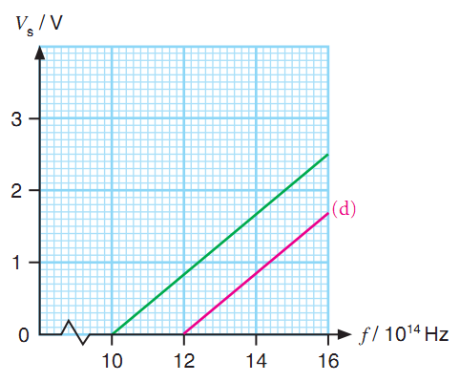

14. (a) From the graph, the stopping potential is   
*V*s = −1.6 V.

The frequency of the radiation is   
%FontSize=10
%TeXFontSize=10
\documentclass{article}
\pagestyle{empty}
\endofdump
\begin{document}

\begin{align*}
f = \frac{c}{\lambda} 
= \frac{\num{3e8}}{\num{300e-9}}
= \SI{1e15}{\hertz}
\end{align*}


\end{document}

The work function is   
%FontSize=9
%TeXFontSize=9
\documentclass{article}
\pagestyle{empty}
\endofdump
\begin{document}

\begin{align*} 
\phi &= hf - eV_\text{s} \\
&= (\num{6.63e-34})(\num{1e15})- (\num{1.60e-19})(1.6) \\
&= \bx{ \SI{4.07e-19}{\joule} }
\end{align*}

\end{document}

**OR:** Note that *hc* = 1243 eV nm.

%FontSize=10
%TeXFontSize=10
\documentclass{article}
\pagestyle{empty}
\endofdump
\begin{document}

\[ \phi 
= \frac{hc}{\lambda} - eV_\text{s}
= \frac{1243}{300} - 1.6
= \SI{2.54}{\eV}
\]

\end{document}

(b) Applying %FontSize=10
%TeXFontSize=10
\documentclass{article}
\pagestyle{empty}
\endofdump
\begin{document}
\[
eV_\text{s} = hf - \phi
\]
\end{document}, the new stopping potential   
%FontSize=9
%TeXFontSize=9
\documentclass{article}
\pagestyle{empty}
\endofdump
\begin{document}

\begin{align*}
V_\text{s} &= \frac{hf - \phi}{e} \\
&= \frac{ (\num{6.63e-34})(\num{2e15}) - (\num{4.07e-19}) }
 { \num{1.6e-19} } \\
&= \num{5.74375}
= \bx{ \SI{5.74}{\volt} }
\end{align*}

\end{document}

**OR:** Reducing the wavelength by half to   
150 nm,  
%FontSize=10
%TeXFontSize=10
\documentclass{article}
\pagestyle{empty}
\endofdump
\begin{document}
\[ eV'_\text{s} 
= \frac{hc}{\lambda'} - \phi
= \frac{1243}{150} - 2.54
= \SI{5.74}{\eV}\]

\end{document}

Therefore, *V*s = 5.74 V.

(c) The expected *I*p–*V* graph is shown below (solid line).

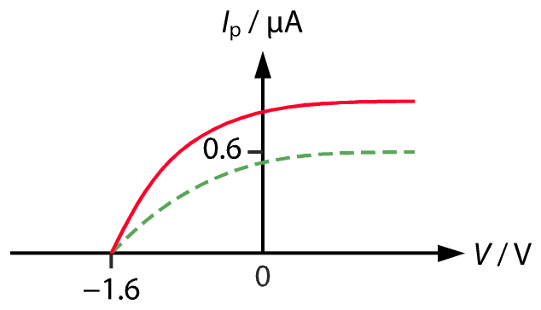

Chapter Exercise

Chapter Ex. MC (p.37)

1. B

Note that *hc* = 1243 eV nm. The energy of a photon of the yellow light is  
%FontSize=10
%TeXFontSize=10
\documentclass{article}
\pagestyle{empty}
\endofdump
\begin{document}
\begin{align*}
E &= hf = \frac{hc}{\lambda} 
= \frac{1243}{570} 
\approx \SI{2.18}{\eV}
\end{align*}
\end{document}

As no photoelectron is emitted, the work function must be larger than 2.18 eV. Note that intensity is irrelevant to whether electrons are emitted, and the exact work function of the surface cannot be determined from the given facts.

2. D

The initial KE of the fastest photoelectrons is   
*K*max = *hf* − *ϕ*, thus the initial KE of all the photoelectrons must be smaller than or equal to that value. Whether the photoelectrons can reach the positive anode or not is irrelevant.

3. B

(2) is correct. Because of the glass plate, the intensity of the UV radiation falling on the metal surface is lowered. So, less photons hit the metal surface.

(1) and (3) are **incorrect**. The number of photons emitted depends on the source. The work function of metal is a property of the metal. Putting a glass plate in between will not disturb the function of the source nor alter the property of the metal.

4. C

The stopping potential *V*s is independent of the intensity *I* of the radiation.

5. D

Photon energy *E* = *hf* :

|  |  |  |
| --- | --- | --- |
| **radiation** | ***f* / 1014 Hz** | ***hf* / eV** |
| *X* | 9.0 | 3.73 |
| *Y* | 10.0 | 4.14 |
| Z | 11.0 | 4.56 |

Applying %FontSize=10
%TeXFontSize=10
\documentclass{article}
\pagestyle{empty}
\endofdump
\begin{document}
\[
K_{\max} = eV_\text{s} = hf - \phi
\]
\end{document}, we have:

|  |  |  |
| --- | --- | --- |
| **photocell** | **radiation** | ***V*s / eV** |
| *P* | *X* | 0.93 |
| *P* | *Z* | 1.76 |
| *Q* | *X* | 0.43 |
| *R* | *Y* | 0.14 |

Hence, the smallest stopping potential is obtained when photocell *R* and radiation *Y* are used.  
Note that the *hf* of radiation *X* is smaller than the *ϕ* of photocell *R*.

6. B

The stopping potential is given by  
%FontSize=10
%TeXFontSize=10
\documentclass{article}
\pagestyle{empty}
\endofdump
\begin{document}
\[ 
\underbrace{K_{\max}}_{eV_\text{s}} 
= hf - \phi = \frac{hc}{\lambda} - \phi 
\]
\end{document}

7. C

Equal intensity but higher frequency ⇒ the beam contains less number of photons, but each photon has higher energy *E* = *hf*.

8. C

Equal intensity but lower frequency ⇒ the beam contains more number of photons, but each photon has higher energy *E* = *hf*.

9. D

From Einstein photoelectric equation,   
*E*max = *hf* − *ϕ,* we see that the *E*max–*f* graph is a straight line with a positive slope.

10. A

Option B is **incorrect**. Electrons emission only occurs when the light is above the threshold frequency, i.e. below a certain threshold wavelength since λ = *c*/*f*.

11. B

The work function is *ϕ* = *hf* − *K*max = 7 − 4 = 3 eV. When photons of energy 4 eV are incident, the maximum KE is *hf* − *ϕ* = 4 − 3 = 1 eV. So the stopping potential is 1 V.

12. C

Note that *K* = *h*(*f* − *f*0). The slope of the graph is *h*/*e*, which is a constant. The horizontal intercept is the threshold frequency *f*0, which depends only on the properties of the metal, not the incident light.

13. D

The work function is equal to *ϕ* = *hf* − *K*max = 3.41 − 0.54 = 2.87 eV. It follows that  
%FontSize=10
%TeXFontSize=10
\documentclass{article}
\pagestyle{empty}
\endofdump
\begin{document}

\begin{align*}
  f_0 
  &= \frac{\phi}{h}
  = \frac{ \SI{2.87}{\eV} }{ h } 
  = \frac{2.87 \times (\num{1.6e-19})}{ \num{6.63e-34} } \\
  &= \SI{6.93e14}{\hertz}
\end{align*}

\end{document}

**OR:** Note that *c* = 3× 108 m s−1 = 3× 1017 nm s−1 and *hc* = 1243 eV nm. So,   
%FontSize=10
%TeXFontSize=10
\documentclass{article}
\pagestyle{empty}
\endofdump
\begin{document}

\begin{align*} 
f_0 
&= \frac{\phi}{h}  = \frac{\phi c}{hc}
= \frac{(2.87)(\num{3e17})}{1243} \\
&= \SI{6.93e14}{\hertz} 
\end{align*}

\end{document}

14. B

Equal intensity but higher frequency   
⇒ less number of photons, but each photon carries higher energy (∵*E* = *hf*).

Less photons ⇒ smaller *I*.

Higher energy *hf* ⇒ higher *K*max ⇒ higher *V*s

▪ Remember

%FontSize=10
%TeXFontSize=10
\documentclass{article}
\pagestyle{empty}
\endofdump
\begin{document}
\[ \underbrace{K_{\max}\vphantom{\phi}}_{eV_\text{s}} 
= hf - \underbrace{\phi}_{hf_0} \]

\end{document}

15. B

Each data point is shifted down by a fixed amount.

16. E

Both light intensity and photoelectric current are proportional to the number of photons. All other relations involving *K* or *hf* must include a threshold *hf*0. Their graphs therefore will **not** pass through the origin.

Chapter Ex. SQ (p.39)

17. (a) The photoelectrons emitted is attracted back to the cathode *P* due to the opposing pd across the two terminals. Thus, increasing the opposing pd by increasing *x* leads to a decrease in the photoelectric current *I*. (1A)

When *x* = 20 cm, even the photoelectrons emitted with the maximum KE cannot reach the anode *X*, thus the current remains zero regardless of any further increase in *x*. (1A)

(b) When *x* = 20 cm, the opposing pd across *P* and *X* gives the stopping potential, hence   
%FontSize=10
%TeXFontSize=10
\documentclass{article}
\pagestyle{empty}
\endofdump
\begin{document}
\begin{align*}
V_\text{s} &= 6\times\frac{20}{30} = \SI{4}{\volt}\om
\end{align*}
\end{document}

Note that *hc* =1243 eV nm.

The work function is  
%FontSize=10
%TeXFontSize=10
ontSize=10
%TeXFontSize=10
\documentclass{article}
\pagestyle{empty}
\endofdump
\begin{document}
\begin{align*}
\phi &= hf - e V_\text{s} 
 = \frac{hc}{\lambda} - e V_\text{s} \om \\
     &= \frac{1243}{200} - 4 
 \approx \SI{2.22}{\eV} \oa 
\end{align*}
\end{document}

The threshold frequency is%FontSize=10
%TeXFontSize=10
\documentclass{article}
\pagestyle{empty}
\endofdump
\begin{document}
\begin{align*}
 f_0 &= \frac{\phi}{h} 
     = \frac{ \num{3.545e-19} }{ \num{6.63e-34} } \om \\
  &= \num{5.3469e14} 
     \approx \bx{ \SI{5.35e14}{\hertz} }  \oa
\end{align*}
\end{document}

(c) (i) The horizontal intercept represents the stopping potential *V*s , (1A)  
which varies with the work function *ϕ* and the radiation frequency *f* by   
%FontSize=10
%TeXFontSize=10
\documentclass{article}
\pagestyle{empty}
\endofdump
\begin{document}
\begin{flalign*}
 V_\text{s} = \frac{h}{e} f - \frac{\phi}{e}  \oa 
\end{flalign*}
\end{document}

(ii) The vertical intercept represents the number of photoelectrons emitted from the cathode *P*. (1A)

Increasing the number of photons delivered to the photocell increases the number of photoelectrons emitted and hence the vertical intercept. (1A)

(iii) Since the two graphs have a common horizontal intercept, (1A)  
the two beams have **equal** frequency. (1A)

From the new graph, the current of the new beam is always larger, (1A)  
hence its intensity must be **higher**. (1A)

18. (a) Part of the ammeter reading would be contributed by the walls of the chamber if the walls were photoemissive.

(b) (i) The frequency *f* = *c*/λ and the stopping potential *V*s are tabulated as follows. (1A)

|  |  |  |
| --- | --- | --- |
| **λ / nm** | ***f* / 1014 Hz** | ***V*s / V** |
| 405 | 7.41 | 0.220 |
| 365 | 8.22 | 0.563 |
| 313 | 9.59 | 1.15 |
| 254 | 11.8 | 2.10 |
| 210 | 14.3 | 3.14 |

The graph of *V*s against *f*:   
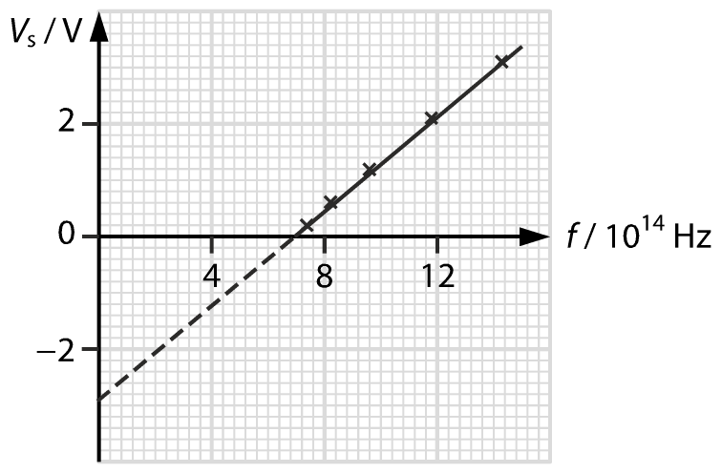

Correct axis: **1A**Correct graph: **1A**

(ii) No (1A)  
%FontSize=10
%TeXFontSize=10
\documentclass{article}
\pagestyle{empty}
\endofdump
\begin{document}
\[
V_\text{s} = \frac{h}{e}\cdot f - \frac{\phi}{e}
\implies
V_\text{s} = \frac{hc}{e}\cdot\frac{1}{\lambda} - \frac{\phi}{e}
\]
\end{document}

(iii) From the vertical intercepts, (1M)  
the work function of lithium is **2.9 eV**. (1A)

(iv) The slope of the graph equals *h*/*e*.  
%FontSize=10
%TeXFontSize=10
\documentclass{article}
\pagestyle{empty}
\endofdump
\begin{document}
\begin{flalign*} 
&& \text{slope} 
&= \frac{2.8 - 0.8}{\num{13.6e14} - \num{8.8e14}} &\\
&& &= \SI{4.167e-15}{\volt\second}
\end{flalign*}
\end{document}

The estimated Planck constant is  
%FontSize=10
%TeXFontSize=10
ontSize=10
%TeXFontSize=10
\documentclass{article}
\pagestyle{empty}
\endofdump
\begin{document}
\begin{align*}
h &= \text{slope} \times e \\
  &= ( \num{4.167e-15} )( \num{1.60e-19} )  \\
  &= \num{6.667e-34}  \\
  &\approx \SI{6.78e-34}{\joule\second} \oa 
\end{align*}
\end{document}

The percentage error of the estimated value is  
%FontSize=10
%TeXFontSize=10
ontSize=10
%TeXFontSize=10
\documentclass{article}
\pagestyle{empty}
\endofdump
\begin{document}
\begin{align*}
\frac{\Delta h}{h} \times 100\%
&= \frac{ \num{6.667} - \num{6.626} }{ \num{6.626} } 
 \times 100\% \\
&\approx \bx{0.619\%} \oa
\end{align*}
\end{document}

19. (a) Connect the apparatus as shown.

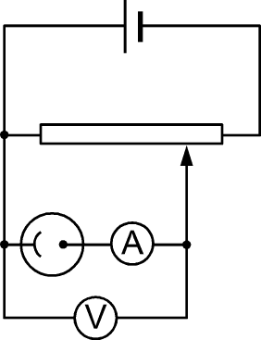

Illuminate the photocell with the radiation. (1A)

Adjust the rheostat until the ammeter registers a zero reading. (1A)

Read the stopping potential *V*s of the plate from the voltmeter. (1A)

Calculate the maximum kinetic energy of the photoelectrons using   %FontSize=10
%TeXFontSize=10
\documentclass{article}
\pagestyle{empty}
\endofdump
\begin{document}
\[
K_\text{max} = eV_s.
\]
\end{document} (1A)

(b) (i) From *E* = *hf* = *hc*/λ, radiation of shorter wavelength is photons of higher energy. (1A)

Applying *K*max = *hf* – *ϕ*, the maximum kinetic energy of the photoelectrons increases. (1A)

(ii) From *E* = *hf*, the energy of a photon only depends on the radiation frequency. (1A)

Applying *K*max = *hf* – *ϕ*, the maximum kinetic energy of the photoelectrons remains unchanged, regardless of the increase in the radiation intensity. (1A)

(iii) Applying *K*max = *hf* – *ϕ*, the maximum kinetic energy of the photoelectrons remains unchanged as the work function remains unchanged. (1A)

The cathode–anode distance does not affect the maximum kinetic energy (as long as the pd is unchanged). (1A)

(iv) From *E* = *hf*, the energy of a photon does not depend on the intensity of the radiation used. (1A)

Thus, the distance between the source and the cathode of the photocell does not affect the maximum KE of the photoelectrons. (1A)

(c) Electrons are held by metal ions at different strengths, (1A)  
and so require different amounts of energy to escape, causing each carries different amounts of kinetic energy after the escape. (1A)

20. (a) (i) The work function of a metal is the minimum energy required to remove an electron from the metal surface. (1A)

(ii) Note *hc* = 1243 eV nm. From Einstein’s equation,%FontSize=10
%TeXFontSize=10
\documentclass{article}
\pagestyle{empty}
\endofdump
\begin{document}
\begin{flalign*}
&&  eV_\text{s} &= hf - \phi 
   = \frac{hc}{\lambda} - \phi   \om \\
&& &= \frac{1243}{200} - 3.66 
 = 2.556  \oa
\end{flalign*}
\end{document}

So the stopping potential is **2.56 V**, (1A)  
and the maximum KE of the photoelectrons emitted is *K*max   
= *eV*s = **2.56 eV** or 4.09 × 1019 J. (1A)

(b) (i) The energy of each photon of the radiation is %FontSize=10
%TeXFontSize=10
\documentclass{article}
\pagestyle{empty}
\endofdump
\begin{document}
\begin{align*}
E &= hf = \frac{hc}{\lambda} = \frac{1243}{200} 
   = \SI{6.215}{\eV} \om
\end{align*}
\end{document}

The number of photons delivered in   
1 second is  
%FontSize=10
%TeXFontSize=10
\documentclass{article}
\pagestyle{empty}
\endofdump
\begin{document}
\begin{align*}
N  &= \frac{IA}{E} 
    = \frac{ (200)(\num{16e-6}) }{ 6.215\times \num{1.6e-19} } \\
 &= \num{3.218e15}
 \approx \bx{\num{3.22e15}} \oa
\end{align*}
\end{document}

(ii) Number of photoelectrons emitted   
%FontSize=10
%TeXFontSize=10
\documentclass{article}
\pagestyle{empty}
\endofdump
\begin{document}
\begin{align*}
N' &= 0.03 N = 0.03\times (\num{3.218e15}) \om\\
   &= \bx{\num{9.65e13}} \oa
\end{align*}
\end{document}

21. (a) A metal surface emits photoelectrons only if the frequency of the incident radiation is larger than the threshold frequency of the metal. (1A)

(b) Electrons in a metal surface are held by metal ions and thus require extra energy to escape. (1A)

By viewing a beam of radiation as discrete packs of energy called photons, each electron in the metal surface can only absorb a discrete amount of energy from a single photon. (1A)

Only when the energy of the photon absorbed is large enough can the electron escape. (1A)

(c) The wave theory states that the electrons in the metal surface can absorb energy from the incident radiation continuously. (1A)

The quantum theory states that the electrons can only absorb discrete amounts of energy in the form of photons. (1A)

(d) Here are the differences:

• The wave theory predicts that, illuminating a metal surface with radiation of greater intensity transfers more energy to the surface per second, thus the maximum kinetic energy of the photoelectrons increases. (1A)

Moreover, the emission of photoelectrons should occur at any frequency. (1A)

• The quantum theory predicts that the emission of photoelectrons occurs only when the incident radiation has a frequency higher than the threshold frequency of the metal, and is independent of its intensity. (1A)

Moreover, the maximum kinetic energy of the photoelectrons and the radiation frequency are related by *K*max = *hf* – *ϕ*. (1A)

22. (a) (i) According to wave theory, energy that light carries depends on the light intensity. (1A)

Photoelectrons should be emitted at any frequency if the incident light is intense enough or the time of exposure is long enough. (1A)

(ii) Note that *hc* = 1243 eV nm. According to photoelectric equation,  
%FontSize=10
%TeXFontSize=10
\documentclass{article}
\pagestyle{empty}
\endofdump
\begin{document}
\begin{flalign*}
%&&\half m_\text{e} v_{\max}^2 &= hf - \phi \\
%&& 0 &= hf_0 - \phi &\om\\
&& \phi &= hf_0 = \frac{hc}{\lambda_0} 
 = \frac{1243}{527} 
     \approx \bx{\SI{2.36}{\eV}}  \omoa
%&& &= \num{6.63e-34} \frac{\num{3e8}}{\num{5.27e-7}}  \oa\\
%&& &= \SI{3.77e-19}{\joule} \\
\end{flalign*}
\end{document}

(iii) The minimum energy required to remove an electron from a metal surface (against the attractive electric force of the metal). (1A)

(b) (i) Number of photoelectrons per second  
%FontSize=10
%TeXFontSize=10
\documentclass{article}
\pagestyle{empty}
\endofdump
\begin{document}
\begin{flalign*} 
&& N   = \frac{I}{e} 
      = \frac{\num{1e-8}}{\num{1.6e-19}} 
    = \num{6.25e10}  &\om
\end{flalign*}
\end{document}

Number of photons per second  
%FontSize=10
%TeXFontSize=10
\documentclass{article}
\pagestyle{empty}
\endofdump
\begin{document}

\begin{flalign*}
&&  n &= \frac{\num{6.25e10}}{5\%} = \bx{\num{1.25e12}} \oa
\end{flalign*}

\end{document}

(ii) Peter’s claim is correct.

More photons will be emitted if a light source of the same type but of higher intensity is used. (1A)

Hence, sufficient photons will be scattered by a smaller amount of smoke particles. (1A)

23. (a) (i) Energy of a photon  
%FontSize=10
%TeXFontSize=10
\documentclass{article}
\pagestyle{empty}
\endofdump
\begin{document}
\begin{align*}
E = hf  
  &= \text{work function} + \text{max.\ KE} \\
  &= 2.30 + 0.81  \\
  &= \pmb{ \SI{3.11}{\eV} } \oa
\end{align*}
\end{document}

(ii) The work function of a metal is only the minimum energy required to emit an electron. Only the free electrons at the surface have the maximum KE. (1A)

(b) (i) The effective area is  
*A* = 0.01 nm2 = 0.01 × 10−18 m

The energy absorbed by an atom per second is  
%FontSize=10
%TeXFontSize=10
\documentclass{article}
\pagestyle{empty}
\endofdump
\begin{document}
\[ P %= \text{intensity} \times A 
   = (0.01)(\num{0.01e-18}) 
   = \SI{1e-22}{\watt} \]\end{document}

Since the energy absorbed by an atom (= *Pt*) is equal to the work function *ϕ*, the min. time required is   
%FontSize=10
%TeXFontSize=10
ontSize=10
%TeXFontSize=10
\documentclass{article}
\pagestyle{empty}
\endofdump
\begin{document}
\begin{flalign*}
%  && \text{intensity} &\times A \times t = \phi &\om\\
%  && \therefore\; t &= \frac{\phi}{\text{intensity}\times A \times t} \\
%  && Pt &= \phi \om \\
  && t  &= \frac{\phi}{P} 
   = \frac{ 2.30 \times (\num{1.60e-19}) }{ \num{1e-22} } \om\\
%    { (0.01)(\num{0.01e-18}) } \\
&& &= \bx{ \SI{3680}{\second} }  \oa
\end{flalign*}
\end{document}

(ii) If a single photon has sufficient energy to knock out an electron, the electron gains enough energy in only one collision. (1A)

(c) Number of photons hitting the surface per second  
%FontSize=10
%TeXFontSize=10
\documentclass{article}
\pagestyle{empty}
\endofdump
\begin{document}
\begin{flalign*}
&& N &= \frac{0.01 \times (\num{4e-4})}
 {3.11 \times \num{1.60e-19}} 
      = \bx{ \num{8.04e12} }  \oa
\end{flalign*}\end{document}

Maximum photoelectric current  
  %FontSize=10
%TeXFontSize=10
\documentclass{article}
\pagestyle{empty}
\endofdump
\begin{document}
\begin{align*}
 I &= N\times \text{efficiency} \times \text{charge} \\
   &= (\num{8.04e12})(0.1)(\num{1.60e-19})  \om\\
   &= \bx{ \SI{1.29e-7}{\ampere} }  \oa
\end{align*}
\end{document}

(d) Saturated current will be halved but cut-off voltage remains unchanged (dotted). (2A)  
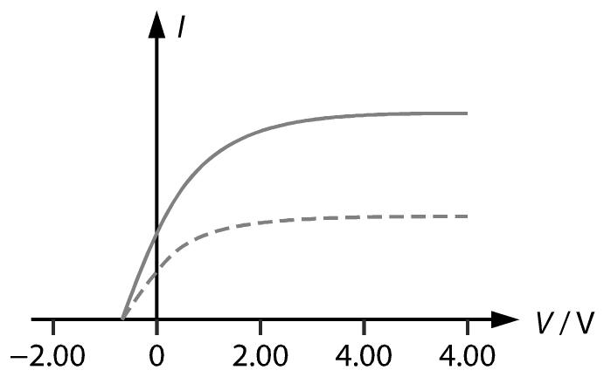

24. (a) The minimum energy required to free an electron from the surface of a metal. (1A)

(b) Part of the energy gained by an electron from a photon is lost through the collisions with surrounding electrons/ions. (1A)

(c) (i) The max. KE of the photoelectron is   
%FontSize=10
%TeXFontSize=10
\documentclass{article}
\pagestyle{empty}
\endofdump
\begin{document}
\begin{align*}
 K_{\max} &= hf - \phi 
      = \frac{hc}{\lambda} - \phi \\
     &= \frac{1243}{230} - 2.21 
     = \bx{ \SI{3.19}{\eV} }  \oa 
%
%&= \frac{ (\num{6.63e-34})(\num{3e8}) }{\num{230e-9}} 
%     - 2.21 \times \num{1.60e-19}  &\om\\
%&= \bx{\SI{5.11e-19}{\joule}} 
% \quad (\text{or } \SI{3.19}{\eV})  &\oa
\end{align*}
\end{document}  
or 5.11 × 1019 J.

(ii) Note that *eV*s = *K*max. So, the stopping potential is *V*s = **3.19V**. (1A)

(d) Energy supplied per second

= 3 × (8.0 × 10−3)2 = 1.92 × 10−4 J. (1M)

Energy of each photon%FontSize=10
%TeXFontSize=10
ontSize=10
%TeXFontSize=10
\documentclass{article}
\pagestyle{empty}
\endofdump
\begin{document}

\begin{align*}
&= \num{6.63e-34} \times \frac{\num{3e8}}{\num{230e-9}} \\ 
&=\SI{8.65e-19}{\joule} \om 
\end{align*}

\end{document}

No. of photoelectrons emitted per second  
%FontSize=10
%TeXFontSize=10
\documentclass{article}
\pagestyle{empty}
\endofdump
\begin{document}
\[
= \frac{\num{1.92e-4}}{\num{8.65e-19}} = \bx{\num{2.22e14}} \oa
\]
\end{document}

(e) (i) As the energy of each photon increases, *K*max of the photoelectrons increases. (1A)

Thus stopping potential increases. (1A)

(ii) As the intensity is constant and each photon has more energy, the number of photons arriving the metal plate per second decreases. (1A)

Thus number of photoelectrons emitted per second decreases. (1A)

25. (a) Connect a photocell to a variable voltage source via an sensitive ammeter, as shown. (1A)

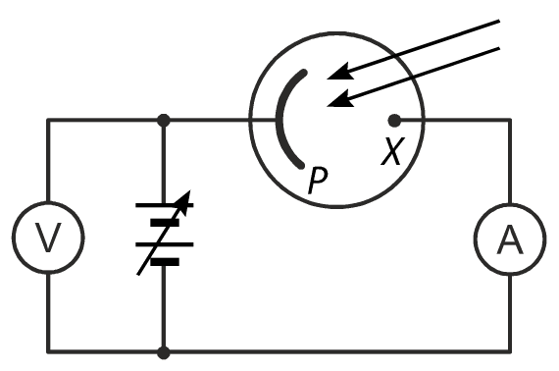

The stopping potential (–*V*s) indicates the maximum KE of the ejected electron because *K*max = *eV*s. (1A)

Change the intensity of the incident radiation. The corresponding stopping potential is obtained by adjusting the reversed voltage until the ammeter reading just becomes zero. (1A)

The stopping potential remains the same for different intensity of the incident radiation. (1A)

(b) (i) Observations (2) and (3) are contrary to the prediction. (1A)

Prediction contrary to (2): According to wave theory, radiation of higher intensity transfer more energy to the metal per second. Therefore, a certain number of photoelectrons should be expected to be emitted with higher speeds when the intensity of the incident radiation increases. (1A)

Prediction contrary to (3): According to the wave theory, the energy of radiation is solely determined by the intensity of the radiation. Electrons should be emitted at any frequency if the time of exposure is long enough for electrons to gather enough energy to escape from the metal surface. (1A)

(ii) Einstein proposed that radiation is emitted and absorbed only in whole numbers of quanta called photons. A photon has energy *hf*, where *f* is the frequency of the radiation. (1A)

Each photoemission is the result of absorption of one photon if *hf* > *ϕ*, where *ϕ* is the work function, i.e., the minimum energy required for an electron to escape from the metal surface. The maximum KE of the photoelectrons is thus *K*max = *hf* − *ϕ*. (1A)

Because *ϕ* is a constant for particular metal, there is a minimum frequency *f*0 below which no photoemission is possible (Observation 3). (1A)

Therefore, *ϕ* = *hf* and *K*max = *h*(*f* − *f*0). This means, the maximum KE of photoelectrons depends on the frequency *f* of the incident radiation. Increasing the intensity only increases the number of photons, and the number of the photoelectrons. (Observation 2). (1A)

26. (a) (i) Due to the photoelectric effect, the photoemissive cathode emits electrons when illuminated by radiation higher than its threshold frequency. (1A)

(ii) No. (1A)

Only the radiation with frequency higher than the threshold frequency of the photoemissive cathode can be detected. (1A)

(b) The dynodes are arranged in such a way to accelerate the incident electrons, (1A)  
and hence to induce the emission of additional electrons. (1A)

(c) PMTs can greatly amplify weak light signals. (1A)

Hence they are useful in amplifying the weak light signals from distant stars. (1A)