Follow-up Examples (Ch.1)

Lighting

Example 1.1\* (p.19)

Ada decides to replace the lamp in her room by one the following types of lamps. All of them have similar luminous flux output.

|  |  |  |  |
| --- | --- | --- | --- |
|  | *P* | *Q* | *R* |
| power rating | 4 W | 11 W | 40 W |
| price | $100 | $35 | $8 |
| lifetime | 25 000 hours | 9000 hours | 1000 hours |

(a) Which one is most probably an LED lamp?

\_\_\_\_\_\_\_\_\_\_\_\_\_\_\_\_\_\_\_\_\_\_\_\_\_\_\_\_\_\_\_\_\_\_\_\_\_\_\_\_\_\_\_\_\_\_\_\_\_\_\_\_\_\_\_\_\_\_\_\_\_\_\_\_\_\_

(b) Rank the lamps in descending order of efficacy.

\_\_\_\_\_\_\_\_\_\_\_\_\_\_\_\_\_\_\_\_\_\_\_\_\_\_\_\_\_\_\_\_\_\_\_\_\_\_\_\_\_\_\_\_\_\_\_\_\_\_\_\_\_\_\_\_\_\_\_\_\_\_\_\_\_\_

\_\_\_\_\_\_\_\_\_\_\_\_\_\_\_\_\_\_\_\_\_\_\_\_\_\_\_\_\_\_\_\_\_\_\_\_\_\_\_\_\_\_\_\_\_\_\_\_\_\_\_\_\_\_\_\_\_\_\_\_\_\_\_\_\_\_

(c) Ada concerns the total cost of the lamp the most. Recommend a lamp for her by considering 10 000 hours of use. Given that the electricity cost is $1.2 per kW h.

\_\_\_\_\_\_\_\_\_\_\_\_\_\_\_\_\_\_\_\_\_\_\_\_\_\_\_\_\_\_\_\_\_\_\_\_\_\_\_\_\_\_\_\_\_\_\_\_\_\_\_\_\_\_\_\_\_\_\_\_\_\_\_\_\_\_

\_\_\_\_\_\_\_\_\_\_\_\_\_\_\_\_\_\_\_\_\_\_\_\_\_\_\_\_\_\_\_\_\_\_\_\_\_\_\_\_\_\_\_\_\_\_\_\_\_\_\_\_\_\_\_\_\_\_\_\_\_\_\_\_\_\_

\_\_\_\_\_\_\_\_\_\_\_\_\_\_\_\_\_\_\_\_\_\_\_\_\_\_\_\_\_\_\_\_\_\_\_\_\_\_\_\_\_\_\_\_\_\_\_\_\_\_\_\_\_\_\_\_\_\_\_\_\_\_\_\_\_\_

Example 1.2\* (p.25)

Bruce uses a lux meter to measures the illuminance of a surface at a distance of 20 m from the advertisement light of a shop at night. He adjusts the orientation of the sensor of the meter to obtain a maximum reading of 160 lx.

(a) What is the orientation of the sensor of the meter in order to obtain the maximum reading?

\_\_\_\_\_\_\_\_\_\_\_\_\_\_\_\_\_\_\_\_\_\_\_\_\_\_\_\_\_\_\_\_\_\_\_\_\_\_\_\_\_\_\_\_\_\_\_\_\_\_\_\_\_\_\_\_\_\_\_\_\_\_\_\_\_\_

\_\_\_\_\_\_\_\_\_\_\_\_\_\_\_\_\_\_\_\_\_\_\_\_\_\_\_\_\_\_\_\_\_\_\_\_\_\_\_\_\_\_\_\_\_\_\_\_\_\_\_\_\_\_\_\_\_\_\_\_\_\_\_\_\_\_

(b) Find the luminous flux produced by the light.

\_\_\_\_\_\_\_\_\_\_\_\_\_\_\_\_\_\_\_\_\_\_\_\_\_\_\_\_\_\_\_\_\_\_\_\_\_\_\_\_\_\_\_\_\_\_\_\_\_\_\_\_\_\_\_\_\_\_\_\_\_\_\_\_\_\_

\_\_\_\_\_\_\_\_\_\_\_\_\_\_\_\_\_\_\_\_\_\_\_\_\_\_\_\_\_\_\_\_\_\_\_\_\_\_\_\_\_\_\_\_\_\_\_\_\_\_\_\_\_\_\_\_\_\_\_\_\_\_\_\_\_\_

\_\_\_\_\_\_\_\_\_\_\_\_\_\_\_\_\_\_\_\_\_\_\_\_\_\_\_\_\_\_\_\_\_\_\_\_\_\_\_\_\_\_\_\_\_\_\_\_\_\_\_\_\_\_\_\_\_\_\_\_\_\_\_\_\_\_

(c) Bruce now moves to a distance of 10 m from the light and takes the measurement again. How does the maximum reading of the illuminance change?

\_\_\_\_\_\_\_\_\_\_\_\_\_\_\_\_\_\_\_\_\_\_\_\_\_\_\_\_\_\_\_\_\_\_\_\_\_\_\_\_\_\_\_\_\_\_\_\_\_\_\_\_\_\_\_\_\_\_\_\_\_\_\_\_\_\_

\_\_\_\_\_\_\_\_\_\_\_\_\_\_\_\_\_\_\_\_\_\_\_\_\_\_\_\_\_\_\_\_\_\_\_\_\_\_\_\_\_\_\_\_\_\_\_\_\_\_\_\_\_\_\_\_\_\_\_\_\_\_\_\_\_\_

Example 1.3\* (p.26)

Charles screws a CFL into the socket of a storeroom of dimensions 2 m × 2 m × 2.5 m as shown. The CFL is located at *O*. The interior walls of the storeroom are painted in black. The right shows the energy label of the CFL.

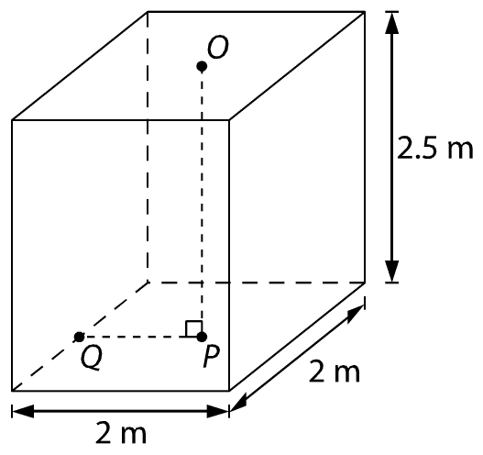 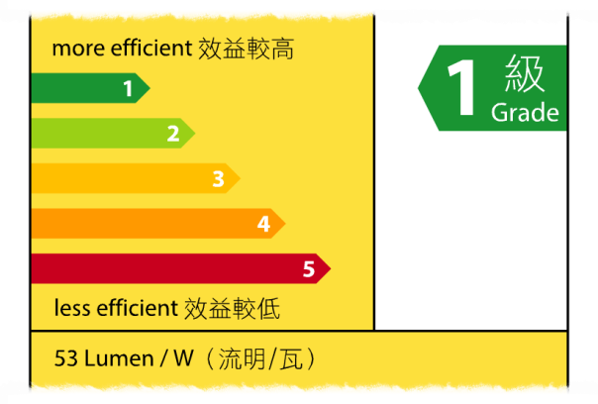

(a) Find the luminous flux of the CFL if its power rating is 11 W.

\_\_\_\_\_\_\_\_\_\_\_\_\_\_\_\_\_\_\_\_\_\_\_\_\_\_\_\_\_\_\_\_\_\_\_\_\_\_\_\_\_\_\_\_\_\_\_\_\_\_\_\_\_\_\_\_\_\_\_\_\_\_\_\_\_\_

\_\_\_\_\_\_\_\_\_\_\_\_\_\_\_\_\_\_\_\_\_\_\_\_\_\_\_\_\_\_\_\_\_\_\_\_\_\_\_\_\_\_\_\_\_\_\_\_\_\_\_\_\_\_\_\_\_\_\_\_\_\_\_\_\_\_

(b) *P* is a small surface directly below *O* on the floor. And *Q* is a small surface on the ground next to the wall. Find the illuminance on them.

\_\_\_\_\_\_\_\_\_\_\_\_\_\_\_\_\_\_\_\_\_\_\_\_\_\_\_\_\_\_\_\_\_\_\_\_\_\_\_\_\_\_\_\_\_\_\_\_\_\_\_\_\_\_\_\_\_\_\_\_\_\_\_\_\_\_

\_\_\_\_\_\_\_\_\_\_\_\_\_\_\_\_\_\_\_\_\_\_\_\_\_\_\_\_\_\_\_\_\_\_\_\_\_\_\_\_\_\_\_\_\_\_\_\_\_\_\_\_\_\_\_\_\_\_\_\_\_\_\_\_\_\_

\_\_\_\_\_\_\_\_\_\_\_\_\_\_\_\_\_\_\_\_\_\_\_\_\_\_\_\_\_\_\_\_\_\_\_\_\_\_\_\_\_\_\_\_\_\_\_\_\_\_\_\_\_\_\_\_\_\_\_\_\_\_\_\_\_\_

\_\_\_\_\_\_\_\_\_\_\_\_\_\_\_\_\_\_\_\_\_\_\_\_\_\_\_\_\_\_\_\_\_\_\_\_\_\_\_\_\_\_\_\_\_\_\_\_\_\_\_\_\_\_\_\_\_\_\_\_\_\_\_\_\_\_

\_\_\_\_\_\_\_\_\_\_\_\_\_\_\_\_\_\_\_\_\_\_\_\_\_\_\_\_\_\_\_\_\_\_\_\_\_\_\_\_\_\_\_\_\_\_\_\_\_\_\_\_\_\_\_\_\_\_\_\_\_\_\_\_\_\_

\_\_\_\_\_\_\_\_\_\_\_\_\_\_\_\_\_\_\_\_\_\_\_\_\_\_\_\_\_\_\_\_\_\_\_\_\_\_\_\_\_\_\_\_\_\_\_\_\_\_\_\_\_\_\_\_\_\_\_\_\_\_\_\_\_\_

(c) The measured values of the illuminance of *P* and *Q* are greater than the values found in (b). If the interior walls of the storeroom are painted in white, the values would be even larger. Briefly explain why.

\_\_\_\_\_\_\_\_\_\_\_\_\_\_\_\_\_\_\_\_\_\_\_\_\_\_\_\_\_\_\_\_\_\_\_\_\_\_\_\_\_\_\_\_\_\_\_\_\_\_\_\_\_\_\_\_\_\_\_\_\_\_\_\_\_\_

\_\_\_\_\_\_\_\_\_\_\_\_\_\_\_\_\_\_\_\_\_\_\_\_\_\_\_\_\_\_\_\_\_\_\_\_\_\_\_\_\_\_\_\_\_\_\_\_\_\_\_\_\_\_\_\_\_\_\_\_\_\_\_\_\_\_

\_\_\_\_\_\_\_\_\_\_\_\_\_\_\_\_\_\_\_\_\_\_\_\_\_\_\_\_\_\_\_\_\_\_\_\_\_\_\_\_\_\_\_\_\_\_\_\_\_\_\_\_\_\_\_\_\_\_\_\_\_\_\_\_\_\_

Example 1.4\* (p.27)

Daisy hangs a lamp of efficacy of 60 lm W−1 above a circular table of radius 1 m as shown. *P* is the centre of the table while *Q* is a point on the edge. The lamp is 1.2 m above *P*. Treat the lamp as a point light source.

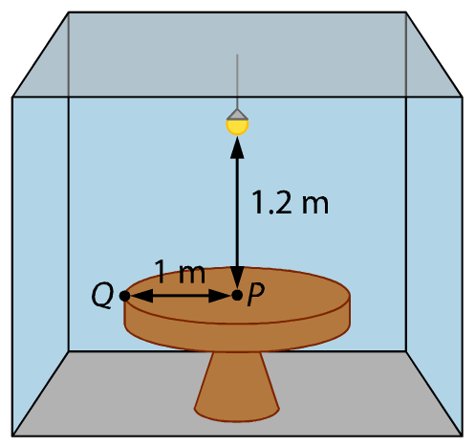

(a) Explain which small area, *P* or *Q*, is less illuminated on the table. Daisy hopes that every part of the table has an illuminance of over 25 lx. What is the minimum luminous flux that the light should produce? Neglect the diffuse reflection from the ceiling and the walls.

\_\_\_\_\_\_\_\_\_\_\_\_\_\_\_\_\_\_\_\_\_\_\_\_\_\_\_\_\_\_\_\_\_\_\_\_\_\_\_\_\_\_\_\_\_\_\_\_\_\_\_\_\_\_\_\_\_\_\_\_\_\_\_\_\_\_

\_\_\_\_\_\_\_\_\_\_\_\_\_\_\_\_\_\_\_\_\_\_\_\_\_\_\_\_\_\_\_\_\_\_\_\_\_\_\_\_\_\_\_\_\_\_\_\_\_\_\_\_\_\_\_\_\_\_\_\_\_\_\_\_\_\_

\_\_\_\_\_\_\_\_\_\_\_\_\_\_\_\_\_\_\_\_\_\_\_\_\_\_\_\_\_\_\_\_\_\_\_\_\_\_\_\_\_\_\_\_\_\_\_\_\_\_\_\_\_\_\_\_\_\_\_\_\_\_\_\_\_\_

\_\_\_\_\_\_\_\_\_\_\_\_\_\_\_\_\_\_\_\_\_\_\_\_\_\_\_\_\_\_\_\_\_\_\_\_\_\_\_\_\_\_\_\_\_\_\_\_\_\_\_\_\_\_\_\_\_\_\_\_\_\_\_\_\_\_

\_\_\_\_\_\_\_\_\_\_\_\_\_\_\_\_\_\_\_\_\_\_\_\_\_\_\_\_\_\_\_\_\_\_\_\_\_\_\_\_\_\_\_\_\_\_\_\_\_\_\_\_\_\_\_\_\_\_\_\_\_\_\_\_\_\_

\_\_\_\_\_\_\_\_\_\_\_\_\_\_\_\_\_\_\_\_\_\_\_\_\_\_\_\_\_\_\_\_\_\_\_\_\_\_\_\_\_\_\_\_\_\_\_\_\_\_\_\_\_\_\_\_\_\_\_\_\_\_\_\_\_\_

\_\_\_\_\_\_\_\_\_\_\_\_\_\_\_\_\_\_\_\_\_\_\_\_\_\_\_\_\_\_\_\_\_\_\_\_\_\_\_\_\_\_\_\_\_\_\_\_\_\_\_\_\_\_\_\_\_\_\_\_\_\_\_\_\_\_

(b) Daisy switches on the light for 5 hours every day. Find the total electricity cost of using the lamp for one year. The electricity cost is $1.1 per kW h.

\_\_\_\_\_\_\_\_\_\_\_\_\_\_\_\_\_\_\_\_\_\_\_\_\_\_\_\_\_\_\_\_\_\_\_\_\_\_\_\_\_\_\_\_\_\_\_\_\_\_\_\_\_\_\_\_\_\_\_\_\_\_\_\_\_\_

\_\_\_\_\_\_\_\_\_\_\_\_\_\_\_\_\_\_\_\_\_\_\_\_\_\_\_\_\_\_\_\_\_\_\_\_\_\_\_\_\_\_\_\_\_\_\_\_\_\_\_\_\_\_\_\_\_\_\_\_\_\_\_\_\_\_

\_\_\_\_\_\_\_\_\_\_\_\_\_\_\_\_\_\_\_\_\_\_\_\_\_\_\_\_\_\_\_\_\_\_\_\_\_\_\_\_\_\_\_\_\_\_\_\_\_\_\_\_\_\_\_\_\_\_\_\_\_\_\_\_\_\_

\_\_\_\_\_\_\_\_\_\_\_\_\_\_\_\_\_\_\_\_\_\_\_\_\_\_\_\_\_\_\_\_\_\_\_\_\_\_\_\_\_\_\_\_\_\_\_\_\_\_\_\_\_\_\_\_\_\_\_\_\_\_\_\_\_\_

(c) Suggest two methods to increase the illuminance on the table while keeping the electricity cost fixed.

\_\_\_\_\_\_\_\_\_\_\_\_\_\_\_\_\_\_\_\_\_\_\_\_\_\_\_\_\_\_\_\_\_\_\_\_\_\_\_\_\_\_\_\_\_\_\_\_\_\_\_\_\_\_\_\_\_\_\_\_\_\_\_\_\_\_

\_\_\_\_\_\_\_\_\_\_\_\_\_\_\_\_\_\_\_\_\_\_\_\_\_\_\_\_\_\_\_\_\_\_\_\_\_\_\_\_\_\_\_\_\_\_\_\_\_\_\_\_\_\_\_\_\_\_\_\_\_\_\_\_\_\_

\_\_\_\_\_\_\_\_\_\_\_\_\_\_\_\_\_\_\_\_\_\_\_\_\_\_\_\_\_\_\_\_\_\_\_\_\_\_\_\_\_\_\_\_\_\_\_\_\_\_\_\_\_\_\_\_\_\_\_\_\_\_\_\_\_\_

\_\_\_\_\_\_\_\_\_\_\_\_\_\_\_\_\_\_\_\_\_\_\_\_\_\_\_\_\_\_\_\_\_\_\_\_\_\_\_\_\_\_\_\_\_\_\_\_\_\_\_\_\_\_\_\_\_\_\_\_\_\_\_\_\_\_

Answers:

Example 1.1\*

(a) Lamp *P* is probably an LED light.

(b) *P*, *Q*, *R* (The smaller the power rating is, the higher the efficacy is.)

(c) Tabulate the data as follows.

|  |  |  |  |
| --- | --- | --- | --- |
|  | *P* | *Q* | *R* |
| price | $100 | $35 | $8 |
| no. of lamps | 1 | 2 | 10 |
| cost of lamp | $100 | $35 × 2 = $70 | $8 × 10 = $80 |
| cost of electricity | $1.2 × 0.004 × 10 000  = $48 | $1.2 × 0.011 × 10 000  =$132 | $1.2 × 0.04 × 10 000  = $480 |
| total cost | $100 + $48 = $148 | $70 + $132 = $202 | $80 + $480 = $560 |

Therefore lamp *P* is recommended.

Example 1.2\*

(a) The reading is the maximum when the sensor’s surface faces the light directly.

(b) By *%FontSize=10
%TeXFontSize=10
\documentclass{article}
\pagestyle{empty}
\endofdump
\begin{document}
\[
E = \frac{\Phi}{4 \pi r^2}
\]
\end{document}*, the luminous flux Φ produced by the light

= 4*πr*2∙*E*

= 4*π*(202)(160)

= 8.042 × 105 ≈ 8.04 × 105 lm

(c) Since %FontSize=10
%TeXFontSize=10
\documentclass{article}
\pagestyle{empty}
\endofdump
\begin{document}
\[
E \propto \frac{1}{r^2}
\]
\end{document}, the maximum reading is increased by 4 times when the distance is decreased by half.

Example 1.3\*

(a) Luminous flux Φ = 53 × 11 = 583 lm

(b) Note that %FontSize=10
%TeXFontSize=10
ontSize=10
%TeXFontSize=10
ontSize=10
%TeXFontSize=10
\documentclass{article}
\pagestyle{empty}
\endofdump
\begin{document}
\[
E_Q 
%= \frac{\Phi}{4 \pi d^2}\cdot\cos^3\theta
%= \frac{\Phi}{4 \pi (r\cos\theta)^2}\cdot\cos^3\theta
= \frac{\Phi}{4 \pi r^2}\cdot\cos\theta
%\therefore E_Q &= \frac{\Phi}{4 \pi r^2}\cdot\cos\theta = \frac{583}{4\pi(7.25)}\cdot\frac{2.5}{\sqrt{7.25}} \approx \SI{5.94}{\lumen}
\]
\end{document}


%\begin{document}
%\begin{flalign*}
%E_Q &= \frac{\Phi}{4 \pi d^2}\cdot\cos^3\theta \\
%&= \frac{\Phi}{4 \pi (r\cos\theta)^2}\cdot\cos^3\theta \\
%&= \frac{\Phi}{4 \pi r^2}\cdot\cos\theta \\
%\therefore E_Q &= \frac{\Phi}{4 \pi r^2}\cdot\cos\theta \\
%&= \frac{583}{4\pi(7.25)}\cdot\frac{2.5}{\sqrt{7.25}} \approx \SI{5.94}{\lumen}
%\end{flalign*}
%\end{document}
%
, therefore we have

%FontSize=10
%TeXFontSize=10
ontSize=10
%TeXFontSize=10
ontSize=10
%TeXFontSize=10
ontSize=10
%TeXFontSize=10
\documentclass{article}
\pagestyle{empty}
\endofdump
\begin{document}
\begin{flalign*}
E_Q &= \frac{\Phi}{4 \pi r^2}\cdot\cos\theta \\
%\therefore E_Q &= \frac{\Phi}{4 \pi r^2}\cdot\cos\theta \\
&= \frac{583}{4\pi\left(1^2 + 2.5^2\right)}\cdot\frac{2.5}{\sqrt{1^2 + 2.5^2}} \approx \SI{5.94}{\lux}
\end{flalign*}
\end{document}

%\begin{document}
%\begin{flalign*}
%E_Q &= \frac{\Phi}{4 \pi d^2}\cdot\cos^3\theta
%= \frac{\Phi}{4 \pi (r\cos\theta)^2}\cdot\cos^3\theta
%= \frac{\Phi}{4 \pi r^2}\cdot\cos\theta \\
%\therefore E_Q &= \frac{\Phi}{4 \pi r^2}\cdot\cos\theta = \frac{583}{4\pi(7.25)}\cdot\frac{2.5}{\sqrt{7.25}} \approx \SI{5.94}{\lumen}
%\end{flalign*}
%\end{document}

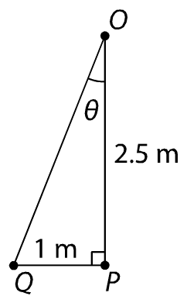

(c) The diffuse reflection of light from the black wall and the ceiling also contribute to the illuminance on *P* and *Q* thus the measured values are greater. If the walls are painted in white, the diffuse reflection would be stronger.

Example 1.4\*

(a) *Q* because it is the farthest from the lamp.

%FontSize=10
%TeXFontSize=10
ontSize=10
%TeXFontSize=10
\documentclass{article}
\pagestyle{empty}
\endofdump
\begin{document}
\begin{flalign*}
E_Q &= \frac{\Phi}{4 \pi r^2}\cdot\cos\theta \\
25 &= \frac{\Phi}{4 \pi \left(1^2 + 1.2^2\right)}\cdot\frac{1.2}{\sqrt{1^2 + 1.2^2}} \\
%\Phi &= \frac{4 \pi r^2 \cdot E_Q}{\cos\theta} \\
%&= \frac{4 \pi \left(1^2 + 1.2^2\right) \cdot 25}{\frac{1.2}{\sqrt{1^2 + 1.2^2}}} \\
\therefore \Phi &=997.8 \approx \SI{998}{\lumen}
\end{flalign*}
\end{document}

(b) The rated power of the lamp = %FontSize=10
%TeXFontSize=10
\documentclass{article}
\pagestyle{empty}
\endofdump
\begin{document}
\[
\frac{997.8}{60} = \SI{16.63}{\watt}
\]
\end{document}

Annual energy consumption = 16.63 × 5 × 365 = 30 300 W h = 30.3 kW h

The total electricity cost = 30.3 × 1.1 = $33.3

(c) 1. Install a reflector to reflect light onto the table.

2. Use a lamp of a lower rated power but higher luminous efficacy.