跟進例題　　（第1章）

照 明

例題1.1\*　（第19頁）

美儀欲更換房間內的燈泡。下表列出三款選擇，三者輸出的光通量相近。

|  |  |  |  |
| --- | --- | --- | --- |
|  | *P* | *Q* | *R* |
| 額定功率 | 4 W | 11 W | 40 W |
| 價 格 | $100 | $35 | $8 |
| 壽 命 | 25 000小時 | 9000小時 | 1000小時 |

(a) 哪款燈最有可能是LED燈？

\_\_\_\_\_\_\_\_\_\_\_\_\_\_\_\_\_\_\_\_\_\_\_\_\_\_\_\_\_\_\_\_\_\_\_\_\_\_\_\_\_\_\_\_\_\_\_\_\_\_\_\_\_\_\_\_\_\_\_\_\_\_\_\_\_\_

(b) 把這三款電燈的發光效率由高至低排列。

\_\_\_\_\_\_\_\_\_\_\_\_\_\_\_\_\_\_\_\_\_\_\_\_\_\_\_\_\_\_\_\_\_\_\_\_\_\_\_\_\_\_\_\_\_\_\_\_\_\_\_\_\_\_\_\_\_\_\_\_\_\_\_\_\_\_

\_\_\_\_\_\_\_\_\_\_\_\_\_\_\_\_\_\_\_\_\_\_\_\_\_\_\_\_\_\_\_\_\_\_\_\_\_\_\_\_\_\_\_\_\_\_\_\_\_\_\_\_\_\_\_\_\_\_\_\_\_\_\_\_\_\_

(c) 美儀選擇時最着重電燈的總成本。試考慮各燈使用10 000小時的總成本，並為美儀選擇最適合的電燈。假設每千瓦小時的電費為 $1.2。

\_\_\_\_\_\_\_\_\_\_\_\_\_\_\_\_\_\_\_\_\_\_\_\_\_\_\_\_\_\_\_\_\_\_\_\_\_\_\_\_\_\_\_\_\_\_\_\_\_\_\_\_\_\_\_\_\_\_\_\_\_\_\_\_\_\_

\_\_\_\_\_\_\_\_\_\_\_\_\_\_\_\_\_\_\_\_\_\_\_\_\_\_\_\_\_\_\_\_\_\_\_\_\_\_\_\_\_\_\_\_\_\_\_\_\_\_\_\_\_\_\_\_\_\_\_\_\_\_\_\_\_\_

\_\_\_\_\_\_\_\_\_\_\_\_\_\_\_\_\_\_\_\_\_\_\_\_\_\_\_\_\_\_\_\_\_\_\_\_\_\_\_\_\_\_\_\_\_\_\_\_\_\_\_\_\_\_\_\_\_\_\_\_\_\_\_\_\_\_

例題1.2\*　（第25頁）

啟恆在距離一間商鋪的廣告射燈20 m處，用光度計量度該廣告射燈對該處的照明度。藉着調節光度計的感光元件的方向，啟恆得出的最大讀數為160 lx。

(a) 光度計的感光元件應如何放置，以便得出最大的讀數？

\_\_\_\_\_\_\_\_\_\_\_\_\_\_\_\_\_\_\_\_\_\_\_\_\_\_\_\_\_\_\_\_\_\_\_\_\_\_\_\_\_\_\_\_\_\_\_\_\_\_\_\_\_\_\_\_\_\_\_\_\_\_\_\_\_\_

\_\_\_\_\_\_\_\_\_\_\_\_\_\_\_\_\_\_\_\_\_\_\_\_\_\_\_\_\_\_\_\_\_\_\_\_\_\_\_\_\_\_\_\_\_\_\_\_\_\_\_\_\_\_\_\_\_\_\_\_\_\_\_\_\_\_

(b) 求廣告射燈所產生的光通量。

\_\_\_\_\_\_\_\_\_\_\_\_\_\_\_\_\_\_\_\_\_\_\_\_\_\_\_\_\_\_\_\_\_\_\_\_\_\_\_\_\_\_\_\_\_\_\_\_\_\_\_\_\_\_\_\_\_\_\_\_\_\_\_\_\_\_

\_\_\_\_\_\_\_\_\_\_\_\_\_\_\_\_\_\_\_\_\_\_\_\_\_\_\_\_\_\_\_\_\_\_\_\_\_\_\_\_\_\_\_\_\_\_\_\_\_\_\_\_\_\_\_\_\_\_\_\_\_\_\_\_\_\_

\_\_\_\_\_\_\_\_\_\_\_\_\_\_\_\_\_\_\_\_\_\_\_\_\_\_\_\_\_\_\_\_\_\_\_\_\_\_\_\_\_\_\_\_\_\_\_\_\_\_\_\_\_\_\_\_\_\_\_\_\_\_\_\_\_\_

(c) 啟恆現在移近至距離廣告射燈10 m處再進行量度。最大讀數會如何改變？

\_\_\_\_\_\_\_\_\_\_\_\_\_\_\_\_\_\_\_\_\_\_\_\_\_\_\_\_\_\_\_\_\_\_\_\_\_\_\_\_\_\_\_\_\_\_\_\_\_\_\_\_\_\_\_\_\_\_\_\_\_\_\_\_\_\_

\_\_\_\_\_\_\_\_\_\_\_\_\_\_\_\_\_\_\_\_\_\_\_\_\_\_\_\_\_\_\_\_\_\_\_\_\_\_\_\_\_\_\_\_\_\_\_\_\_\_\_\_\_\_\_\_\_\_\_\_\_\_\_\_\_\_

例題1.3\*　（第26頁）

如圖左所示，景文為一間大小為2 m × 2 m × 2.5 m的儲物室安裝慳電膽。慳電膽位於*O*點。而儲物室的牆身則漆成黑色。圖右為該慳電膽的能源標籤。

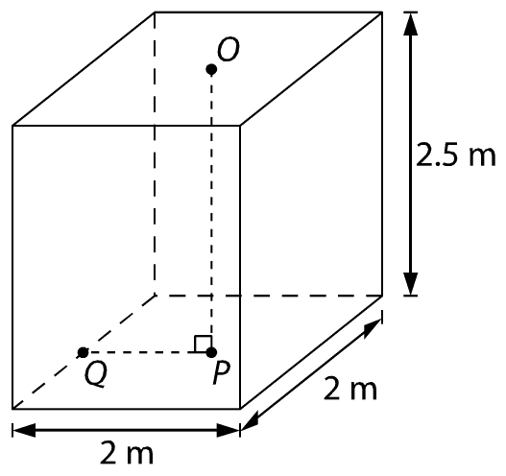 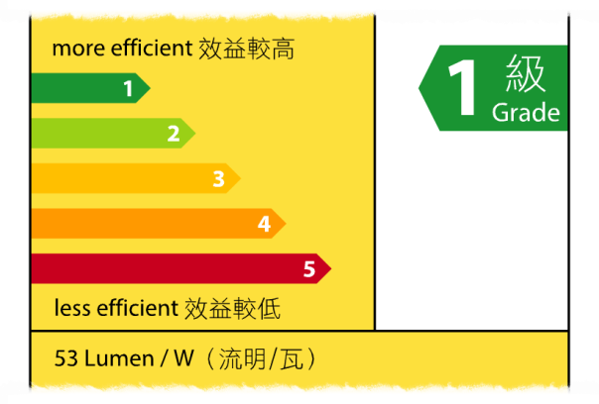

(a) 若慳電膽的額定功率為11 W，求慳電膽釋放的光通量。

\_\_\_\_\_\_\_\_\_\_\_\_\_\_\_\_\_\_\_\_\_\_\_\_\_\_\_\_\_\_\_\_\_\_\_\_\_\_\_\_\_\_\_\_\_\_\_\_\_\_\_\_\_\_\_\_\_\_\_\_\_\_\_\_\_\_

\_\_\_\_\_\_\_\_\_\_\_\_\_\_\_\_\_\_\_\_\_\_\_\_\_\_\_\_\_\_\_\_\_\_\_\_\_\_\_\_\_\_\_\_\_\_\_\_\_\_\_\_\_\_\_\_\_\_\_\_\_\_\_\_\_\_

(b) 區域*P*位於*O*點正下方，而區域*Q*則位於地上，緊靠牆邊。求*P*及*Q*的照明度。

\_\_\_\_\_\_\_\_\_\_\_\_\_\_\_\_\_\_\_\_\_\_\_\_\_\_\_\_\_\_\_\_\_\_\_\_\_\_\_\_\_\_\_\_\_\_\_\_\_\_\_\_\_\_\_\_\_\_\_\_\_\_\_\_\_\_

\_\_\_\_\_\_\_\_\_\_\_\_\_\_\_\_\_\_\_\_\_\_\_\_\_\_\_\_\_\_\_\_\_\_\_\_\_\_\_\_\_\_\_\_\_\_\_\_\_\_\_\_\_\_\_\_\_\_\_\_\_\_\_\_\_\_

\_\_\_\_\_\_\_\_\_\_\_\_\_\_\_\_\_\_\_\_\_\_\_\_\_\_\_\_\_\_\_\_\_\_\_\_\_\_\_\_\_\_\_\_\_\_\_\_\_\_\_\_\_\_\_\_\_\_\_\_\_\_\_\_\_\_

\_\_\_\_\_\_\_\_\_\_\_\_\_\_\_\_\_\_\_\_\_\_\_\_\_\_\_\_\_\_\_\_\_\_\_\_\_\_\_\_\_\_\_\_\_\_\_\_\_\_\_\_\_\_\_\_\_\_\_\_\_\_\_\_\_\_

\_\_\_\_\_\_\_\_\_\_\_\_\_\_\_\_\_\_\_\_\_\_\_\_\_\_\_\_\_\_\_\_\_\_\_\_\_\_\_\_\_\_\_\_\_\_\_\_\_\_\_\_\_\_\_\_\_\_\_\_\_\_\_\_\_\_

\_\_\_\_\_\_\_\_\_\_\_\_\_\_\_\_\_\_\_\_\_\_\_\_\_\_\_\_\_\_\_\_\_\_\_\_\_\_\_\_\_\_\_\_\_\_\_\_\_\_\_\_\_\_\_\_\_\_\_\_\_\_\_\_\_\_

(c) 利用儀器量度*P*及*Q*的照明度時，發覺量度得出的數值高於(b)部的計算  
結果。而且若把儲物室的牆身漆上白色，儀器量度得出的讀數會更高。試扼要解釋原因。

\_\_\_\_\_\_\_\_\_\_\_\_\_\_\_\_\_\_\_\_\_\_\_\_\_\_\_\_\_\_\_\_\_\_\_\_\_\_\_\_\_\_\_\_\_\_\_\_\_\_\_\_\_\_\_\_\_\_\_\_\_\_\_\_\_\_

\_\_\_\_\_\_\_\_\_\_\_\_\_\_\_\_\_\_\_\_\_\_\_\_\_\_\_\_\_\_\_\_\_\_\_\_\_\_\_\_\_\_\_\_\_\_\_\_\_\_\_\_\_\_\_\_\_\_\_\_\_\_\_\_\_\_

\_\_\_\_\_\_\_\_\_\_\_\_\_\_\_\_\_\_\_\_\_\_\_\_\_\_\_\_\_\_\_\_\_\_\_\_\_\_\_\_\_\_\_\_\_\_\_\_\_\_\_\_\_\_\_\_\_\_\_\_\_\_\_\_\_\_

例題1.4\*　（第27頁）

如圖所示，安琪在一張圓桌上安裝一盞發光效率為60 lm W−1的電燈。圓桌的半徑為1 m。細小區域*P*位處圓桌中心，而細小區域*Q*則位處圓桌邊緣。電燈位於區域*P*對上1.2 m的地方。視電燈為點光源。

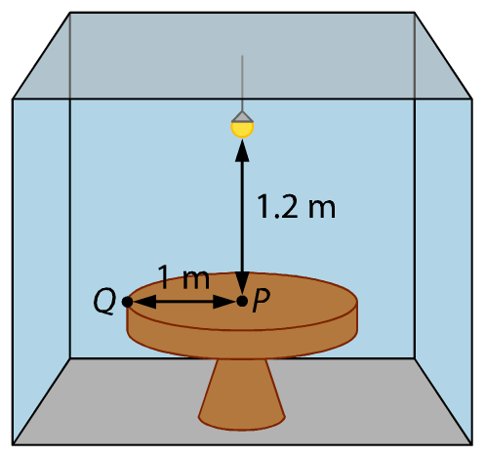

(a) 試解釋區域*P*、*Q*中，哪一個位置的照明較差。安琪希望枱面各處的照明度都超過 25 lx，求光源需產生的最少光通量。天花和牆壁的漫反射可略去不計。

\_\_\_\_\_\_\_\_\_\_\_\_\_\_\_\_\_\_\_\_\_\_\_\_\_\_\_\_\_\_\_\_\_\_\_\_\_\_\_\_\_\_\_\_\_\_\_\_\_\_\_\_\_\_\_\_\_\_\_\_\_\_\_\_\_\_

\_\_\_\_\_\_\_\_\_\_\_\_\_\_\_\_\_\_\_\_\_\_\_\_\_\_\_\_\_\_\_\_\_\_\_\_\_\_\_\_\_\_\_\_\_\_\_\_\_\_\_\_\_\_\_\_\_\_\_\_\_\_\_\_\_\_

\_\_\_\_\_\_\_\_\_\_\_\_\_\_\_\_\_\_\_\_\_\_\_\_\_\_\_\_\_\_\_\_\_\_\_\_\_\_\_\_\_\_\_\_\_\_\_\_\_\_\_\_\_\_\_\_\_\_\_\_\_\_\_\_\_\_

\_\_\_\_\_\_\_\_\_\_\_\_\_\_\_\_\_\_\_\_\_\_\_\_\_\_\_\_\_\_\_\_\_\_\_\_\_\_\_\_\_\_\_\_\_\_\_\_\_\_\_\_\_\_\_\_\_\_\_\_\_\_\_\_\_\_

\_\_\_\_\_\_\_\_\_\_\_\_\_\_\_\_\_\_\_\_\_\_\_\_\_\_\_\_\_\_\_\_\_\_\_\_\_\_\_\_\_\_\_\_\_\_\_\_\_\_\_\_\_\_\_\_\_\_\_\_\_\_\_\_\_\_

\_\_\_\_\_\_\_\_\_\_\_\_\_\_\_\_\_\_\_\_\_\_\_\_\_\_\_\_\_\_\_\_\_\_\_\_\_\_\_\_\_\_\_\_\_\_\_\_\_\_\_\_\_\_\_\_\_\_\_\_\_\_\_\_\_\_

\_\_\_\_\_\_\_\_\_\_\_\_\_\_\_\_\_\_\_\_\_\_\_\_\_\_\_\_\_\_\_\_\_\_\_\_\_\_\_\_\_\_\_\_\_\_\_\_\_\_\_\_\_\_\_\_\_\_\_\_\_\_\_\_\_\_

(b) 安琪每天開燈5小時。求使用該燈一年的電費。電費為每千瓦小時 $1.1。

\_\_\_\_\_\_\_\_\_\_\_\_\_\_\_\_\_\_\_\_\_\_\_\_\_\_\_\_\_\_\_\_\_\_\_\_\_\_\_\_\_\_\_\_\_\_\_\_\_\_\_\_\_\_\_\_\_\_\_\_\_\_\_\_\_\_

\_\_\_\_\_\_\_\_\_\_\_\_\_\_\_\_\_\_\_\_\_\_\_\_\_\_\_\_\_\_\_\_\_\_\_\_\_\_\_\_\_\_\_\_\_\_\_\_\_\_\_\_\_\_\_\_\_\_\_\_\_\_\_\_\_\_

\_\_\_\_\_\_\_\_\_\_\_\_\_\_\_\_\_\_\_\_\_\_\_\_\_\_\_\_\_\_\_\_\_\_\_\_\_\_\_\_\_\_\_\_\_\_\_\_\_\_\_\_\_\_\_\_\_\_\_\_\_\_\_\_\_\_

\_\_\_\_\_\_\_\_\_\_\_\_\_\_\_\_\_\_\_\_\_\_\_\_\_\_\_\_\_\_\_\_\_\_\_\_\_\_\_\_\_\_\_\_\_\_\_\_\_\_\_\_\_\_\_\_\_\_\_\_\_\_\_\_\_\_

(c) 在保持電費不變的情況下，試建議兩個能夠增強枱面照明的方法。

\_\_\_\_\_\_\_\_\_\_\_\_\_\_\_\_\_\_\_\_\_\_\_\_\_\_\_\_\_\_\_\_\_\_\_\_\_\_\_\_\_\_\_\_\_\_\_\_\_\_\_\_\_\_\_\_\_\_\_\_\_\_\_\_\_\_

\_\_\_\_\_\_\_\_\_\_\_\_\_\_\_\_\_\_\_\_\_\_\_\_\_\_\_\_\_\_\_\_\_\_\_\_\_\_\_\_\_\_\_\_\_\_\_\_\_\_\_\_\_\_\_\_\_\_\_\_\_\_\_\_\_\_

\_\_\_\_\_\_\_\_\_\_\_\_\_\_\_\_\_\_\_\_\_\_\_\_\_\_\_\_\_\_\_\_\_\_\_\_\_\_\_\_\_\_\_\_\_\_\_\_\_\_\_\_\_\_\_\_\_\_\_\_\_\_\_\_\_\_

\_\_\_\_\_\_\_\_\_\_\_\_\_\_\_\_\_\_\_\_\_\_\_\_\_\_\_\_\_\_\_\_\_\_\_\_\_\_\_\_\_\_\_\_\_\_\_\_\_\_\_\_\_\_\_\_\_\_\_\_\_\_\_\_\_\_

答案：

例題1.1\*

(a) 燈泡*P*最有可能是LED燈。

(b) *P*, *Q*, *R*（消耗最少功率者具有最高的發光效率）

(c) 表列數據如下：

|  |  |  |  |
| --- | --- | --- | --- |
|  | *P* | *Q* | *R* |
| 價 格 | $100 | $35 | $8 |
| 所需電燈數目 | 1 | 2 | 10 |
| 電燈成本 | $100 | $35 × 2 = $70 | $8 × 10 = $80 |
| 電費成本 | $1.2 × 0.004 × 10 000  = $48 | $1.2 × 0.011 × 10 000  =$132 | $1.2 × 0.04 × 10 000  = $480 |
| 總成本 | $100 + $48 = $148 | $70 + $132 = $202 | $80 + $480 = $560 |

故建議使用燈泡*P*。

例題1.2\*

(a) 光度計的感光元件需正面向着光源。

(a) 運用*%FontSize=10
%TeXFontSize=10
\documentclass{article}
\pagestyle{empty}
\endofdump
\begin{document}
\[
E = \frac{\Phi}{4 \pi r^2}
\]
\end{document}*，廣告射燈所產生的光通量Φ

= 4*πr*2∙*E*

= 4*π*(202)(160)

= 8.042 × 105 ≈ 8.04 × 105 lm

(b) 由於%FontSize=10
%TeXFontSize=10
\documentclass{article}
\pagestyle{empty}
\endofdump
\begin{document}
\[
E \propto \frac{1}{r^2}
\]
\end{document}，把距離減半會使最大讀數倍大4倍。

例題1.3\*

(a) 光通量Φ = 53 × 11 = 583 lm

(b) 注意%FontSize=10
%TeXFontSize=10
ontSize=10
%TeXFontSize=10
ontSize=10
%TeXFontSize=10
\documentclass{article}
\pagestyle{empty}
\endofdump
\begin{document}
\[
E_Q 
%= \frac{\Phi}{4 \pi d^2}\cdot\cos^3\theta
%= \frac{\Phi}{4 \pi (r\cos\theta)^2}\cdot\cos^3\theta
= \frac{\Phi}{4 \pi r^2}\cdot\cos\theta
%\therefore E_Q &= \frac{\Phi}{4 \pi r^2}\cdot\cos\theta = \frac{583}{4\pi(7.25)}\cdot\frac{2.5}{\sqrt{7.25}} \approx \SI{5.94}{\lumen}
\]
\end{document}


%\begin{document}
%\begin{flalign*}
%E_Q &= \frac{\Phi}{4 \pi d^2}\cdot\cos^3\theta \\
%&= \frac{\Phi}{4 \pi (r\cos\theta)^2}\cdot\cos^3\theta \\
%&= \frac{\Phi}{4 \pi r^2}\cdot\cos\theta \\
%\therefore E_Q &= \frac{\Phi}{4 \pi r^2}\cdot\cos\theta \\
%&= \frac{583}{4\pi(7.25)}\cdot\frac{2.5}{\sqrt{7.25}} \approx \SI{5.94}{\lumen}
%\end{flalign*}
%\end{document}
%
，因此

%FontSize=10
%TeXFontSize=10
ontSize=10
%TeXFontSize=10
ontSize=10
%TeXFontSize=10
ontSize=10
%TeXFontSize=10
\documentclass{article}
\pagestyle{empty}
\endofdump
\begin{document}
\begin{flalign*}
E_Q &= \frac{\Phi}{4 \pi r^2}\cdot\cos\theta \\
%\therefore E_Q &= \frac{\Phi}{4 \pi r^2}\cdot\cos\theta \\
&= \frac{583}{4\pi\left(1^2 + 2.5^2\right)}\cdot\frac{2.5}{\sqrt{1^2 + 2.5^2}} \approx \SI{5.94}{\lux}
\end{flalign*}
\end{document}

%\begin{document}
%\begin{flalign*}
%E_Q &= \frac{\Phi}{4 \pi d^2}\cdot\cos^3\theta
%= \frac{\Phi}{4 \pi (r\cos\theta)^2}\cdot\cos^3\theta
%= \frac{\Phi}{4 \pi r^2}\cdot\cos\theta \\
%\therefore E_Q &= \frac{\Phi}{4 \pi r^2}\cdot\cos\theta = \frac{583}{4\pi(7.25)}\cdot\frac{2.5}{\sqrt{7.25}} \approx \SI{5.94}{\lumen}
%\end{flalign*}
%\end{document}

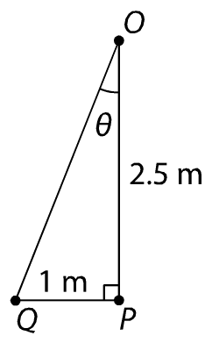

(c) 黑色的牆壁和天花板亦會有漫反射，增加*P*和*Q*的照明度，故量度到的數值會較(b)為高。而且若牆壁漆上白色，其漫反射會更強。

例題1.4\*

(a) *Q*點。因為該點距離光源最遠。

%FontSize=10
%TeXFontSize=10
ontSize=10
%TeXFontSize=10
\documentclass{article}
\pagestyle{empty}
\endofdump
\begin{document}
\begin{flalign*}
E_Q &= \frac{\Phi}{4 \pi r^2}\cdot\cos\theta \\
25 &= \frac{\Phi}{4 \pi \left(1^2 + 1.2^2\right)}\cdot\frac{1.2}{\sqrt{1^2 + 1.2^2}} \\
%\Phi &= \frac{4 \pi r^2 \cdot E_Q}{\cos\theta} \\
%&= \frac{4 \pi \left(1^2 + 1.2^2\right) \cdot 25}{\frac{1.2}{\sqrt{1^2 + 1.2^2}}} \\
\therefore \Phi &=997.8 \approx \SI{998}{\lumen}
\end{flalign*}
\end{document}

(b) 電燈的額定功率= %FontSize=10
%TeXFontSize=10
\documentclass{article}
\pagestyle{empty}
\endofdump
\begin{document}
\[
\frac{997.8}{60} = \SI{16.63}{\watt}
\]
\end{document}

每年總能源消耗= 16.63 × 5 × 365 = 30 300 W h = 30.3 kW h

總電費= 30.3 × 1.1 = $33.3

(c) 1. 用反光板把光反射至枱面。

2. 用額定功率較低但發光效率較高的燈。