Follow-up Examples (Ch.1)

Photoelectric Effect

Example 1.1\* (p.10)

A monochromatic light is incident on a photocell connected to a simple circuit so that photoelectrons are emitted from the metal plate. The initial speed of the fastest photoelectrons is about 0.0024*c*, where  
*c* = 2.998 × 108 m s−1 is the speed of light in vacuum.

(a) Calculate the maximum speed of the fastest photoelectrons in m s−1.

\_\_\_\_\_\_\_\_\_\_\_\_\_\_\_\_\_\_\_\_\_\_\_\_\_\_\_\_\_\_\_\_\_\_\_\_\_\_\_\_\_\_\_\_\_\_\_\_\_\_\_\_\_\_\_\_\_\_\_\_\_\_\_\_\_\_

\_\_\_\_\_\_\_\_\_\_\_\_\_\_\_\_\_\_\_\_\_\_\_\_\_\_\_\_\_\_\_\_\_\_\_\_\_\_\_\_\_\_\_\_\_\_\_\_\_\_\_\_\_\_\_\_\_\_\_\_\_\_\_\_\_\_

(b) Find the maximum KE of the fastest photoelectron in terms of eV. Take electron mass *m* = 9.11 × 10−31 kg and the magnitude of the electron  
charge *e* = 1.602 ×10−19 C.

\_\_\_\_\_\_\_\_\_\_\_\_\_\_\_\_\_\_\_\_\_\_\_\_\_\_\_\_\_\_\_\_\_\_\_\_\_\_\_\_\_\_\_\_\_\_\_\_\_\_\_\_\_\_\_\_\_\_\_\_\_\_\_\_\_\_

\_\_\_\_\_\_\_\_\_\_\_\_\_\_\_\_\_\_\_\_\_\_\_\_\_\_\_\_\_\_\_\_\_\_\_\_\_\_\_\_\_\_\_\_\_\_\_\_\_\_\_\_\_\_\_\_\_\_\_\_\_\_\_\_\_\_

\_\_\_\_\_\_\_\_\_\_\_\_\_\_\_\_\_\_\_\_\_\_\_\_\_\_\_\_\_\_\_\_\_\_\_\_\_\_\_\_\_\_\_\_\_\_\_\_\_\_\_\_\_\_\_\_\_\_\_\_\_\_\_\_\_\_

Example 1.2\* (p.19)

Fred projects a red laser beam of wavelength 650 nm perpendicularly onto a surface by a laser pointer of output power of 5 × 10−4 W.

(a) Calculate the energy of a photon of the laser beam emitted.  
Take *h* = 6.63 × 10−34 J s and *c* = 3 × 108 m s−1.

\_\_\_\_\_\_\_\_\_\_\_\_\_\_\_\_\_\_\_\_\_\_\_\_\_\_\_\_\_\_\_\_\_\_\_\_\_\_\_\_\_\_\_\_\_\_\_\_\_\_\_\_\_\_\_\_\_\_\_\_\_\_\_\_\_\_

\_\_\_\_\_\_\_\_\_\_\_\_\_\_\_\_\_\_\_\_\_\_\_\_\_\_\_\_\_\_\_\_\_\_\_\_\_\_\_\_\_\_\_\_\_\_\_\_\_\_\_\_\_\_\_\_\_\_\_\_\_\_\_\_\_\_

(b) Calculate the number of photons that hit the surface in 1 minute.

\_\_\_\_\_\_\_\_\_\_\_\_\_\_\_\_\_\_\_\_\_\_\_\_\_\_\_\_\_\_\_\_\_\_\_\_\_\_\_\_\_\_\_\_\_\_\_\_\_\_\_\_\_\_\_\_\_\_\_\_\_\_\_\_\_\_

\_\_\_\_\_\_\_\_\_\_\_\_\_\_\_\_\_\_\_\_\_\_\_\_\_\_\_\_\_\_\_\_\_\_\_\_\_\_\_\_\_\_\_\_\_\_\_\_\_\_\_\_\_\_\_\_\_\_\_\_\_\_\_\_\_\_

\_\_\_\_\_\_\_\_\_\_\_\_\_\_\_\_\_\_\_\_\_\_\_\_\_\_\_\_\_\_\_\_\_\_\_\_\_\_\_\_\_\_\_\_\_\_\_\_\_\_\_\_\_\_\_\_\_\_\_\_\_\_\_\_\_\_

(c) Find the intensity of the light if the area illuminated is 1.2 mm2.

\_\_\_\_\_\_\_\_\_\_\_\_\_\_\_\_\_\_\_\_\_\_\_\_\_\_\_\_\_\_\_\_\_\_\_\_\_\_\_\_\_\_\_\_\_\_\_\_\_\_\_\_\_\_\_\_\_\_\_\_\_\_\_\_\_\_

\_\_\_\_\_\_\_\_\_\_\_\_\_\_\_\_\_\_\_\_\_\_\_\_\_\_\_\_\_\_\_\_\_\_\_\_\_\_\_\_\_\_\_\_\_\_\_\_\_\_\_\_\_\_\_\_\_\_\_\_\_\_\_\_\_\_

(d) Fred now moves few steps backwards so that the area illuminated is doubled. How do the following quantities change?

(i) The intensity of the light

(ii) The number of photons that hit the surface in 1 minute

\_\_\_\_\_\_\_\_\_\_\_\_\_\_\_\_\_\_\_\_\_\_\_\_\_\_\_\_\_\_\_\_\_\_\_\_\_\_\_\_\_\_\_\_\_\_\_\_\_\_\_\_\_\_\_\_\_\_\_\_\_\_\_\_\_\_

\_\_\_\_\_\_\_\_\_\_\_\_\_\_\_\_\_\_\_\_\_\_\_\_\_\_\_\_\_\_\_\_\_\_\_\_\_\_\_\_\_\_\_\_\_\_\_\_\_\_\_\_\_\_\_\_\_\_\_\_\_\_\_\_\_\_

\_\_\_\_\_\_\_\_\_\_\_\_\_\_\_\_\_\_\_\_\_\_\_\_\_\_\_\_\_\_\_\_\_\_\_\_\_\_\_\_\_\_\_\_\_\_\_\_\_\_\_\_\_\_\_\_\_\_\_\_\_\_\_\_\_\_

Example 1.3\* (p.22)

A caesium photocell of work function 2.14 eV is illuminated by a beam of microwaves of wavelength 3 cm and intensity of 5 mW m−2.

(a) According to classical theory of light, photoelectrons should be emitted if the time of exposure is long enough. Estimate the minimum time required for a caesium atom to absorb enough energy and then escape.

Take the effective area of a caesium atom in absorbing enough energy as 10−20 m2 and the magnitude of the electron charge *e* = 1.6 × 10−19 C.

\_\_\_\_\_\_\_\_\_\_\_\_\_\_\_\_\_\_\_\_\_\_\_\_\_\_\_\_\_\_\_\_\_\_\_\_\_\_\_\_\_\_\_\_\_\_\_\_\_\_\_\_\_\_\_\_\_\_\_\_\_\_\_\_\_\_

\_\_\_\_\_\_\_\_\_\_\_\_\_\_\_\_\_\_\_\_\_\_\_\_\_\_\_\_\_\_\_\_\_\_\_\_\_\_\_\_\_\_\_\_\_\_\_\_\_\_\_\_\_\_\_\_\_\_\_\_\_\_\_\_\_\_

\_\_\_\_\_\_\_\_\_\_\_\_\_\_\_\_\_\_\_\_\_\_\_\_\_\_\_\_\_\_\_\_\_\_\_\_\_\_\_\_\_\_\_\_\_\_\_\_\_\_\_\_\_\_\_\_\_\_\_\_\_\_\_\_\_\_

\_\_\_\_\_\_\_\_\_\_\_\_\_\_\_\_\_\_\_\_\_\_\_\_\_\_\_\_\_\_\_\_\_\_\_\_\_\_\_\_\_\_\_\_\_\_\_\_\_\_\_\_\_\_\_\_\_\_\_\_\_\_\_\_\_\_

\_\_\_\_\_\_\_\_\_\_\_\_\_\_\_\_\_\_\_\_\_\_\_\_\_\_\_\_\_\_\_\_\_\_\_\_\_\_\_\_\_\_\_\_\_\_\_\_\_\_\_\_\_\_\_\_\_\_\_\_\_\_\_\_\_\_

\_\_\_\_\_\_\_\_\_\_\_\_\_\_\_\_\_\_\_\_\_\_\_\_\_\_\_\_\_\_\_\_\_\_\_\_\_\_\_\_\_\_\_\_\_\_\_\_\_\_\_\_\_\_\_\_\_\_\_\_\_\_\_\_\_\_

(b) According to quantum theory of light, determine whether photoelectrons could be emitted or not. Given that *h* = 6.63 × 10−34 J s and *c* = 3 × 108 m s−1.

\_\_\_\_\_\_\_\_\_\_\_\_\_\_\_\_\_\_\_\_\_\_\_\_\_\_\_\_\_\_\_\_\_\_\_\_\_\_\_\_\_\_\_\_\_\_\_\_\_\_\_\_\_\_\_\_\_\_\_\_\_\_\_\_\_\_

\_\_\_\_\_\_\_\_\_\_\_\_\_\_\_\_\_\_\_\_\_\_\_\_\_\_\_\_\_\_\_\_\_\_\_\_\_\_\_\_\_\_\_\_\_\_\_\_\_\_\_\_\_\_\_\_\_\_\_\_\_\_\_\_\_\_

\_\_\_\_\_\_\_\_\_\_\_\_\_\_\_\_\_\_\_\_\_\_\_\_\_\_\_\_\_\_\_\_\_\_\_\_\_\_\_\_\_\_\_\_\_\_\_\_\_\_\_\_\_\_\_\_\_\_\_\_\_\_\_\_\_\_

Example 1.4\* (p.23)

A caesium surface has a work function of 2.14 eV.

(a) Find the threshold wavelength of the caesium surface. Given that  
*h* = 6.63 × 10−34 J s, *c* = 3 × 108 m s−1 and *e* = 1.6 ×10−19 C.

\_\_\_\_\_\_\_\_\_\_\_\_\_\_\_\_\_\_\_\_\_\_\_\_\_\_\_\_\_\_\_\_\_\_\_\_\_\_\_\_\_\_\_\_\_\_\_\_\_\_\_\_\_\_\_\_\_\_\_\_\_\_\_\_\_\_

\_\_\_\_\_\_\_\_\_\_\_\_\_\_\_\_\_\_\_\_\_\_\_\_\_\_\_\_\_\_\_\_\_\_\_\_\_\_\_\_\_\_\_\_\_\_\_\_\_\_\_\_\_\_\_\_\_\_\_\_\_\_\_\_\_\_

\_\_\_\_\_\_\_\_\_\_\_\_\_\_\_\_\_\_\_\_\_\_\_\_\_\_\_\_\_\_\_\_\_\_\_\_\_\_\_\_\_\_\_\_\_\_\_\_\_\_\_\_\_\_\_\_\_\_\_\_\_\_\_\_\_\_

(b) The surface is illuminated by two beams of monochromatic light of wavelength 410 nm and 650 nm respectively. From the result of (a), determine whether photoelectrons could be emitted or not. If so, find the maximum KE and the maximum speed of the photoelectrons emitted. Take the electron mass as 9.11 × 10−31 kg.

\_\_\_\_\_\_\_\_\_\_\_\_\_\_\_\_\_\_\_\_\_\_\_\_\_\_\_\_\_\_\_\_\_\_\_\_\_\_\_\_\_\_\_\_\_\_\_\_\_\_\_\_\_\_\_\_\_\_\_\_\_\_\_\_\_\_

\_\_\_\_\_\_\_\_\_\_\_\_\_\_\_\_\_\_\_\_\_\_\_\_\_\_\_\_\_\_\_\_\_\_\_\_\_\_\_\_\_\_\_\_\_\_\_\_\_\_\_\_\_\_\_\_\_\_\_\_\_\_\_\_\_\_

\_\_\_\_\_\_\_\_\_\_\_\_\_\_\_\_\_\_\_\_\_\_\_\_\_\_\_\_\_\_\_\_\_\_\_\_\_\_\_\_\_\_\_\_\_\_\_\_\_\_\_\_\_\_\_\_\_\_\_\_\_\_\_\_\_\_

\_\_\_\_\_\_\_\_\_\_\_\_\_\_\_\_\_\_\_\_\_\_\_\_\_\_\_\_\_\_\_\_\_\_\_\_\_\_\_\_\_\_\_\_\_\_\_\_\_\_\_\_\_\_\_\_\_\_\_\_\_\_\_\_\_\_

\_\_\_\_\_\_\_\_\_\_\_\_\_\_\_\_\_\_\_\_\_\_\_\_\_\_\_\_\_\_\_\_\_\_\_\_\_\_\_\_\_\_\_\_\_\_\_\_\_\_\_\_\_\_\_\_\_\_\_\_\_\_\_\_\_\_

\_\_\_\_\_\_\_\_\_\_\_\_\_\_\_\_\_\_\_\_\_\_\_\_\_\_\_\_\_\_\_\_\_\_\_\_\_\_\_\_\_\_\_\_\_\_\_\_\_\_\_\_\_\_\_\_\_\_\_\_\_\_\_\_\_\_

\_\_\_\_\_\_\_\_\_\_\_\_\_\_\_\_\_\_\_\_\_\_\_\_\_\_\_\_\_\_\_\_\_\_\_\_\_\_\_\_\_\_\_\_\_\_\_\_\_\_\_\_\_\_\_\_\_\_\_\_\_\_\_\_\_\_

\_\_\_\_\_\_\_\_\_\_\_\_\_\_\_\_\_\_\_\_\_\_\_\_\_\_\_\_\_\_\_\_\_\_\_\_\_\_\_\_\_\_\_\_\_\_\_\_\_\_\_\_\_\_\_\_\_\_\_\_\_\_\_\_\_\_

\_\_\_\_\_\_\_\_\_\_\_\_\_\_\_\_\_\_\_\_\_\_\_\_\_\_\_\_\_\_\_\_\_\_\_\_\_\_\_\_\_\_\_\_\_\_\_\_\_\_\_\_\_\_\_\_\_\_\_\_\_\_\_\_\_\_

Example 1.5\* (p.27)

The following graph indicates how the stopping potential *V*s changes with the frequency *f* of monochromatic light in a photoelectric experiment using a caesium photocell. Given *e* = 1.6 × 10−19 C.

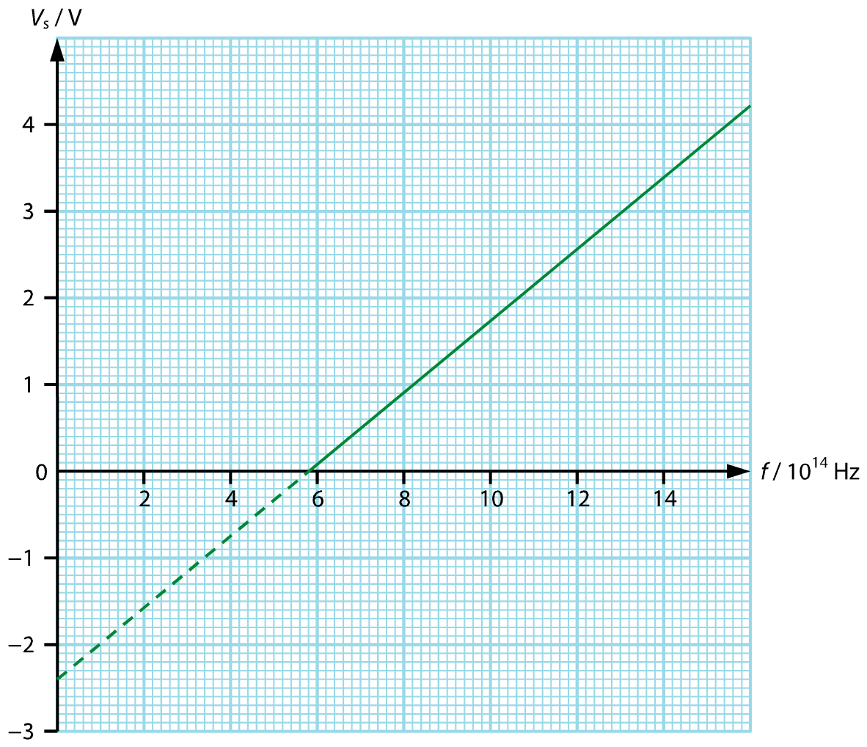

(a) What does the slope of the graph represent? Find the slope of the graph and hence estimate the Planck constant.

\_\_\_\_\_\_\_\_\_\_\_\_\_\_\_\_\_\_\_\_\_\_\_\_\_\_\_\_\_\_\_\_\_\_\_\_\_\_\_\_\_\_\_\_\_\_\_\_\_\_\_\_\_\_\_\_\_\_\_\_\_\_\_\_\_\_

\_\_\_\_\_\_\_\_\_\_\_\_\_\_\_\_\_\_\_\_\_\_\_\_\_\_\_\_\_\_\_\_\_\_\_\_\_\_\_\_\_\_\_\_\_\_\_\_\_\_\_\_\_\_\_\_\_\_\_\_\_\_\_\_\_\_

\_\_\_\_\_\_\_\_\_\_\_\_\_\_\_\_\_\_\_\_\_\_\_\_\_\_\_\_\_\_\_\_\_\_\_\_\_\_\_\_\_\_\_\_\_\_\_\_\_\_\_\_\_\_\_\_\_\_\_\_\_\_\_\_\_\_

\_\_\_\_\_\_\_\_\_\_\_\_\_\_\_\_\_\_\_\_\_\_\_\_\_\_\_\_\_\_\_\_\_\_\_\_\_\_\_\_\_\_\_\_\_\_\_\_\_\_\_\_\_\_\_\_\_\_\_\_\_\_\_\_\_\_

\_\_\_\_\_\_\_\_\_\_\_\_\_\_\_\_\_\_\_\_\_\_\_\_\_\_\_\_\_\_\_\_\_\_\_\_\_\_\_\_\_\_\_\_\_\_\_\_\_\_\_\_\_\_\_\_\_\_\_\_\_\_\_\_\_\_

\_\_\_\_\_\_\_\_\_\_\_\_\_\_\_\_\_\_\_\_\_\_\_\_\_\_\_\_\_\_\_\_\_\_\_\_\_\_\_\_\_\_\_\_\_\_\_\_\_\_\_\_\_\_\_\_\_\_\_\_\_\_\_\_\_\_

(b) What do the *y*-intercept and the *x*-intercept of the graph represent?

\_\_\_\_\_\_\_\_\_\_\_\_\_\_\_\_\_\_\_\_\_\_\_\_\_\_\_\_\_\_\_\_\_\_\_\_\_\_\_\_\_\_\_\_\_\_\_\_\_\_\_\_\_\_\_\_\_\_\_\_\_\_\_\_\_\_

\_\_\_\_\_\_\_\_\_\_\_\_\_\_\_\_\_\_\_\_\_\_\_\_\_\_\_\_\_\_\_\_\_\_\_\_\_\_\_\_\_\_\_\_\_\_\_\_\_\_\_\_\_\_\_\_\_\_\_\_\_\_\_\_\_\_

(c) From the graph, estimate the work function (in eV) and the threshold frequency of caesium.

\_\_\_\_\_\_\_\_\_\_\_\_\_\_\_\_\_\_\_\_\_\_\_\_\_\_\_\_\_\_\_\_\_\_\_\_\_\_\_\_\_\_\_\_\_\_\_\_\_\_\_\_\_\_\_\_\_\_\_\_\_\_\_\_\_\_

\_\_\_\_\_\_\_\_\_\_\_\_\_\_\_\_\_\_\_\_\_\_\_\_\_\_\_\_\_\_\_\_\_\_\_\_\_\_\_\_\_\_\_\_\_\_\_\_\_\_\_\_\_\_\_\_\_\_\_\_\_\_\_\_\_\_

(d) Calcium has a work function of about 2.9 eV. Sketch the *V*s–*f* graph of Calcium on the above graph. Hence find the threshold frequency of calcium.

\_\_\_\_\_\_\_\_\_\_\_\_\_\_\_\_\_\_\_\_\_\_\_\_\_\_\_\_\_\_\_\_\_\_\_\_\_\_\_\_\_\_\_\_\_\_\_\_\_\_\_\_\_\_\_\_\_\_\_\_\_\_\_\_\_\_

\_\_\_\_\_\_\_\_\_\_\_\_\_\_\_\_\_\_\_\_\_\_\_\_\_\_\_\_\_\_\_\_\_\_\_\_\_\_\_\_\_\_\_\_\_\_\_\_\_\_\_\_\_\_\_\_\_\_\_\_\_\_\_\_\_\_

Example 1.6\* (p.29)

A photocell is connected to a d.c. voltage source. The photocell is then illuminated by a beam of green light of wavelength 530 nm. The green light has an intensity of 0.05 W m−2. The area of the photoemissive surface is 9 × 10−6 m2. The graph below shows how the photocurrent *I*p changes with the applied voltage *V*. The photocurrent reaches a maximum value of *X*.

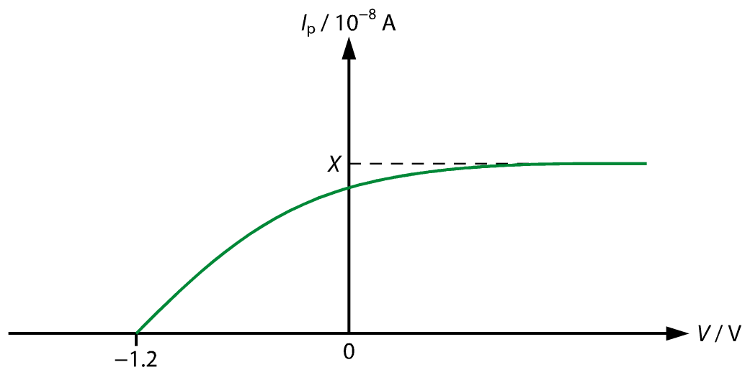

Take *h* = 6.63 × 10−34 J s, *c* = 3 × 108 m s−1 and *e* = 1.602 ×10−19 C.

(a) What does the *x*-intercept of the graph represent?

\_\_\_\_\_\_\_\_\_\_\_\_\_\_\_\_\_\_\_\_\_\_\_\_\_\_\_\_\_\_\_\_\_\_\_\_\_\_\_\_\_\_\_\_\_\_\_\_\_\_\_\_\_\_\_\_\_\_\_\_\_\_\_\_\_\_

\_\_\_\_\_\_\_\_\_\_\_\_\_\_\_\_\_\_\_\_\_\_\_\_\_\_\_\_\_\_\_\_\_\_\_\_\_\_\_\_\_\_\_\_\_\_\_\_\_\_\_\_\_\_\_\_\_\_\_\_\_\_\_\_\_\_

(b) Find the maximum KE of the photoelectrons emitted and the work function of the metal in eV.

\_\_\_\_\_\_\_\_\_\_\_\_\_\_\_\_\_\_\_\_\_\_\_\_\_\_\_\_\_\_\_\_\_\_\_\_\_\_\_\_\_\_\_\_\_\_\_\_\_\_\_\_\_\_\_\_\_\_\_\_\_\_\_\_\_\_

\_\_\_\_\_\_\_\_\_\_\_\_\_\_\_\_\_\_\_\_\_\_\_\_\_\_\_\_\_\_\_\_\_\_\_\_\_\_\_\_\_\_\_\_\_\_\_\_\_\_\_\_\_\_\_\_\_\_\_\_\_\_\_\_\_\_

\_\_\_\_\_\_\_\_\_\_\_\_\_\_\_\_\_\_\_\_\_\_\_\_\_\_\_\_\_\_\_\_\_\_\_\_\_\_\_\_\_\_\_\_\_\_\_\_\_\_\_\_\_\_\_\_\_\_\_\_\_\_\_\_\_\_

\_\_\_\_\_\_\_\_\_\_\_\_\_\_\_\_\_\_\_\_\_\_\_\_\_\_\_\_\_\_\_\_\_\_\_\_\_\_\_\_\_\_\_\_\_\_\_\_\_\_\_\_\_\_\_\_\_\_\_\_\_\_\_\_\_\_

\_\_\_\_\_\_\_\_\_\_\_\_\_\_\_\_\_\_\_\_\_\_\_\_\_\_\_\_\_\_\_\_\_\_\_\_\_\_\_\_\_\_\_\_\_\_\_\_\_\_\_\_\_\_\_\_\_\_\_\_\_\_\_\_\_\_

\_\_\_\_\_\_\_\_\_\_\_\_\_\_\_\_\_\_\_\_\_\_\_\_\_\_\_\_\_\_\_\_\_\_\_\_\_\_\_\_\_\_\_\_\_\_\_\_\_\_\_\_\_\_\_\_\_\_\_\_\_\_\_\_\_\_

(c) Find the number of photons hitting the surface per second.  
If 1 photoelectron is emitted for every 5 photons hitting the surface, find *X*.

\_\_\_\_\_\_\_\_\_\_\_\_\_\_\_\_\_\_\_\_\_\_\_\_\_\_\_\_\_\_\_\_\_\_\_\_\_\_\_\_\_\_\_\_\_\_\_\_\_\_\_\_\_\_\_\_\_\_\_\_\_\_\_\_\_\_

\_\_\_\_\_\_\_\_\_\_\_\_\_\_\_\_\_\_\_\_\_\_\_\_\_\_\_\_\_\_\_\_\_\_\_\_\_\_\_\_\_\_\_\_\_\_\_\_\_\_\_\_\_\_\_\_\_\_\_\_\_\_\_\_\_\_

\_\_\_\_\_\_\_\_\_\_\_\_\_\_\_\_\_\_\_\_\_\_\_\_\_\_\_\_\_\_\_\_\_\_\_\_\_\_\_\_\_\_\_\_\_\_\_\_\_\_\_\_\_\_\_\_\_\_\_\_\_\_\_\_\_\_

\_\_\_\_\_\_\_\_\_\_\_\_\_\_\_\_\_\_\_\_\_\_\_\_\_\_\_\_\_\_\_\_\_\_\_\_\_\_\_\_\_\_\_\_\_\_\_\_\_\_\_\_\_\_\_\_\_\_\_\_\_\_\_\_\_\_

\_\_\_\_\_\_\_\_\_\_\_\_\_\_\_\_\_\_\_\_\_\_\_\_\_\_\_\_\_\_\_\_\_\_\_\_\_\_\_\_\_\_\_\_\_\_\_\_\_\_\_\_\_\_\_\_\_\_\_\_\_\_\_\_\_\_

\_\_\_\_\_\_\_\_\_\_\_\_\_\_\_\_\_\_\_\_\_\_\_\_\_\_\_\_\_\_\_\_\_\_\_\_\_\_\_\_\_\_\_\_\_\_\_\_\_\_\_\_\_\_\_\_\_\_\_\_\_\_\_\_\_\_

(d) The experiment is repeated using another green light of the same wavelength but a higher intensity. Sketch its *I*p–*V* graph on the graph above.

(e) The experiment is repeated again using a beam of red light and blue light respectively. The saturation photocurrents of them are the same as that of the green light. The graph below shows the result obtained. The dotted line represents the graph of the original green light.

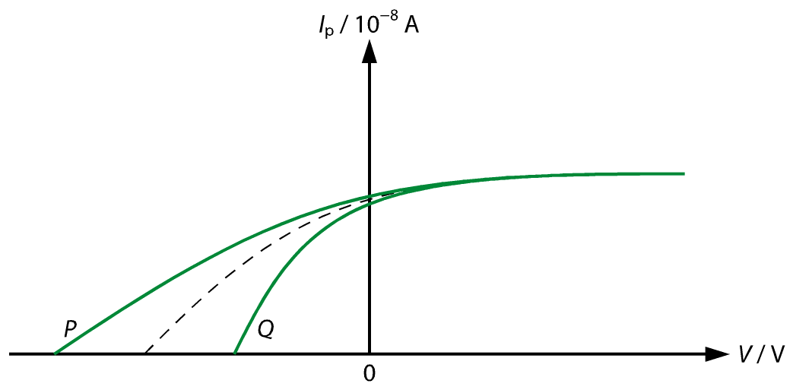

Match *P* and *Q* with the red light and the blue light.

\_\_\_\_\_\_\_\_\_\_\_\_\_\_\_\_\_\_\_\_\_\_\_\_\_\_\_\_\_\_\_\_\_\_\_\_\_\_\_\_\_\_\_\_\_\_\_\_\_\_\_\_\_\_\_\_\_\_\_\_\_\_\_\_\_\_

\_\_\_\_\_\_\_\_\_\_\_\_\_\_\_\_\_\_\_\_\_\_\_\_\_\_\_\_\_\_\_\_\_\_\_\_\_\_\_\_\_\_\_\_\_\_\_\_\_\_\_\_\_\_\_\_\_\_\_\_\_\_\_\_\_\_

Answers:

Example 1.1\*

(a) *v*max = 0.0024 × (2.998 × 108) = 719 520 m s−1

(b) The maximum KE of the fastest photoelectron

%FontSize=10
%TeXFontSize=10
\documentclass{article}
\pagestyle{empty}
\endofdump
\begin{document}
\begin{flalign*}
K_\text{max} &= \frac{1}{2}mv_\text{max}^2 \\
&= \frac{1}{2}\left(\num{9.11e-31}\right)(\num{719520})^2 \\
&= \SI{2.36e-19}{\joule} \\
&= \frac{\num{2.36e-19}}{\num{1.602e-19}} \\
&= \SI{1.47}{\electronvolt}
\end{flalign*}
\end{document}

Example 1.2\*

(a) %FontSize=10
%TeXFontSize=10
\documentclass{article}
\pagestyle{empty}
\endofdump
\begin{document}
\[
E = \frac{hc}{\lambda} = \frac{\left(\num{6.63e-34}\right)\left(\num{3e8}\right)}{\num{650e-9}} = \SI{3.06e-19}{\joule}
\]
\end{document}

(b) Light energy transferred in 1 min

= *Pt* = (5 × 10−4)(60) = 0.03 J

Number of photons hitting the surface in 1 min

%FontSize=10
%TeXFontSize=10
\documentclass{article}
\pagestyle{empty}
\endofdump
\begin{document}
\[
=\frac{0.03}{\num{3.06e-19}}=\num{9.80e16}
\]
\end{document}

(c) %FontSize=10
%TeXFontSize=10
ontSize=10
%TeXFontSize=10
\documentclass{article}
\pagestyle{empty}
\endofdump
\begin{document}
\[
\text{Intensity} = \frac{\text{Power}}{\text{Area}} = \frac{\num{5e-4}}{(1.2)\left(\num{e-6}\right)} = \SI{417}{\watt\per\metre\squared}
\]
\end{document}

(d) (i) The intensity is decreased by half.

(ii) The number of photons that hit the surface remains unchanged.

Example 1.3\*

(a) Rate of energy delivered to the effective area

Power = intensity × area = 5 × 10−3 × 10−20 = 5 × 10−23 W

Minimum time required %FontSize=10
%TeXFontSize=10
\documentclass{article}
\pagestyle{empty}
\endofdump
\begin{document}
\[
= \frac{\phi}{P} = \frac{(2.14)\left(\num{1.6e-19}\right)}{\num{5e-23}} = \SI{6848}{\second}
\]
\end{document}

(b) Energy carried by a microwaves photon %FontSize=10
%TeXFontSize=10
\documentclass{article}
\pagestyle{empty}
\endofdump
\begin{document}
\[
=\frac{hc}{\lambda} = \frac{\left(\num{6.63e-34}\right)\left(\num{3e8}\right)}{\num{3e-2}} = \num{6.63e-24}{\joule} = \SI{4.14e-5}{\electronvolt} \ll \SI{2.14}{\electronvolt}
\]
\end{document}

No photoelectrons could be emitted.

Example 1.4\*

(a) The threshold wavelength *λ*0 is given by

%FontSize=10
%TeXFontSize=10
\documentclass{article}
\pagestyle{empty}
\endofdump
\begin{document}
\begin{flalign*}
h f_0 &= \phi \\
\frac{hc}{\lambda_0} &= \phi \\
\frac{\left(\num{6.63e-34}\right)\left(\num{3e8}\right)}{\lambda_0} &= (2.14)\left(\num{1.6e-19}\right) \\
\therefore \lambda_0 &= \SI{5.81e-7}{\metre} = \SI{581}{\nano\metre}
\end{flalign*}
\end{document}

(b) ∵ 410 nm < 581 nm < 650 nm

Photoelectrons could be emitted for the light of wavelength 410 nm, but couldn’t for the light of wavelength 650 nm.

The energy of a photon of the light of wavelength 410 nm

%FontSize=10
%TeXFontSize=10
\documentclass{article}
\pagestyle{empty}
\endofdump
\begin{document}
\[
E=\frac{hc}{\lambda} = \frac{\left(\num{6.63e-34}\right)\left(\num{3e8}\right)}{\num{410e-9}} = \num{4.851e-19}{\joule}
\]
\end{document}

By the Einstein’s photoelectric equation, we have

*K*max = *hf* – *φ* = 4.851 × 10−19 – (2.14)(1.6 × 10−19) = 1.427 × 10−19 J

Maximum speed is given by

%FontSize=10
%TeXFontSize=10
ontSize=10
%TeXFontSize=10
\documentclass{article}
\pagestyle{empty}
\endofdump
\begin{document}
\begin{flalign*}
\frac{1}{2}m_\text{e}v_\text{max}^2 &= K_\text{max} \\
\frac{1}{2}\left(\num{9.11e-31}\right)v_\text{max}^2 &= \num{1.427e-19} \\
\therefore v_\text{max} &= \SI{5.60e5}{\metre\per\second}
\end{flalign*}
\end{document}

Example 1.5\*

(a) %FontSize=10
%TeXFontSize=10
\documentclass{article}
\pagestyle{empty}
\endofdump
\begin{document}
\[
\because eV_\text{s} = hf - \phi \implies V_\text{s} = \frac{hf}{e} - \frac{\phi}{e}
\]
\end{document}

The slope represents %FontSize=10
%TeXFontSize=10
\documentclass{article}
\pagestyle{empty}
\endofdump
\begin{document}
\[
\frac{h}{e}
\]
\end{document}, where *h* is the Planck constant and *e* is the magnitude of the electron charge.

The slope of the graph is given by

%FontSize=10
%TeXFontSize=10
\documentclass{article}
\pagestyle{empty}
\endofdump
\begin{document}
\[
\frac{(3.4 - 0.9) \si{\volt}}{(14-8)\times 10^{14}~\si{\hertz}} = \SI{4.17e-15}{\volt\second}
\]
\end{document}

Therefore

%FontSize=10
%TeXFontSize=10
\documentclass{article}
\pagestyle{empty}
\endofdump
\begin{document}
\[
\frac{h}{e} = \num{4.17e-15} \implies h = \left(\num{4.17e-15}\right) \times \left(\num{1.6e-19}\right) = \SI{6.672e-34}{\joule\second}
\]
\end{document}

(b) The *y*-intercept represents %FontSize=10
%TeXFontSize=10
\documentclass{article}
\pagestyle{empty}
\endofdump
\begin{document}
\[
\frac{\phi}{e}
\]
\end{document} and *x*-intercept represents the threshold frequency *f*0.

(c) From the graph, the work function of caesium is 2.4 eV and the threshold frequency of caesium is 5.8 × 1014 Hz.

(d) From the graph, the threshold frequency of Calcium is about 7.0 × 1014 Hz.

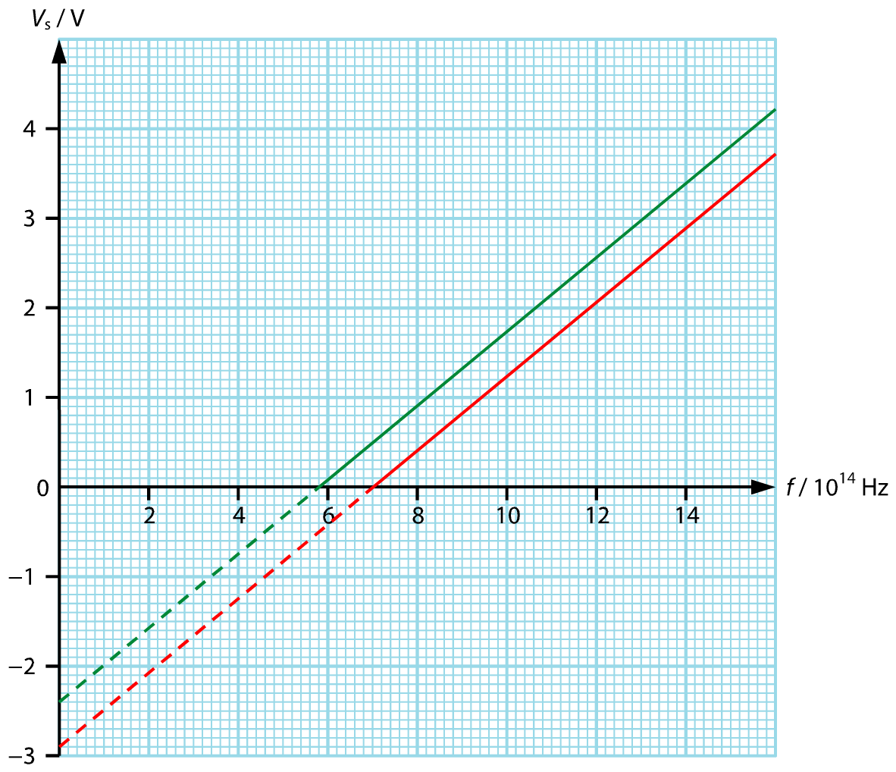

Example 1.6\*

(a) It means −*V*s, where *V*s is the stopping potential.

(b) The maximum KE of the photoelectrons = *eV*s = (1.6 × 10−19)(1.2) = 1.92 × 10−19 J

By *K*max = *hf* − *φ*, we have

%FontSize=10
%TeXFontSize=10
\documentclass{article}
\pagestyle{empty}
\endofdump
\begin{document}
\begin{flalign*}
\phi &= hf - K_\text{max} = \frac{hc}{\lambda} - K_\text{max} \\
&= \frac{\left(\num{6.63e-34}\right)\left(\num{3e8}\right)}{\num{530e-9}} - \num{1.92e-19} \\
&= \num{3.753e-19} - \num{1.92e-19} = \SI{1.833e-19}{\joule} = \SI{1.15}{\electronvolt}
\end{flalign*}
\end{document}

(c) Power of the photons hitting the surface = intensity × area = (0.05)( 9 × 10−6) = 4.5 × 10−7 W

Number of photons hitting the surface

%FontSize=10
%TeXFontSize=10
\documentclass{article}
\pagestyle{empty}
\endofdump
\begin{document}
\[
=\frac{\text{Total power of the photons}}{\text{Energy carried by each photon}} = \frac{\num{4.5e-7}}{\num{3.753e-19}} = \SI{1.199e12}{\per\second}
\]
\end{document}

Therefore

%FontSize=10
%TeXFontSize=10
\documentclass{article}
\pagestyle{empty}
\endofdump
\begin{document}
\[
X = \frac{\num{1.199e12}}{5}\cdot\num{1.6e-19} = \SI{3.84e-8}{\ampere}
\]
\end{document}

(d)

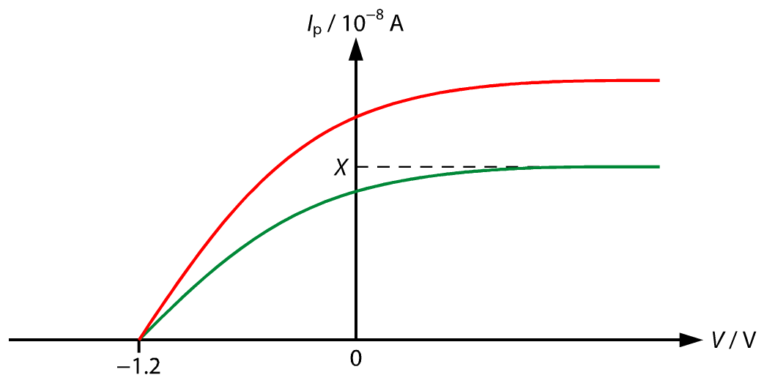

(e) *Q*: red light; *P*: blue light