# Chapter 1 Photoelectric Effect

## Multiple Choice Questions

### (Level 1)

Code: 71A1Q001, Total marks: 1

Which of the following statements about the electron-volt is/are correct?

(1) It is equal to the work done on an electron in moving it through a p.d. of 1 V.

(2) It is a unit of energy used in particle physics.

(3) It is an SI unit.

A. (1) only

B. (1) and (2) only

C. (2) and (3) only

D. (1), (2) and (3)

Answer: B

Code: 71A1Q002, Total marks: 1

Which of the following is equal to 1 J?

(1) 1 N m

(2) 3.6 × 10−6 kW h

(3) 1.60 × 1019 eV

A. (1) only

B (2) only

C. (1) and (3) only

D. (2) and (3) only

Answer: A

Code: 71A1Q003, Total marks: 1

Which of the following figures correctly shows the circuit used for measuring the stopping voltage in an experiment on the photoelectric effect using a photocell?

A. 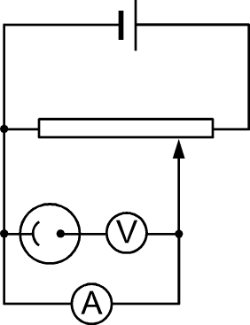 B. 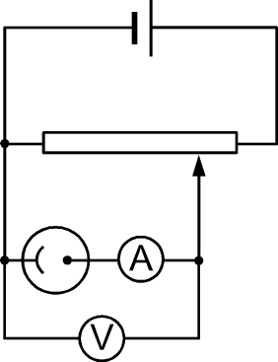

C. 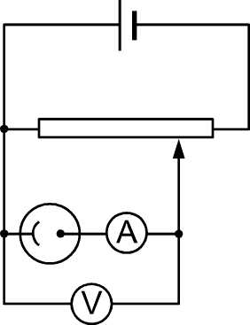 D. 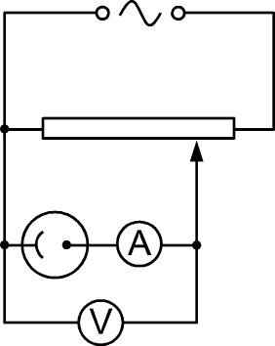

Answer: C

Code: 71A1Q004, Total marks: 1

Which of the following statements about the concept of photon is/are correct?

(1) All phenomena of light can be explained by the concept of photon.

(2) If the intensity of radiation of a fixed wavelength increases, the energy of each photon increases.

(3) For radiation of wavelength *λ*, the energy carried by each photon is %FontSize=12
%TeXFontSize=12
\documentclass{article}
\pagestyle{empty}
\endofdump
\begin{document}
\[
\frac{hc}{\lambda}
\]
\end{document}.

A. (1) only

B (3) only

C. (1) and (2) only

D. (2) and (3) only

Answer: B

Code: 71A1Q005, Total marks: 1

Which of the following statements about the photoelectric effect are **incorrect**?

(1) The maximum kinetic energy of the emitted photoelectrons is given by   
K.E.max = *hf* where *f* is the frequency of the incident radiation.

(2) The photoelectric effect can be explained by the wave theory of light.

(3) There is no time delay in the emission of photoelectrons when radiation of sufficiently high frequency is applied.

A. (1) and (2) only

B. (2) and (3) only

C. (1) and (3) only

D. (1), (2) and (3)

Answer: A

Code: 71A1Q006, Total marks: 1

In an experiment on the photoelectric effect, stopping potentials *V*s are measured when radiation of different frequencies *f* is shone on a metal. The following graph is obtained.

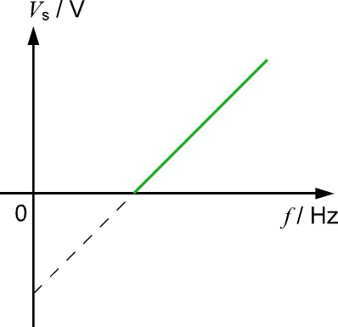

What does the slope of the graph represent?

Given: *φ* = the work function of the metal

*e* = the magnitude of charge of an electron

*f*0 = the threshold frequency of the metal

A. %FontSize=12
%TeXFontSize=12
\documentclass{article}
\pagestyle{empty}
\endofdump
\begin{document}
\[
- \frac{\phi}{e}
\]
\end{document}

B. %FontSize=12
%TeXFontSize=12
\documentclass{article}
\pagestyle{empty}
\endofdump
\begin{document}
\[
\frac{\phi}{e}
\]
\end{document}

C. %FontSize=12
%TeXFontSize=12
\documentclass{article}
\pagestyle{empty}
\endofdump
\begin{document}
\[
\frac{h}{e}
\]
\end{document}

D. *f*0*h*

Answer: C

Code: 71A1Q007, Total marks: 1

In an experiment on the photoelectric effect, stopping potentials *V*s are measured when radiation of different frequencies *f* is shone on a metal. The following graph is obtained.



What does the vertical intercept of the graph represents?

Given: *φ* = the work function of the metal

*e* = the magnitude of charge of an electron

*f*0 = the threshold frequency of the metal

A. %FontSize=12
%TeXFontSize=12
\documentclass{article}
\pagestyle{empty}
\endofdump
\begin{document}
\[
- \frac{\phi}{e}
\]
\end{document}

B. %FontSize=12
%TeXFontSize=12
\documentclass{article}
\pagestyle{empty}
\endofdump
\begin{document}
\[
\frac{\phi}{e}
\]
\end{document}

C. %FontSize=12
%TeXFontSize=12
\documentclass{article}
\pagestyle{empty}
\endofdump
\begin{document}
\[
\frac{h}{e}
\]
\end{document}

D. *f*0*h*

Answer: A

Code: 71A1Q008, Total marks: 1

Which of the following correctly shows the graph of the photoelectric current *I*p against the voltage *V* applied across the electrodes of a photocell when radiation of a fixed frequency but different intensities is shone on the metal plate of the photocell? (Take *V* to be positive when the metal plate is at a lower potential than the other electrode.)

A. 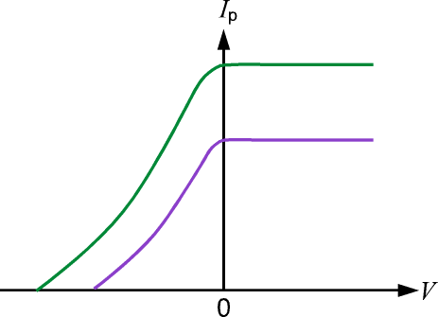 B. 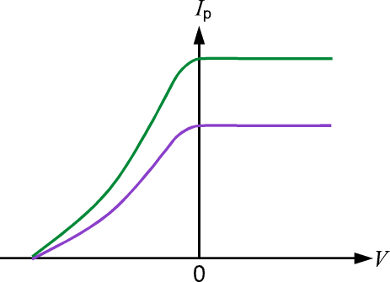

C. 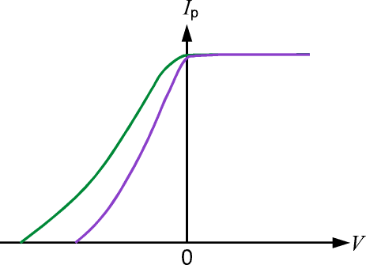 D. 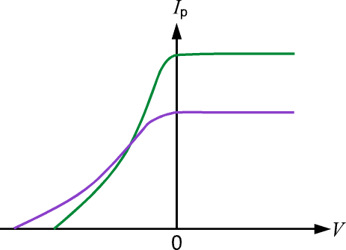

Answer: B

Code: 71A1Q009, Total marks: 1

The work function of a metal is 3.10 eV. Find the maximum wavelength of the electromagnetic wave that can induce the emission of photoelectrons.

A. 369 nm

B. 401 nm

C. 685 nm

D. 888 nm

Answer: B

Code: 71A1Q010, Total marks: 1

The work function of a metal is 5.12 × 10−19 J. If the frequency of the electromagnetic wave shone on the metal is three times the threshold frequency, calculate the maximum kinetic energy of the emitted photoelectrons.

A. 2.50 eV

B. 3.20 eV

C. 6.40 eV

D. 9.60 eV

Answer: C

Code: 71A1Q011, Total marks: 1

Which of the following equations correctly relates the stopping potential *V*s and the radiation frequency *f*?

A. %FontSize=12
%TeXFontSize=12
\documentclass{article}
\pagestyle{empty}
\endofdump
\begin{document}
\[
V_s = hf - \phi
\]
\end{document}

B. %FontSize=12
%TeXFontSize=12
\documentclass{article}
\pagestyle{empty}
\endofdump
\begin{document}
\[
V_s = hf + \phi
\]
\end{document}

C. %FontSize=12
%TeXFontSize=12
\documentclass{article}
\pagestyle{empty}
\endofdump
\begin{document}
\[
V_s = \frac{h}{e} f + \frac{\phi}{e} 
\]
\end{document}

D. %FontSize=12
%TeXFontSize=12
\documentclass{article}
\pagestyle{empty}
\endofdump
\begin{document}
\[
V_s = \frac{h}{e} f - \frac{\phi}{e} 
\]
\end{document}

Answer: D

Code: 71A1Q012, Total marks: 1

A metal of work function 5.93 eV is exposed to an electromagnetic radiation of frequency 7.31 × 1015 Hz. Find the stopping potential.

A. 5.93 V

B. 11.9 V

C. 24.4 V

D. 30.3 V

Answer: C

Code: 71A1Q013, Total marks: 1

A metal of work function 7.84 ×10−19 J is exposed to an electromagnetic radiation. If the stopping potential is 4.0 V, find the frequency of the radiation.

A. 6.24 × 1014 Hz

B. 9.97 × 1014 Hz

C. 1.18 × 1015 Hz

D. 2.15 × 1015 Hz

Answer: D

### (Level 2)

Code: 71A2Q001, Total marks: 1

A photocell is connected to an ammeter and a d.c. supply as shown.

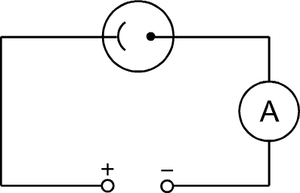

Initially radiation of frequency *f*1 is directed onto the metal plate of the photocell and a current is detected by the ammeter. When the applied voltage is gradually increased to *V*, no current is detected. If the metal plate is exposed to radiation of frequency *f*2 while keeping the applied voltage at *V*, current is once again detected. Which of the following is/are correct?

(1) *f*2 > *f*1

(2) *V* is the stopping potential for the radiation of frequency *f*2.

(3) *f*1 is the threshold frequency of the metal plate.

A. (1) only

B. (2) only

C. (1) and (2) only

D. (2) and (3) only

Answer: A

Code: 71A2Q002, Total marks: 1

In an experiment investigating the work functions of three different metals, stopping potentials *V*s are measured when radiation of different frequencies *f* is shone on the metals respectively. Which of the following graphs shows a possible experimental result?

A.  B. 

C.  D. 

Answer: C

Code: 71A2Q003, Total marks: 1

Which of the following implication of the wave theory of light is **inconsistent** with the photoelectric effect?

(1) The energy of an electromagnetic wave is proportional to its intensity.

(2) The energy of an electromagnetic wave is transferred to the irradiated surface continuously.

(3) The energy transfer rate of an electromagnetic wave is independent of its frequency.

A. (1) and (2) only

B. (2) and (3) only

C. (1) and (3) only

D. (1), (2) and (3)

Answer: B

Code: 71A2Q004, Total marks: 1

In an experiment on the photoelectric effect, electrons are emitted when the metal plate of a photocell is illuminated by yellow light. Which of the following statements about the experiment **must** be correct?

(1) Electrons will also be emitted if the yellow light is replaced by red light.

(2) Electrons are emitted almost immediately after the illumination.

(3) The maximum kinetic energy of the electrons is independent of the intensity of the light used.

A. (1) and (2) only

B. (1) and (3) only

C. (2) and (3) only

D. (1), (2) and (3)

Answer: C

Code: 71A2Q005, Total marks: 1

Which of the following statements about a photon of energy 4.79 eV is/are correct?

(1) Its energy in joules is 2.99 × 1019 J.

(2) Its wavelength is 260 nm.

(3) Its frequency is 2.37 × 1015 Hz.

A. (1) only

B. (2) only

C. (1) and (3) only

D. (2) and (3) only

Answer: B

## Short Questions (<10 marks)

### (Level 1)

Code: 71B1Q001, Total marks: 7

A photocell is connected to an ammeter and a d.c. supply as shown.



The metal plate of the photocell is exposed to radiation of frequency *f*1 and an electric current is detected. When the applied voltage is gradually increased to *V*1, no current is detected. If the applied voltage is reversed, an electric current is once again detected.

(a) Explain what stopping potential is. Does it increase or decrease with the frequency of the radiation? (3 marks)

(b) Sketch a graph of photoelectric current *I*p against the applied voltage *V*. Take *V* to be positive when the metal plate is at a lower potential than the other electrode of the photocell. (2 marks)

(c) Sketch on the same figure the graphs of photoelectric current *I*p against applied voltage *V* if the experiment is repeated with radiation of the same frequency but a lower intensity. (2 marks)

Answer:

(a) The stopping potential is the smallest value (1A) of the supplied voltage that can prevent the most energetic photoelectrons from reaching the anode of the photocell (1A). Its magnitude increases with the frequency of the radiation used (1A).

(b) and (c)

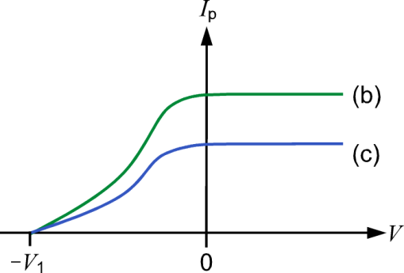 (2A+2A)

Code: 71B1Q002, Total marks: 6

In an experiment on the photoelectric effect, radiation of different frequencies is shone on a metal and the corresponding stopping potentials *V*s are obtained. The following figure shows the graph of *V*s against the radiation frequency *f*.

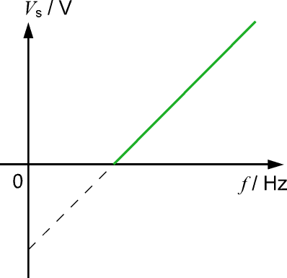

(a) What is threshold frequency? How can it be determined using the above figure?

(2 marks)

(b) A student makes the following statement:

‘The slope of the graph would be different if the experiment is repeated with another metal.’

Do you agree? Explain briefly. (2 marks)

(c) Sketch another graph on the above figure if the experiment is repeated using a metal with a smaller work function. (2 marks)

Answer:

(a) Threshold frequency is the frequency for the incident radiation below which no photoelectrons are emitted from the irradiated metal (1A). It appears on the graph of stopping potential against frequency as the horizontal intercept (1A).

(b) The statement is incorrect (1A). The slope of the graph equals %FontSize=12
%TeXFontSize=12
\documentclass{article}
\pagestyle{empty}
\endofdump
\begin{document}
\[
\frac{h}{e}
\]
\end{document}, where *h* is the Planck constant and *e* is the magnitude of the charge of an electron. It is a constant and will not change with a different metal surface (1A).

(c) 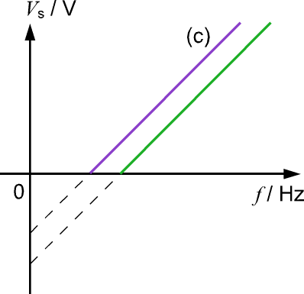

(1A for the new graph with a smaller vertical intercept + 1A for the two graphs to be parallel)

Code: 71B1Q003, Total marks: 6

A photocell is connected to a battery, an ammeter and a potentiometer as shown.

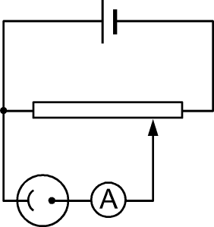

The metal plate of the photocell is illuminated by blue laser of frequency   
640 × 1012 Hz and power *P* = 2.5 mW. The metal plate of the photocell has a work function of 2.52 eV.

(a) (i) Calculate the energy of a single photon of the radiation in eV. (2 marks)

(ii) Calculate the number of photons incident on the metal plate per second.

(2 marks)

(b) The current registered by the ammeter is 100 μA. Find the fraction of incident photons that cause the emission of photoelectrons. (2 marks)

Answer:

(a) (i) The energy *E* of a single photon

%FontSize=12
%TeXFontSize=12
\documentclass{article}
\pagestyle{empty}
\endofdump
\begin{document}
\begin{align*}
&= hf \\
&= \left( \num{6.63e-34} \right) \times \left( \num{640e12} \right) \\
&= \num{4.2432e-19}{\joule} \\
&= \SI{2.652}{\electronvolt}
\end{align*}
\end{document} (1M+1A)

(ii) The number of photons incident on the metal plate per second

%FontSize=12
%TeXFontSize=12
\documentclass{article}
\pagestyle{empty}
\endofdump
\begin{document}
\begin{align*}
&= \frac{P}{E} \\
&= \frac{\num{2.5e-3}}{\num{4.2432e-19}} \\
&= \num{5.8917e15} \\
&\approx \num{5.89e15}
\end{align*}
\end{document} (1M+1A)

(b) If all the incident photons induce the emission of photoelectrons, the current should be

%FontSize=12
%TeXFontSize=12
\documentclass{article}
\pagestyle{empty}
\endofdump
\begin{document}
\begin{align*}
I  &= \frac{C}{t} \\
  &= \frac{\left( \num{5.8917e15} \right) \times \left( \num{1.60e-19}\right) }{1} \\
  &\approx \SI{9.4268e-4}{\ampere}
\end{align*}
\end{document} (1M)

Hence the fraction of incident photons that causes the emission of photoelectrons

%FontSize=12
%TeXFontSize=12
\documentclass{article}
\pagestyle{empty}
\endofdump
\begin{document}
\[
=\frac{\num{e-4}}{\num{9.4268e-4}} \approx 0.106
\]
\end{document} (1A)

### (Level 2)

Code: 71B2Q001, Total marks: 6

(a) Briefly describe what a photon is, and explain how its energy is related to its frequency. (2 marks)

(b) The maximum kinetic energy of photoelectrons is independent of the intensity of the incident light. Briefly explain why this contradicts the wave theory of light, and how it can be explained by the quantum theory of light.

(2 marks)

(c) There is no time delay in the emission of photoelectrons. Briefly explain why this contradicts the wave theory of light, and how it can be explained by the quantum theory of light. (2 marks)

Answer:

(a) A photon is a discrete package of energy that can be absorbed or emitted indivisibly (1A). Its energy *E* is related to its frequency *f* bywhere *h* is the Planck constant (1A).

(b) The wave theory of light predicts that the maximum kinetic energy of the emitted photoelectrons increases with the intensity of the incident light (1A). In the quantum theory, energy is delivered in discrete packets called photons. Since each photon carries the same amount of energy and can only induce the emission of one photoelectron, the maximum kinetic energy of the photoelectrons is independent of the intensity of the incident light (1A).

(c) Since energy is transferred continuously in an electromagnetic wave, electrons in the metal need finite time to absorb enough energy before they can escape (1A). In the quantum theory of light, all the energy of a photon will be transferred to an electron once the photon is absorbed, so there is no time delay (1A).

Code: 71B2Q002, Total marks: 6

A student is choosing a metal and a radiation for an experiment on the photoelectric effect from the following table.

|  |  |  |  |
| --- | --- | --- | --- |
| **metal** | **work function / eV** | **radiation** | **frequency / Hz** |
| *X* | 3.10 | weak UV | 900 × 1012 |
| *Y* | 2.13 | strong violet | 760 × 1012 |
| *Z* | 2.52 | strong green | 580 × 1012 |

The violet and the green lights are of the same intensity while the ultraviolet radiation has a lower intensity than the other two. Find the pair(s) of combination of metal and radiation that will result in

(a) no emission of photoelectrons, (2 marks)

(b) the emission of photoelectrons with the lowest kinetic energy, and (2 marks)

(c) the emission of photoelectrons with the highest kinetic energy in the experiment.

(2 marks)

Answer:

Expressing the energy of a photon of each radiation in eV, we have

UV: %FontSize=12
%TeXFontSize=12
\documentclass{article}
\pagestyle{empty}
\endofdump
\begin{document}
\[
\frac{\left ( \num{6.63e-34} \right ) \times \left ( \num{900e12} \right )}{\num{1.60e-19}} 
\approx \SI{3.73}{\electronvolt}
\]
\end{document}

violet: %FontSize=12
%TeXFontSize=12
\documentclass{article}
\pagestyle{empty}
\endofdump
\begin{document}
\[
\frac{\left ( \num{6.63e-34} \right ) \times \left ( \num{760e12} \right )}{\num{1.60e-19}} 
\approx \SI{3.15}{\electronvolt}
\]
\end{document}

green: %FontSize=12
%TeXFontSize=12
\documentclass{article}
\pagestyle{empty}
\endofdump
\begin{document}
\[
\frac{\left ( \num{6.63e-34} \right ) \times \left ( \num{580e12} \right )}{\num{1.60e-19}} 
\approx \SI{2.40}{\electronvolt}
\]
\end{document}

(a) The energy of the green light photons is the lowest and is lower than the work functions of *X* and *Z* (1A). Thus, the combination of strong green light with *X* and *Z* cannot induce the emission of photoelectrons (1A).

**Note:** According to K.E.max = *hf* − *φ*, K.E.max is equal to the difference between the energy of the incident photon and the work function.

(b) For the emission of photoelectrons with the lowest maximum kinetic energy, the metal should have the highest work function and the photons should have the lowest possible energy (1A). Thus, the combination of strong violet with *X* should be used (1A).

(c) For the emission of photoelectrons with the highest maximum kinetic energy, the metal should have the lowest work function and the photons should have the highest possible energy (1A). Thus, the combination of weak UV radiation with *Y* should be used (1A).

## Long Questions (10 marks)

### (Level 1)

Code: 71C1Q001, Total marks: 10



In an experiment on the photoelectric effect using the above circuit, a photoelectric current is detected by the ammeter when the metal plate of the photocell is illuminated by weak green light of wavelength 495 nm. The threshold frequency of the metal is 5.10 × 1014 Hz, which corresponds to yellow light.

(a) Explain why the wave model of light **cannot** account for the threshold frequency of the metal.

(2 marks)

(b) (i) Calculate the maximum kinetic energy of the emitted photoelectrons.

(ii) Hence find the stopping potential.

(4 marks)

(c) Describe any change to the stopping potential and the maximum photoelectric current if the metal plate is illuminated by

(i) blue light with the same intensity, and

(ii) green light of the same wavelength but of higher intensity respectively.

(4 marks)

Answer:

(a) The energy of a light wave depends on its intensity. (1A) Electrons should be   
 emitted at any frequency if the light is bright enough or the time of exposure is   
 long enough. (1A)

(b) (i) The frequency of the green light

%FontSize=12
%TeXFontSize=12
\documentclass{article}
\pagestyle{empty}
\endofdump
\begin{document}
\[
f = \frac{c}{\lambda}
= \frac{\num{3e8}}{\num{495e-9}}
= \SI{6.0606e14}{\hertz}
\]
\end{document}

Applying %FontSize=12
%TeXFontSize=12
\documentclass{article}
\pagestyle{empty}
\endofdump
\begin{document}
\[
\text{K.E.}_\text{max} = h (f - f_0)
\]
\end{document} , we have

%FontSize=12
%TeXFontSize=12
\documentclass{article}
\pagestyle{empty}
\endofdump
\begin{document}
\begin{align*}
\text{K.E.}_\text{max} &= h(f-f_0) \\
&= \left ( \num{6.63e-34} \right) \times \left ( \num{6.0606e14} - \num{5.10e14} \right) \\
&= \num{6.3688e-20} \\
&\approx \SI{6.37e-20}{\J}
\end{align*}
\end{document} (1M+1A)

(ii) Applying K.E.max = *eV*s, we have

%FontSize=12
%TeXFontSize=12
\documentclass{article}
\pagestyle{empty}
\endofdump
\begin{document}
\begin{align*}
V_s &= \frac{\text{K.E.}_\text{max} }{e} \\ 
&= \frac{\num{6.3688e-20}}{\num{1.60e-19}} \\
&\approx \SI{0.398}{\volt}
\end{align*}
\end{document} (1M+1A)

(c) (i) The stopping potential increases and the current decreases. (2A)

(ii) The stopping potential remains unchanged and the current increases. (2A)

Code: 71C1Q002, Total marks: 10

(a) Photoelectrons are detected when a metal surface is illuminated by violet light but not when it is illuminated by red light. Briefly explain this result.

(4 marks)

(b) Why is the result contrary to the predictions of the wave theory?

(2 marks)

(c) Two beams of electromagnetic radiation, *A* and *B*, are of the same intensity. They are directed onto the same metal surface respectively. If the ratio of their wavelengths is *λA* : *λB* = 2 : 5, find *NA* : *NB* where *NA* and *NB* are the number of photons in each beam of radiation arriving at the surface per unit time.

(4 marks)

Answer:

(a) The energy in light is carried in discrete packets called photons and the energy of each photon is proportional to its frequency (1A). The photons of violet light have higher frequency and hence higher energy than those of red light (1A). Photoelectrons are emitted only if the energy of an incident photon is higher than the work function of the metal surface (1A). Since the work function of the metal surface is higher than the energy of a red photon but lower than the energy of a violet photon, photoelectrons are detected only when it is illuminated by violet light (1A).

(b) The energy of a light wave depends on its intensity. (1A) Photoelectrons should be   
 detected when the metal surface is illuminated by light that is bright enough or   
 the time of exposure is long enough, despite of its colour. (1A)

(c) According to %FontSize=12
%TeXFontSize=12
\documentclass{article}
\pagestyle{empty}
\endofdump
\begin{document}
\[
f =\frac{c}{\lambda}
\]
\end{document}, the ratio of *fA* : *fB* is 5 : 2 (1M). Since the energy of a photon is given by *E* = *hf*, the ratio of their energy *EA* : *EB* is also 5 : 2 (1M). The two beams of radiation have the same intensity and they deliver the same amount of energy per unit time to the surface. As the energy of the photons in radiation *B* is lower, it must deliver more number of photons per unit time. We have *NA* : *NB* = 2 : 5 (1M+1A).

### (Level 2)

Code: 71C2Q001, Total marks: 10

In a photoelectric experiment, a calcium metal plate of area 3 × 10−4 m2 is illuminated by a beam of violet light of intensity 0.032 W m−2 as shown.

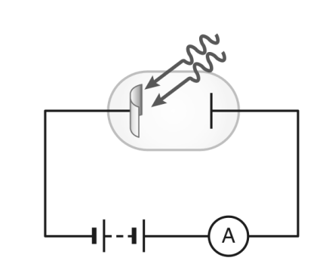

The maximum KE of the photoelectrons is 0.95 eV. The work function of calcium is 2.87 eV. Take *e* = 1.6 × 10−19 C.

(a) Find the energy (in eV) of the photons of the beam of violet light. (1 mark)

(b) Explain why not all the emitted photoelectrons possess the maximum KE.

(1 mark)

(c) (i) Estimate, using the classical wave theory, the minimum time required for a calcium atom to absorb enough energy to eject an electron. Take the effective area of a calcium atom in absorbing energy as 0.2 nm2. (2 marks)

(ii) The experiment shows that the emission of photoelectrons is immediate even though the intensity of the beam is weak. Why? (1 mark)

(d) (i) How many photons fall on the calcium surface in each second? (1 mark)

(ii) If only 5% of the photons can cause the emission of photoelectrons, estimate the maximum photocurrent produced. (2 marks)

(e) The graph below shows how the photocurrent *I*P changes with the applied voltage *V* where *V*s is the stopping potential.

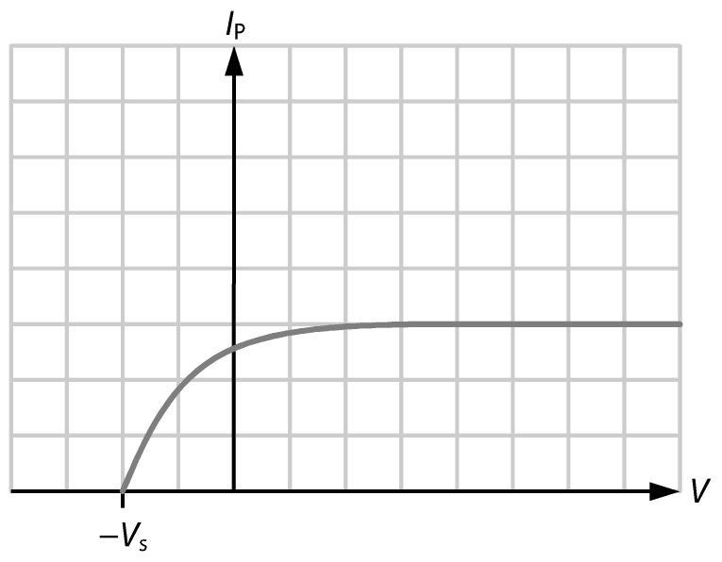

On the same graph, draw the *I*P–*V* graph (in dotted line) that would be obtained if the intensity of the light is doubled. (2 marks)

Answer:

(a) The energy of the photons = 2.87 + 0.95 = 3.82 eV (1A)

(b) Some of the electrons are not at the surface of the metal so that they don’t possess the maximum KE when they are ejected. (1A)

(c) (i) Effective area = 0.2 nm2 = 0.2 (10−9 m)2 = 2 × 10−19 m2

Rate of energy absorbed by each calcium atom

= (2 × 10−19)(0.032) = 6.4 × 10−21 W

The minimum time required to absorb enough energy

%FontSize=12
%TeXFontSize=12
\documentclass{article}
\pagestyle{empty}
\endofdump
\begin{document}
\[
= \frac{\phi}{P} = \frac{(2.87)\left(\num{1.6e-19}\right)}{\num{6.4e-21}} \approx \SI{71.8}{\second} \omoa
\]
\end{document}

(ii) Photoelectron emission is a one-to-one process, so photoelectrons would be ejected immediately if the energy of the photons absorbed is greater than that of the work function of the metal. (1A)

(d) (i) Number of photons falling on the surface

%FontSize=12
%TeXFontSize=12
\documentclass{article}
\pagestyle{empty}
\endofdump
\begin{document}
\[
= \frac{(0.032)\left(\num{3e-4}\right)}{(3.82)\left(\num{1.6e-19}\right)} = \num{1.571e13}\approx \num{1.57e13} \oa
\]
\end{document}

(ii) Maximum photocurrent

= (1.571 × 1013)(0.05)(1.6 × 10−19) (1M)

= 1.26 × 10−7 A (1A)

(e) The new *I*P–*V* graph

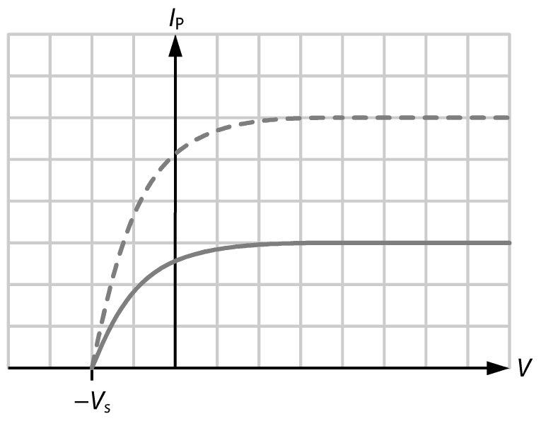 (2A)