NSS Exploring Economics 2 (3rd Edition)

Chapter 10
p. 69
[Living economics 10.1]

p. 92
[10.5 Factors of production in Hong Kong]
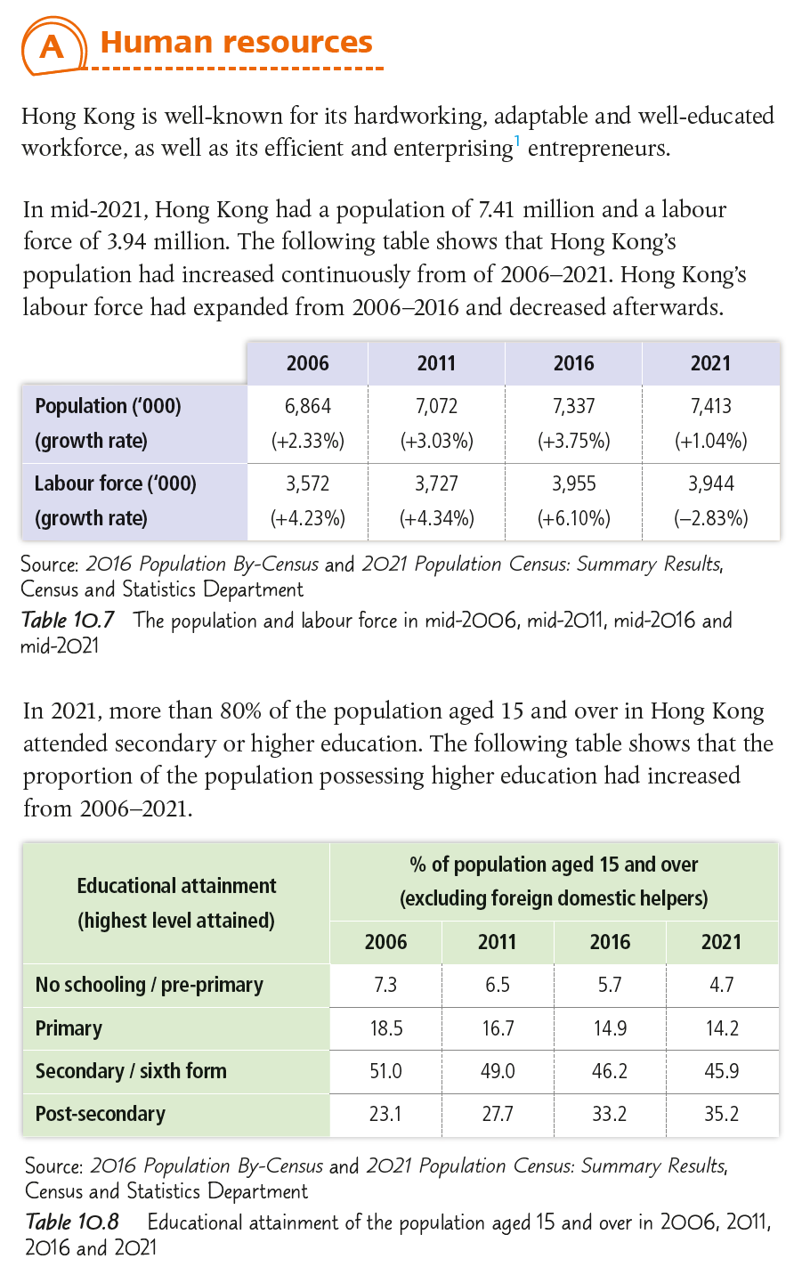

p. 93
[10.5 Factors of production in Hong Kong]
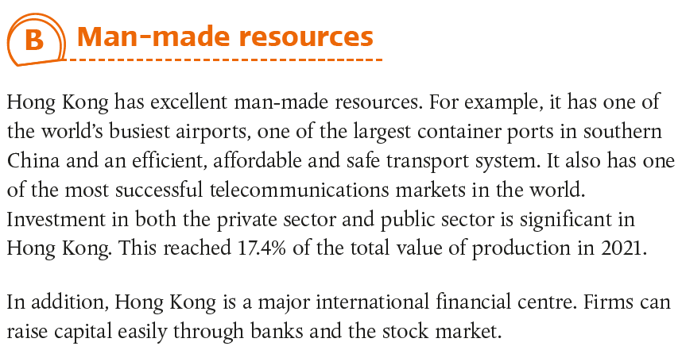

Chapter 10
p. 78
[More practice]
HKDSE 2022, Paper 2, Q9(a)(ii)
HKDSE 2019, Paper 2, Q11(a)
HKDSE 2017, Paper 2, Q12(a)
HKDSE 2013, Paper 2, Q11(b)

p. 85
[More practice]
HKDSE 2022, Paper 2, Q10(d)
HKDSE 2021, Paper 2, Q1(a)
HKDSE 2019, Paper 2, Q9(c)–(d)
HKDSE 2017, Paper 2, Q2(a)
HKDSE 2013, Paper 2, Q10(b)
HKCEE 2010, Paper 1, Q3

p. 97
[MCQ3]
HKDSE 2017, Paper 1, Q11

p. 98
[MCQ6]
HKDSE 2016, Paper 1, Q9

p. 99
[MCQ10]
HKDSE 2019, Paper 1, Q8
HKDSE 2016, Paper 1, Q6

p. 101
[Case analysis 2]
HKDSE 2015, Paper 2, Q10(c)

