**HKDSE**

**BAFS**

**(Nov 2021)**

**Paper 2B**

**Business, Accounting and Financial Studies**

**Mock Exam Paper (Nov 2021)**

Paper 2B

Business Management Elective

Time allowed: 2 hours and 15 minutes

This paper must be answered in English.

**SECTION A** (24 marks)

**Special Arrangement for 2022 HKDSE:**

1 Candidates are only required to answer one out of two questions in Section B, total 18 marks. The paper will carry a total of 62 marks. The weighting of Section B in the paper will remain unchanged.

2 Exam duration will remain 2 hours and 15 minutes.

Candidates taking the DSE exam in 2022 are advised to follow this arrangement when attempting the paper.

**Instructions:**

1. There are THREE sections in this paper.
2. All questions in Sections A and B are compulsory. You are required to answer ONE of the two questions in Section C.

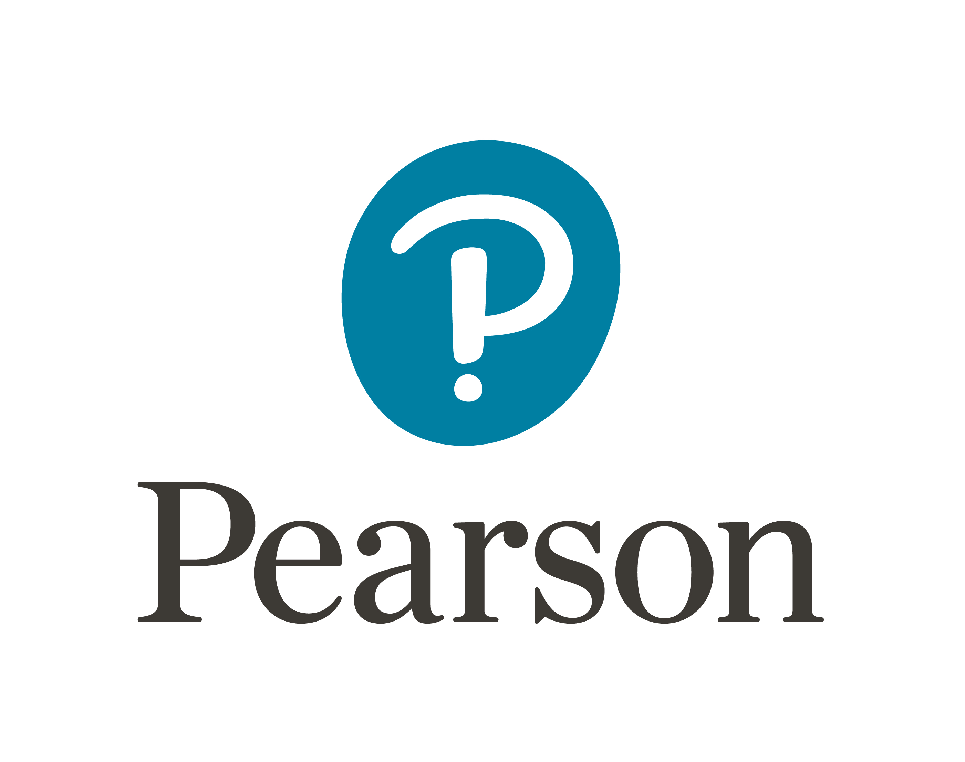

Answer **ALL** questions in this section.

**1** A pharmaceutical company is developing a vaccine for COVID-19 and wants to insure against the risk of loss in sales of this vaccine. However, an insurance agent advises that this risk is non-insurable.

(a) Define pure risk and speculative risk. (2 marks)

(b) Give two reasons why the above risk is non-insurable. (4 marks)

**2** Explain the factors to be considered by a science education company when determining the target market for a science course. (6 marks)

**3** Outline three objectives of providing training to the employees of an airline company.

(6 marks)

**4** A sports equipment company plans to invest in a new machine to enhance its production efficiency. The initial cost of the machine is $580,000. The machine is expected to bring net cash flows of $240,000, $210,000 and $180,000 at the end of the next three years, respectively.

(a) Calculate (to two decimal places) the payback period of the new machine. (2 marks)

(b) List two limitations of making decisions based on the payback period. (2 marks)

(c) Other than the payback period, explain one capital investment appraisal method that also uses net cash flows for the evaluation of projects. (2 marks)

**SECTION B** (36 marks)

Answer **ALL** questions in this section.

**5** United Continental Hotel Group is a multinational company operating more than 30 hotels worldwide. Due to COVID-19, the number of visitors to Hong Kong has dropped sharply. The group’s management discussed how its Hong Kong hotels could better respond to the pandemic.

Brad, the Chief Executive Officer, said, “Even if the impact of COVID-19 has been taken into account when preparing the budget at the beginning of the year, the actual room revenue of our hotels in Hong Kong was still far below the budgeted figure for the first quarter. Who can tell me the reasons? What remedial measures can we take?”

Dicky, the Financial Manager, responded, “We have an unfavourable sales variance. Due to the impact of the pandemic, price competition among local hotels has been increasing. Also, our room facilities were damaged at a faster rate than in the past.”

Wendy, the Marketing Manager, said, “Global travellers had always been our target   
customers. However, we have to change our marketing strategies to attract “staycation” customers. We need to provide such customers with a unique experience.”

Tommy, the Human Resources Manager, responded, “Some customers have recently complained about the poor attitude of our room attendants. We noticed that staff morale was low so I suggest switching to a performance-based compensation method to encourage our staff.”

1. (i) What is an ‘unfavourable sales variance’? (1 mark)

(ii) Explain one possible cause of the above-mentioned sales variance. (2 marks)

1. (i) In response to the changes in the business environment, suggest a suitable target market for the United Continental Hotel Group. (1 mark)

(ii) With reference to any two elements of the marketing mix, suggest one remedial action for each to boost the hotel’s room revenue. (4 marks)

1. Suggest two risk management strategies to cope with the problem of frequent damage to hotel room facilities. (4 marks)
2. (i) Suggest two performance-based compensation methods for the United Continental Hotel Group to motivate employees. (2 marks)

(ii) Compared to time-based compensation, explain two advantages of using performance-based compensation to motivate employees. (4 marks)

(Total: 18 marks)

**6** Baby Pets has been established for five years. It is a company which specialises in providing pet grooming services and selling pet supplies. After reviewing the company’s financial statements for the year ended 31 December 2021, Peter, the General Manager, called a meeting to discuss the company’s performance.

He presented the following financial information for the year:

|  |  |
| --- | --- |
| Credit sales | $1,259,000 |
| Cash sales | $543,000 |
| Credit purchases | $917,325 |
| Cash purchases | $32,850 |
| Average trade payables | $54,470 |

Peter said, ‘In the past few years, our sales revenue has been increasing steadily. However, our cash balance has been declining. What should we do to avoid running out of cash?’

Joseph, the Financial Manager, responded, ‘Improving our cash position is the most important short-term target of the company. I will conduct an analysis and try to improve our cash position by better managing our working capital.’

Tina, the Marketing Manager, said, ‘Recently, we have received customer complaints about poor store environment and rude staff, and sometimes customers have to wait a long time to enjoy pet grooming services. Maintaining the quality of service is one of our top priorities as we are facing fierce competition in the industry.’

Bonnie, the Human Resources Manager, responded, ‘I agree that good service quality is the key to improving customer satisfaction. I recommend hiring secret customers to evaluate our employees’ performance and make improvements.’

(a) Baby Pets plans to hire secret customers to evaluate its employees’ performance. Explain two objectives of performance appraisal to the company. (4 marks)

(b) With reference to any two characteristics of service, explain how Baby Pets can solve its service quality problems. (4 marks)

(c) Give a reason to explain the importance of customer relationship management to improve revenues from existing customers. (2 marks)

(d) Calculate (to two decimal places) the trade payables turnover of Baby Pets in 2021. (2 marks)

(e) With reference to any three components of working capital, suggest one method for each component that can improve the cash position of Baby Pets. (6 marks)

(Total: 18 marks)

**SECTION C** (20 marks)

Answer **ONE** question in this section.

**7** The turnover rate of tutors and teaching assistants at Starry Tutorial School has increased. The management is considering ways to reduce the employee turnover rate. In addition, due to fierce competition in the industry, Starry Tutorial School is formulating market plans to learn more about the factors affecting students’ and parents’ decision in choosing tutorial schools.

(a) With reference to Maslow’s Hierarchy of Needs Theory, suggest ways to reduce the tutorial school’s staff turnover rate. (8 marks)

(b) Illustrate with examples the socio-cultural factors and psychological factors affecting students’ and parents’ decision in choosing tutorial schools. (12 marks)

(Total: 20 marks)

**8** In recent years, consumers' health awareness has increased, and the demand for health supplements has been increasing. A company that manufactures health supplements is planning to expand its business and is considering whether to set up its own physical store or sell its products through large retail chains.

(a) Explain the criteria that the company could use to evaluate whether to use debt or equity financing. (8 marks)

(b) Explain the factors that the company should consider when selecting distribution channels. (12 marks)

(Total: 20 marks)

**END OF PAPER 2B**