**HKDSE**

**BAFS**

**(Nov 2021)**

**Paper 2A**

**Business, Accounting and Financial Studies**

**Mock Exam Paper (Nov 2021)**

Paper 2A

Accounting Module

Time allowed: 2 hours and 15 minutes

This paper must be answered in English.

**SECTION A** (24 marks, weighting 30%)

**Special Arrangement for 2022 HKDSE:**

1 Candidates are only required to answer two out of three questions in Section B, total 24 marks. The paper will carry a total of 68 marks. The weighting of Section B in the paper will remain unchanged.

2 Exam duration will remain 2 hours and 15 minutes.

Candidates taking the DSE exam in 2022 are advised to follow this arrangement when attempting the paper.

**Instructions:**

1. There are THREE sections in this paper.
2. All questions in Sections A are compulsory. You are required to answer TWO of the THREE questions in Section B and ONE of the TWO questions in Section C.

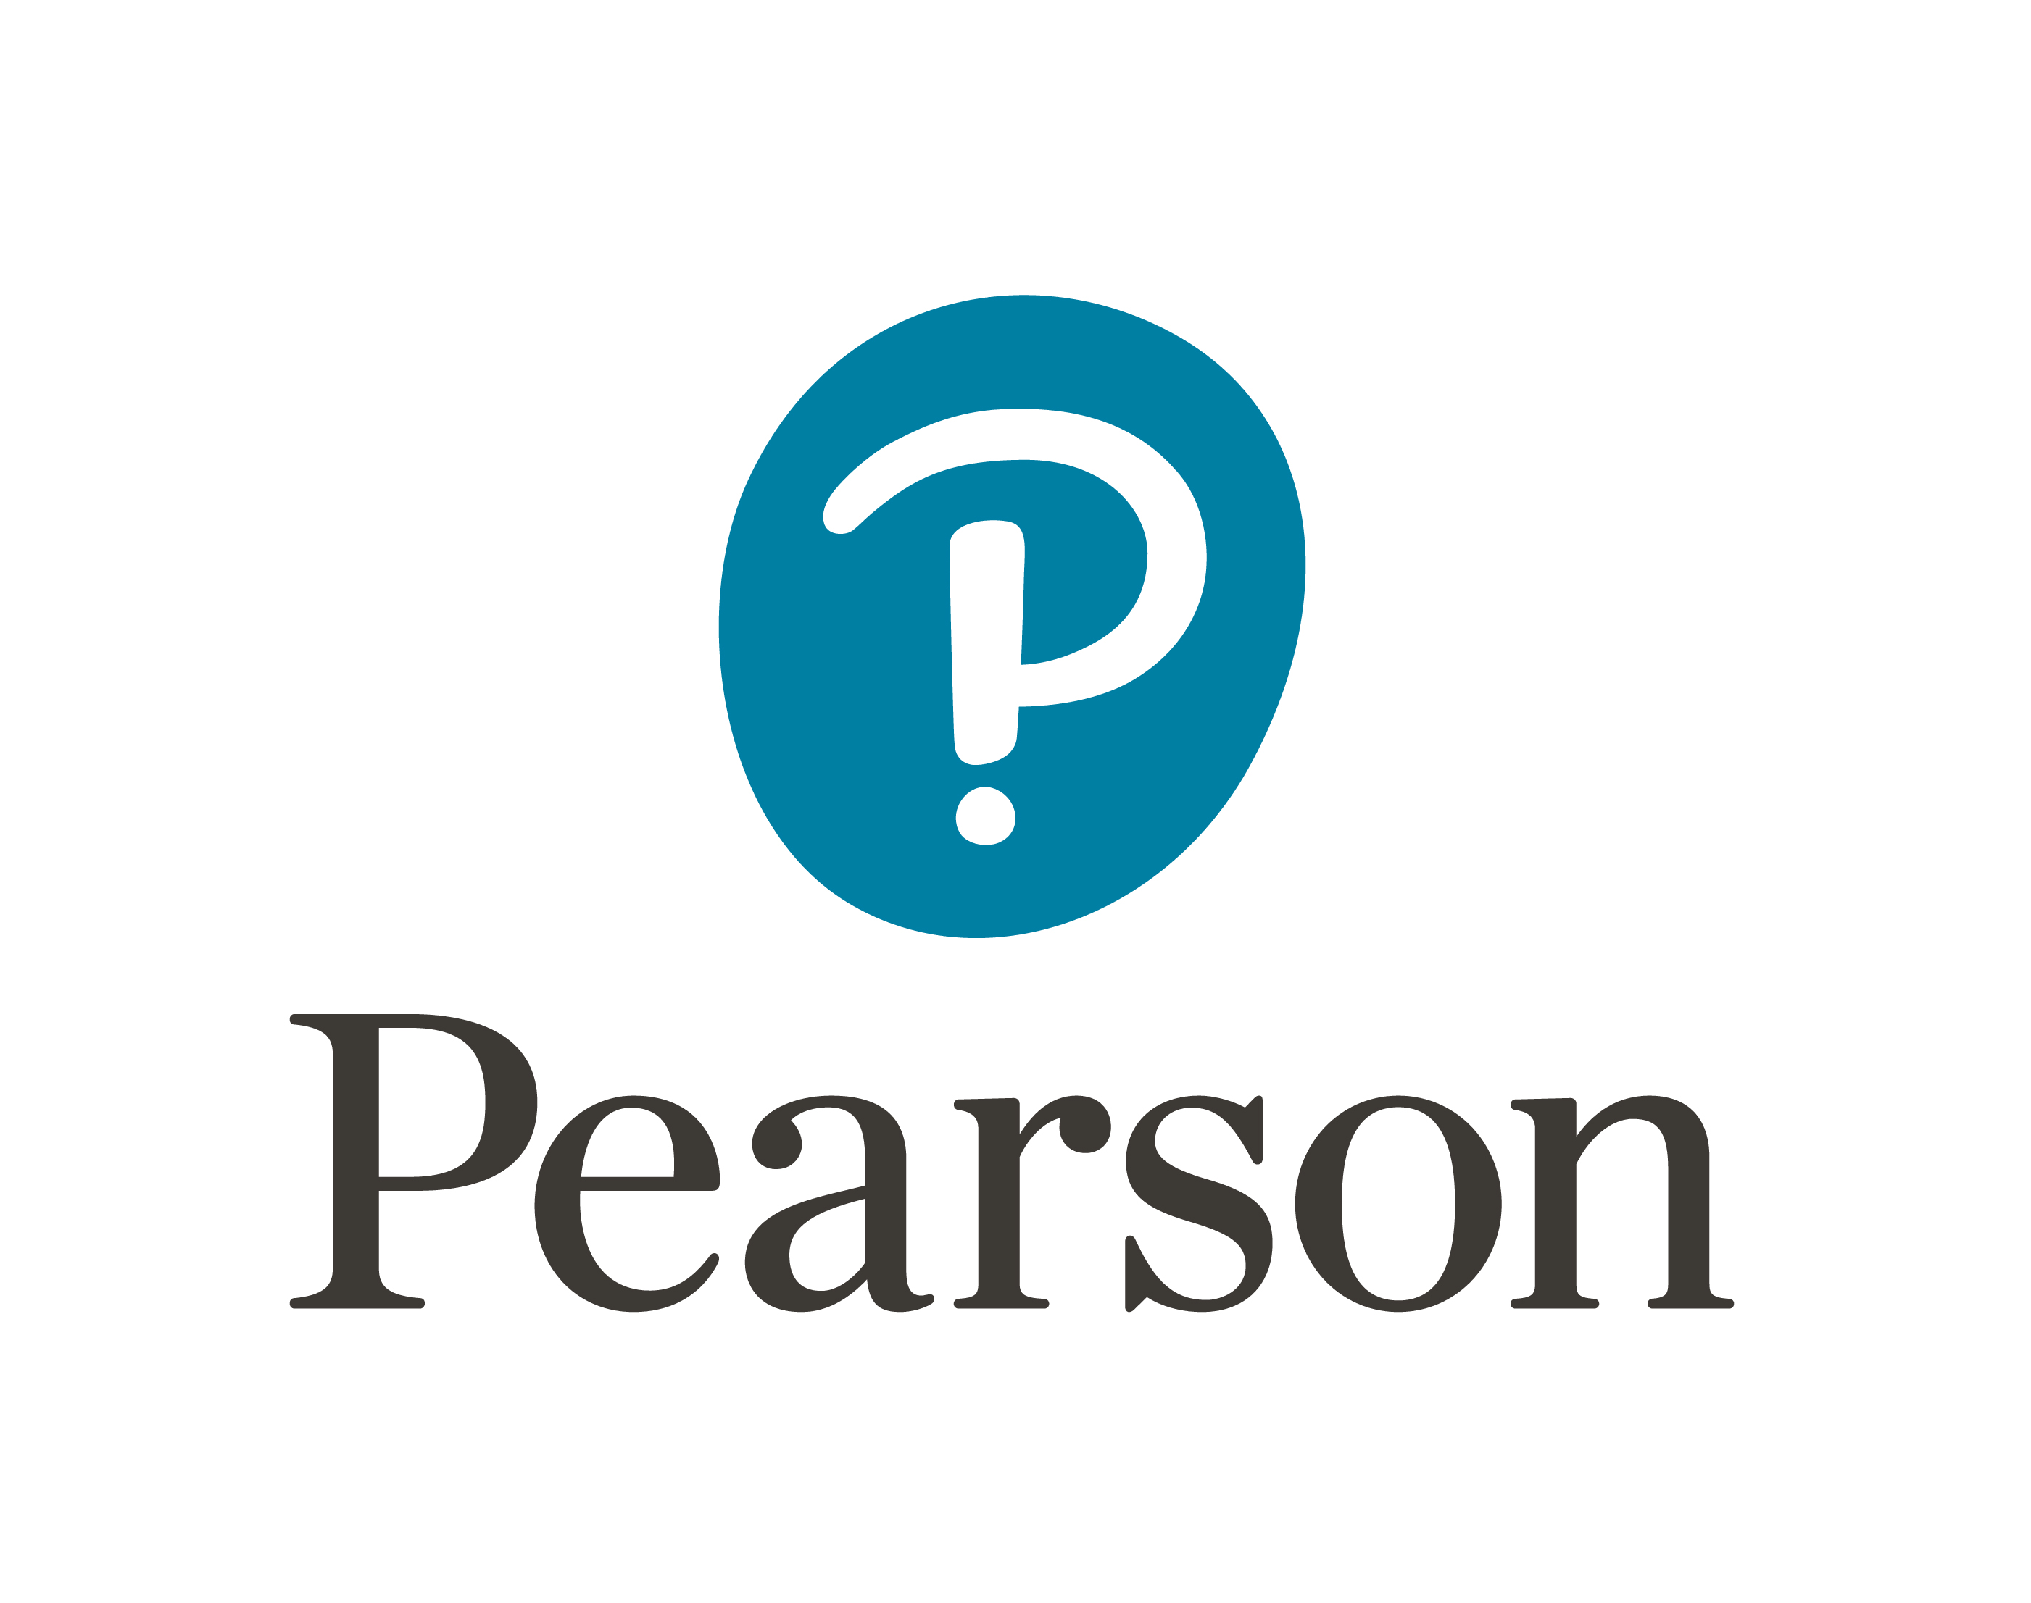







Answer **ALL** questions in this section.

**1** (A) Indicate the accounts to be debited and credited, and the ledgers to be recorded for the following transactions.

|  |  |  |  |  |  |
| --- | --- | --- | --- | --- | --- |
| **Transaction** | | **Debit entry to be recorded** | | **Credit entry to be recorded** | |
| **Account** | **Ledger** | **Account** | **Ledger** |
| **e.g.,** | **Purchased goods in cash.** | **Purchase** | **General ledger** | **Cash** | **Cash book** |
| (a) | Purchased a machine on credit. | (1) | (2) | (3) | (4) |
| (b) | Purchased goods by cheque for owner’s private consumption. | (5) | (6) | (7) | (8) |
| (c) | Received a refund from a supplier in cash. | (9) | (10) | (11) | (12) |
| (d) | Issued a credit note for goods returned. | (13) | (14) | (15) | (16) |
| (e) | Made a refund to a customer by cheque. | (17) | (18) | (19) | (20) |
| (f) | An allowance was given by a credit supplier because of goods damaged in transit. These goods would not be returned to the supplier. | (21) | (22) | (23) | (24) |

(6 marks)

(B) State the book of original entry for recording item (a), (b), (c) and (d) in part (A). (2 marks)

(Total: 8 marks)

**2** (A) ‘Fixed production cost can be variable.’ Do you agree with this statement? Explain. (1 mark)

(B) Ms Wong operates a factory that produces Product Z. She is preparing the budget for the next accounting year and has the following information related to the selling price and production costs:

(i) Unit selling price $800

Direct material cost 0.8 kilograms required per unit of Product Z

Direct labour cost 10 hours required per unit of Product Z

(ii) Each kilogram of direct material costs $30.

(iii) Direct labour rate is $45 per hour.

(iv) Two types of production overheads would be incurred in the production process. Information relating to these overheads at different production levels is as follows:

*Production level 15,000 units 20,000 units 25,000 units 30,000 units*

Type 1 overheads $300,000 $400,000 ? $600,000

Type 2 overheads $325,000 ? $475,000 $550,000

*Required:*

(a) Calculate the unit variable production cost of Product Z. (2 marks)

(b) Calculate the budgeted gross profit at a production level of 20,000 units. (3 marks)

In the coming year, the factory will only produce 15,000 units of Product Z due to a decrease in demand. The maximum capacity for labour hours is 300,000 hours each year. The factory can use the remaining capacity to produce other products, namely, Z Pro, Z Plus and Z Max. The budgeted information related to these three products is as follows:

*Z Pro Z Plus Z Max*

Estimated demand 10,000 units 12,500 units 10,250 units

Estimated unit selling price $820 $749.5 $698

Direct labour hours required per unit 8 hours 6.5 hours 7.5 hours

Direct labour rate $45/hour $45/hour $45/hour

Direct material usage required 0.5 kg/unit 0.7 kg/unit 0.35 kg/unit

Direct material price $30/kg $30/kg $30/kg

Variable production overheads per unit $20 $20 $20

*Required:*

(c) To maximise the total contributions of the factory, calculate the production quantity for each of the three new products. (2 marks)

(Total: 8 marks)

**3** Pear Company uses the weighted average cost method for the valuation of inventory and sells only one product. According to the stocktaking sheet, the opening inventory as at 1 January 2021 included 1,000 units of goods with an average cost of $35 per unit. The following information relates to transactions in 2021.

(i) On 1 January, the bookkeeper discovered that, in 2020, the related carriage inwards of $2,500 was not included in the closing inventory. All of these carriage inwards had been expensed in 2020.

(ii) On 20 February, 800 units of goods were purchased at $27,000.

(iii) On 25 February, 500 units of goods were sold at $50 each.

(iv) On 10 March, 50 units of goods bought on 20 February were returned to suppliers.

(v) On 15 April, 1,200 units of goods were purchased at $38 each. Shipping costs of $1,500 on these goods were also paid.

(vi) On 20 April, a fire broke out in the company’s warehouse. Six hundred units of goods bought on 15 April and 100 units of goods bought in 2020 were lost. The insurance company agreed to compensation of 80% of the lost goods in 2022.

(vii) On 12 May, 300 units of goods were sold at $18,000. Carriage outwards of $1,000 were incurred. On the same day, 150 units of goods were returned from customers.

(vii) On 30 June, it was found that 50 units of goods were damaged. They could only be sold for $20 each after paying a total amount of $150 to repair them.

(ix) For each unit sold, a sales commission of $1.8 would be charged by the agent.

Assume all goods returned from customers could be resold.

*Required:*

(a) Calculate the cost of goods available for sale for the half year ended 30 June 2021.

(3 marks)

(b) Calculate the weighted average cost per unit of goods. (1 mark)

(c) Calculate the value of closing inventory as at 30 June 2021. (3 marks)

(d) Calculate the cost of goods sold for the half year ended 30 June 2021. (1 mark)

(Total: 8 marks)

**SECTION B** (24 marks, weighting 45%)

Answer **TWO** of the **THREE** questions in this section.

**4** The following information was extracted from the statement of financial position as at 30 June 2021 of ABC Ltd:

$

8,000,000 Ordinary share capital 8,000,000

3% Preference share capital 3,000,000

General reserve 2,000,000

Retained profits 5,500,000

5% Debentures (repayable in 2025) 1,200,000

Additional information related to the year ended 30 June 2022:

(i) As at 30 June 2022, the profit and loss account had a credit balance of $1,000,000.

(ii) On 1 September 2021, ABC Ltd issued $2,000,000 3% debentures (repayable in 2030), interest being payable yearly on 31 August. No accounting entries had been made in respect of the debenture interest for the year.

(iii) On 1 April 2022, ABC Ltd issued additional ordinary shares at $1.5 per share, payable in full on application. Oversubscription occurred for this offer and the company received a total of $1,875,000 in application monies. ABC Ltd allotted the shares on 30 April 2022. All applicants received 4 shares for every application of 5 shares. The excess application money would be refunded in July 2022.

(iv) The company declared and paid an interim dividend of $0.02 per share on 1 January 2022. Another dividend for ordinary shareholders was declared and paid on 15 June 2022 so as to achieve a dividend cover ratio of 3.2 times for this fiscal year.

(v) A preference dividend was paid on 30 June 2022.

*Required:*

(a) Prepare a statement to calculate the adjusted net profit for the year ended 30 June 2022. (2 marks)

(b) Calculate the total amount of ordinary dividends declared and paid during the year ended 30 June 2022. (4 marks)

(c) Prepare for ABC Ltd the profit and loss appropriation account for the year ended 30 June 2022. (3 marks)

(d) Calculate the following ratios (to two decimal places) for the year ended 30 June 2022:

(i) Return on capital employed (2 marks)

(ii) Earnings per share (1 mark)

(Total: 12 marks)

**5** Amy and Bobby have been in partnership for many years, sharing profits and losses equally. The account balances as at 31 July 2021 are as follows:

$ $

Property, at cost 2,500,000 Trade payables 750,000

Accumulated depreciation: Property 300,000 Accrued salary [*see* (iv)] 80,000

Equipment, at cost 1,000,000 Cash at bank 500,000

Accumulated depreciation: Equipment 150,000 Capital – Amy 2,500,000

Inventory 300,000 Capital – Bobby 1,500,000

Trade receivables 1,200,000 Current – Amy 188,000

Allowance for doubtful accounts 36,000 Current – Bobby (4,000)

On 1 August 2021, Carol, the manager, was admitted as a new partner to the partnership. The arrangements were as follows:

(i) The property was to be revalued at 120% of its cost and the equipment was to be revalued downwards by 20%. The market price of inventory increased by 25%.

(ii) A trade debtor with an outstanding amount of $100,000 had financial difficulty and may go into liquidation. The partnership estimated that only $40,000 out of the debt could be collected. An allowance for doubtful accounts was to be provided at 8% on the remaining trade debtors accounts.

(iii) Amy, Bobby and Carol agreed to share profits and losses in the ratio of 3 : 2 : 1.

(iv) Carol would add a $70,000 cheque to the partnership for her share of goodwill on the date of her admission. She would also contribute her capital account through the following ways upon her admission:

(1) Two months’ salary amounting to $80,000 owed to her would be transferred to her capital account.

(2) She would settle half the trade payables on behalf of the new partnership.

(v) No goodwill account was to be maintained in the books. Goodwill adjustments were to be made in the partners’ capital accounts.

(vi) The amount of Carol’s salary would remain unchanged, but she would no longer receive the sum in cash or by cheque.

(vii) All partners are entitled to interest on capital, at 5% per annum.

*Required:*

(a) Prepare the following accounts to record Carol’s admission:

(i) the revaluation account (4 marks)

(ii) the partners’ capital accounts in columnar form (4 marks)

(b) Assuming the net profit for the year ended 31 July 2022 was $1,380,150, prepare the profit and loss appropriation account for the year ended 31 July 2022. (4 marks)

(Total: 12 marks)

**6** (A) Define opportunity cost. (2 marks)

(B) XYZ Company commenced on 1 September 2019. The company manufactures only one product, Product X, and utilises the absorption costing system. Its income statement for the year ended 31 August 2022 is as follows:

|  |  |  |  |
| --- | --- | --- | --- |
|  | $ |  | $ |
| Sales (1,500 units) |  |  | 7,500,000 |
| *Less Cost of goods sold:* |  |  |  |
| Direct material cost | 1,440,000 |  |  |
| Direct labour cost | 760,000 |  |  |
| Direct manufacturing expenses | 80,000 |  |  |
| Fixed manufacturing overheads absorbed | 1,850,000 |  |  |
| Cost of goods manufactured during the year | 4,130,000 |  |  |
| *Add* Opening inventory of Product X (300 units) | 495,600 |  |  |
| *Less* Closing inventory of Product X (1,300 units) | (2,147,600) |  |  |
| *Add* Under-absorbed fixed manufacturing overheads | 100,000 |  | (2,578,000) |
| Gross profit |  |  | 4,922,000 |
| *Less* Variable selling expense | 300,000 |  |  |
| Fixed distribution cost | 400,000 |  |  |
| Administrative expenses | 760,400 |  | (1,460,400) |
| Net profit |  |  | 3,461,600 |

Last year’s unit manufacturing cost was the same as that incurred in this year.

*Required:*

(a) Calculate the breakeven sales quantity. (3 marks)

(b) Calculate (to two decimal points) the margin of safety by percentage. (2 marks)

(c) Given fixed manufacturing overheads absorbed per unit produced for the year ended 31 August 2021 were the same as that of this year, prepare a statement to reconcile the above net profit with the net profit under a marginal costing system. (2 marks)

Information related to OPQ Company, a major competitor of XYZ Company, is as follows:

Breakeven sales $1,200,000

Fixed costs $900,000

*Required:*

(d) If the annual sales level of both XYZ and OPQ will be at $9,000,000 in the coming year, use supporting calculations to compare their budgeted total contribution and net profit (assuming there is no opening inventory and closing inventory). Which company will perform better in terms of total contribution? Which company will perform better in terms of net profit? (3 marks)

(Total: 12 marks)

**SECTION C** (20 marks)

Answer **ONE** question in this section.

**7** After preparing an income statement for the year ended 31 October 2021, Fung Limited prepared a trial balance as at the same date and found that it did not agree. The difference was posted to the suspense account.

The following errors were discovered:

(i) Accrued interest expense of $500 as at 31 October 2020 was brought forward at the beginning of next year as $55 on the debit side of the interest revenue account.

(ii) Discounts for the year shown in the payment side of the cash book were $3,500. However, the amount posted to the personal account was only $2,900.

(iii) The payment and receipt side of the bank column in the cash book had been undercast by $800 and $500 respectively.

(iv) Due to physical deterioration, goods costing $3,000 could only be sold for $2,000 after paying $120 to repair them. The bookkeeper recorded this as a $1,000 abnormal inventory loss without adjusting the value of closing inventory.

(v) Ben Limited is both a supplier and a customer of Fung Limited. A contra amount of $45,000 was agreed to. However, it had been recorded on the wrong side of both the trade receivable account and trade payable account.

(vi) On 20 October 2020, a customer paid $4,000 as a non-refundable deposit for goods to be delivered on 10 September 2021. These goods costs $8,000 and will be sold at a 150% mark up. The customer accepted these goods on 13 September 2021 and payment would be made in 2022. No entries had been made in respect of this sale.

(vii) Amounts of $6,500 and $8,000 owed by a credit customer had been previously written off as bad debts for the years ended 31 October 2020 and 2021, respectively. That customer paid back these amounts in cash on 20 October 2021. This had been recorded as a settlement from credit customers. No other accounting entries had been made.

(viii) On 31 October 2021, a 5% allowance for doubtful accounts had been provided on the total amount of trade receivables of $500,000 as shown in the books. However, Fung Limited finally decided to adjust it to 8%. No entries had been made for this adjustment.

(ix) On 1 June 2021, Fung Limited purchased a machine. On that day, the company paid $1,000, $3,000, and $500 for the freight, installation of the machine and teaching staff to operate the machine, respectively. All of these payments had been expensed in the profit and loss account. It is the company’s policy to provide depreciation on non-current assets on a straight-line method at 15% per annum.

*Required:*

(a) Prepare the necessary journal entries to correct the above. Narrations are not required. (17 marks)

(b) Prepare the suspense account to find out the difference as per the trial balance. (3 marks)

(Total: 20 marks)

**8** On 31 December 2021, the Chan company’s cash at bank account had a debit balance of $340,850, which did not agree with the balance shown on the bank statement. Subsequent investigation discovered the following:

(i) During the year, the following cheques had been recorded in the books but still had not been presented to the bank on 31 December 2021:

*Cheque number Payee Date of cheque Amount*

25777 Alien Co 1 April 2021 $20,000

25778 Orange Limited 25 October 2021 $12,000

25779 XYZ Company 5 November 2021 $18,000

25780 Donny Co 15 March 2022 $15,000

It is the bank’s practice not to honour cheques outstanding for more than six months.

(ii) The following information relates to cheques deposited into the company’s bank account in December 2021:

*Cheque number Deposit date Credited by bank Amount*

32885 27 December 2021 — $30,000

32886 28 December 2021 30 December 2021 $40,000

32887 29 December 2021 3 January 2022 $70,000

32888 30 December 2021 4 January 2022 $25,000

Cheque #32885 was dishonoured on 29 December 2021 because the signature on this cheque did not match the bank’s record.

(iii) On 25 March 2021, a credit customer settled the outstanding amount of $4,000 by cheque #32559. The bookkeeper recorded the settlement in the books and put the cheque into a drawer. This cheque was still not presented on 31 December 2021.

(iv) Cheque #32779 for $18,000 dated 20 January 2022 was received from a credit customer on 10 October 2021. It had been recorded as a debtor’s settlement.

(v) A dividend of $1,000 was received through bank transfer. No accounting entries had been made for this.

(vi) On 1 July 2021, the Chan company bought equipment costing $200,000 on credit. The Chan Company would settle the amount on 30 June 2022. The equipment supplier charges interest, payable half-yearly on 31 December 2021 and 30 June 2022, at 5% per annum. No accounting entries had been made for the above.

(vii) Payment to credit suppliers amounting to $11,000 had been debited thrice to the cash at bank account.

(viii) On 30 November 2021, a 6-month short-term deposit of $60,000 with a 3% annual interest rate matured. Half of the amount in the account was renewed on the short-term deposit and the remaining amount was transferred to the current account. The bookkeeper recorded that the entire amount was transferred to the current account.

(ix) A credit transfer of $3,000 appeared on the bank statement. The company was informed by the bank that this amount was wrongly credited and would be adjusted in January 2022.

*Required:*

(a) Update the Chan Company’s cash at bank account. (12 marks)

(b) Prepare a bank reconciliation statement as at 31 December 2021, commencing with the balance of the bank statement. (4 marks)

(c) Explain the function of a bank reconciliation statement. (2 marks)

(d) (i) Indicate the cheque number on the cheque issued by the Chan Company that became stale from the above information. (1 mark)

(ii) Indicate from the above information the cheque number of the post-dated cheque that the Chan Company received. (1 mark)

(Total: 20 marks)

**END OF PAPER 2A**